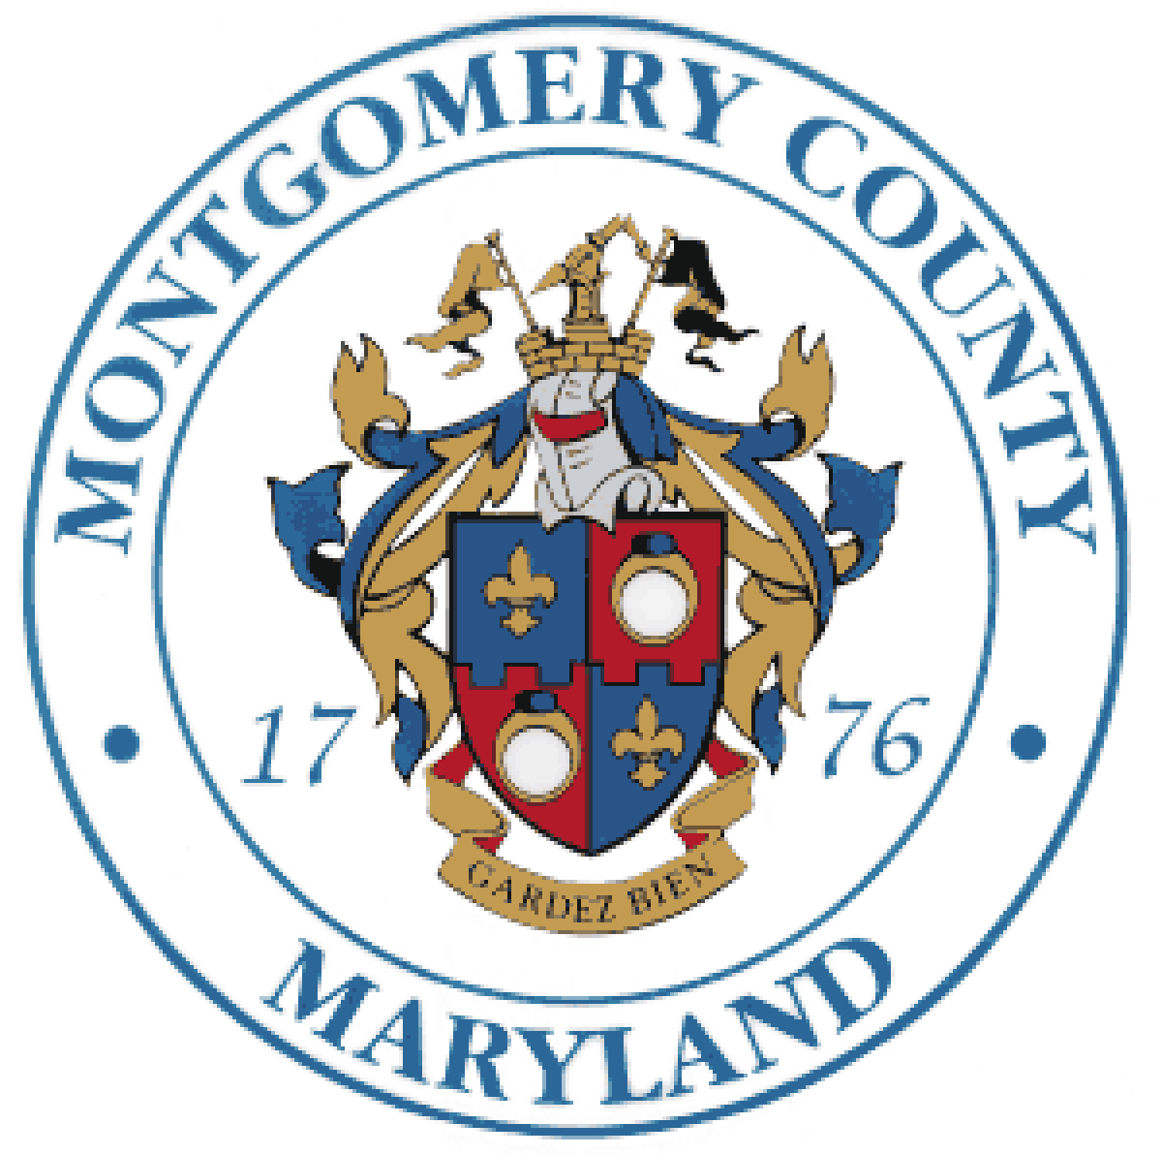
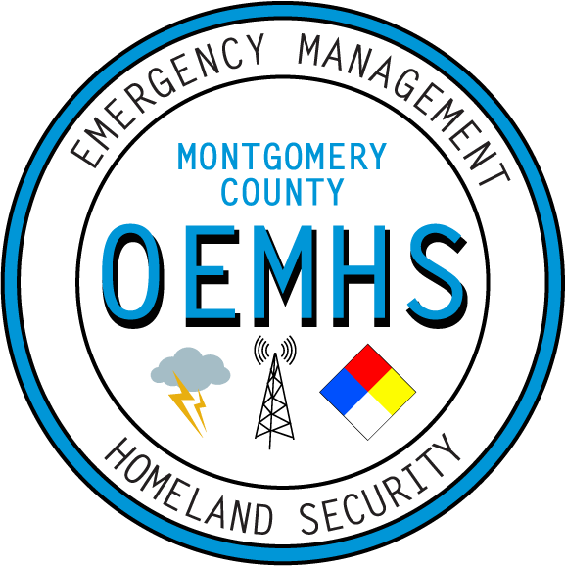
LEPC
4/19/2018
Agenda
LEPC Quarterly Meeting
Location: Public Safety Headquarters
- Welcome / Introductions

- LEPC Updates:
  - Hazmat Permitting Program – Michael Goldfarb
  - OEMHS Updates – Chuck Crisostomo / Earl Stoddard
    - Upcoming Exercises – John Burke
    - Partners in Preparedness – Joe Corona
  - LEPC Core Group Update – Randy Norman
  - Fire-Rescue Hazmat Update – Captain Ivan Browning

- By-Laws Voting

- Commodity Flow Study Overview – Training Outreach

- Hazard Mitigation Program Update and Survey – Michael Boldosser (OEMHS)

- Colonial Pipeline Overview and Safety – Mike Williams

- New Business – Open Forum

