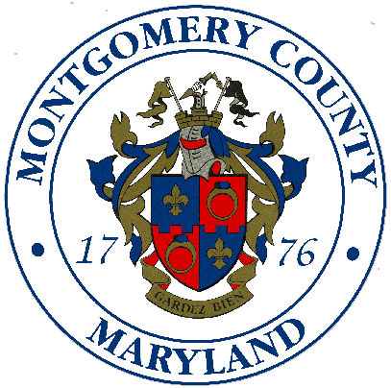
Montgomery County Rapid Transit System (RTS) Steering Committee
June 25, 2013, 4:00 p.m. – 6:00 p.m.
Montgomery County Department of Transportation
101 Monroe Street, 9th Floor Conference Room
Rockville, MD 20850

- Introductions and Welcome -- Arthur Holmes, Chair & Director Montgomery County Department of Transportation
- Approval of Minutes From April 30th Meeting -- Arthur Holmes
- Update on Countywide Transit Corridors Functional Master Plan – Thomas Autrey, Supervisor, MC Planning Department
- Transit Signal Priority Work Group Report -- Casey Anderson, Chair. Presentation by Paul Silberman, Transportation Planning Group Director, Sabra, Wang & Associates, Inc.
- Service Planning and Integration Study Work Group Report -- Dan Wilhelm, Chair. Presentation by Dan Goldfarb, Transportation Planning Manager, VHB
- RTS Finance Working Group Report – Chair, Joe Beach, MC Finance Director

- Transportation Infrastructure Investment Act Project Funding -- Leif Dormsjo, Acting Deputy Transportation Secretary, MDOT
- Purple Line
- RTS Corridor Planning
- Corridor Cities Transitway Projects
- Purple Line Private Public Partnership Initiative -- Leif Dormsjo

- Next Steps and Other Updates – Arthur Holmes
- Meeting Calendar – Next meetings are scheduled for:
- 7/30/13
- 8/27/13
- TBD -- Work Group Meetings

