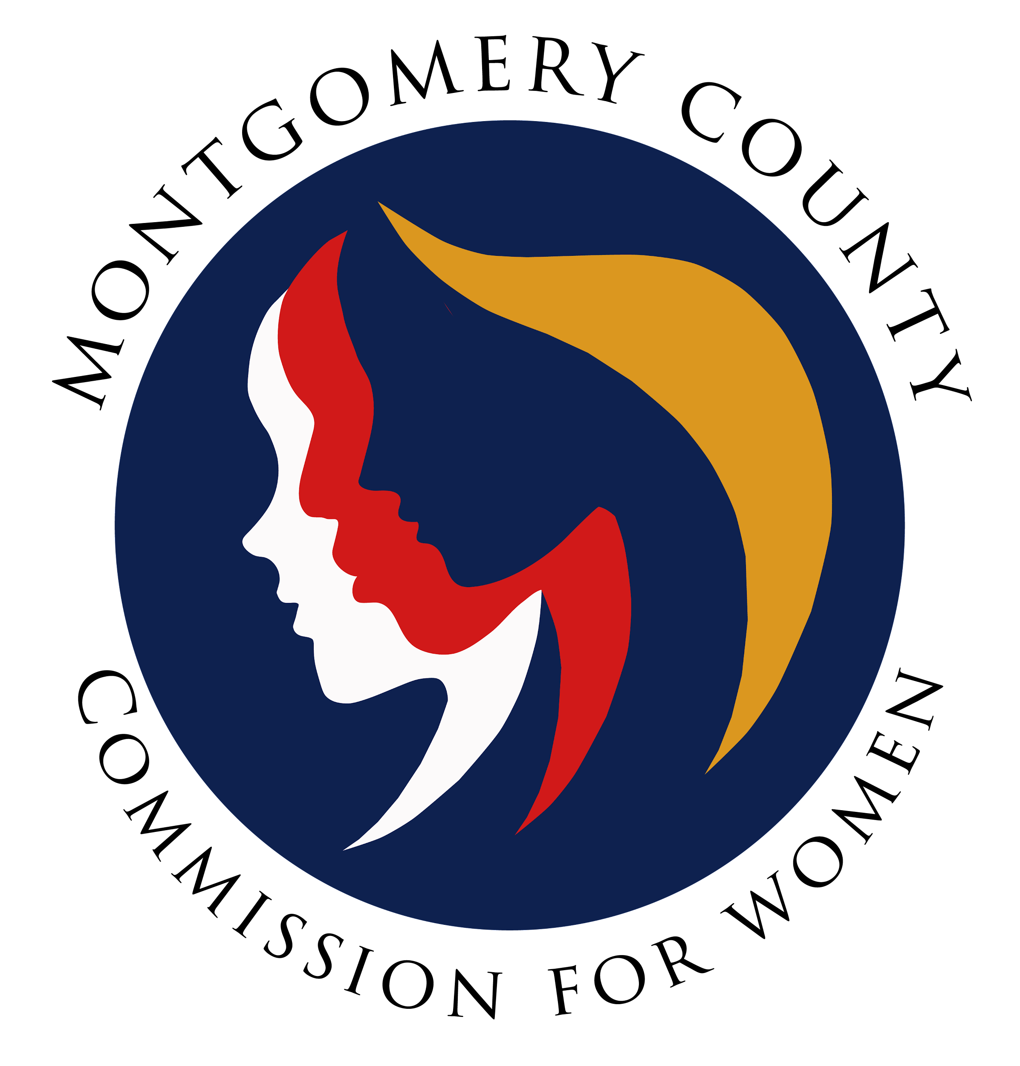
Montgomery County Commission for Women
Monthly Meeting October 14, 2021

Attendance
Attending | Not Attending | Guests
Donna Rojas – Chair  Patricia Maclay – 1st Vice Chair  Tonia Bui – 2nd Vice Chair  Isabel Argoti - Secretary  Nicole Drew  Jan Molino  Diana Rubin  Chai Shenoy  Angela Whitehead Quigley  Ijeoma Enendu  Meredith Weisel  Betty Romero  Staff  Jodi Finkelstein  Ashlyn Davis – Intern  Holly Mancuso – Intern  Gabriela Tomasi - Intern | Arlinda Clark | Tondalayo Royster  Farah Nageer-Kanthor  Tiffany Jones
CFW MEETING MINUTES
October 14, 2021

I. WELCOME AND INTRODUCTIONS Chair Rojas
- Meeting called to order at 7:03 PM
- Presentation from Montgomery Moving Forward - Early Care and Education Priorities and Partnership Opportunities
- The slide deck will be shared and commissioners can share any questions with ED Finkelstien.

II. APPROVAL OF MINUTES AND AGENDA Chair Rojas
- September 2021
- Amendments
  - Commissioner Shenoy - remove Commissioner Rubin as co-chair for Ad Hoc Anti-Hate Committee. Commissioner Weissel was not recently added, she was already there.
  - Change that Commissioner Enendu was present at the last meeting.
- Commissioner Maclay to approve minutes as corrected. Commissioner Whitehead Quigley seconds.

III. EXECUTIVE COMMITTEE REPORT Chair Rojas
- Onboarding Update
  - One of the selected individuals was also selected for another county board so we are waiting to hear back about the individual serving with CFW. They cannot serve on both.
- CFW in the Community
  - We are in the community! Events included on September 19 for the Wheaton Arts Parade and October 4 at the DVCC Kick-Off. Commissioner Rojas encourages all commissioners to sign up for facilitation at an upcoming program. Slots are still open!
- CFW Vision
  - A facilitation was conducted with FY21 members on how we can improve the effectiveness of the commission, especially with internal communication. As we look to serve our community, we should also be working together. We should be respecting one another and our differences.
  - The executive committee is going to look at the overall county vision and core values to see how we should adopt this and remind ourselves about this.
  - When we look at communication, if there is an issue with each other, please try to resolve it with each other. If not resolved, please go to Commissioner Rojas to have a group conversation. If it is not resolved, then we can involve ED Finkelstein.
IV. EXECUTIVE DIRECTOR REPORT Executive Director Finkelstein
- Budget Forums
  - A reminder that the county is holding public budget forums. ED Finkelstein has included the flyer in the agenda.

V. COMMITTEE REPORTS
b. PALS Commissioner Rubin
- Confirmed Lobby Day for Tuesday, December 14, 2021, from 8:45 am - 12:30 pm. Preferred featured speakers are 1) Adrian Jones or 2) Ariana Kelly. Last year it was virtual and the turnout was great with more interactions among legislators.
- A webinar will be held the week before on Tuesday, December 7 about our top four (4) priorities.
- MLAW Conference is being held virtually this year and registration is open. The committee is interested in sponsoring for $100 again this year. Commissioner Rubin moves to approve $100 to sponsor MLAW 2021. Commissioner Molino seconds. No discussion. Approved by 10 votes.
- We are inviting past commissioners and neighboring commissions. This ensures that we keep our community even after serving on the board.
- Commissioner Maclay has some suggested speakers, if needed.
- Commissioner Argoti suggested inviting Emerging Leaders to join for Lobby Day.
f. Public Relations Commissioner Argoti
- Please go “subscribe” to our YouTube page so we can increase our subscribers and unlock access to more editing rights.
- We are promoting our programs that are now live this season. All commissioners should also push out to their own networks and contacts.
g. WLB Commissioner Maclay and Argoti
- The official WLB 2022 theme is Voting Women Change Everything.
- The team continues to meet with the technology team which shows a promising outlook to use Zoom Events for everything from registration to day-of-event.
- Originally the President’s Networking Reception, the Chair’s Networking Reception will be held separately on a different date to be determined.
- Sponsorship information will be released soon.
- The Emerging Leaders Committee needs a co-chair. Commissioner Whitehead Quigley would like someone to shadow and learn the ropes.
- Commissioner Rojas asked how the WLB will work with Oyin being out. Executive Director Finkelstein assured that she has three (3) interns this year to tap into and delegate tasks.

VII. LIAISON REPORTS

b. DVCC Commissioner Drew
- Commissioner Drew will reshare the events happening this month in recognition of Domestic Violence Awareness Month. Please share!

VIII. AD HOC COMMITTEE REPORT(S)

c. Ad Hoc Committee on Hate Violence Commissioner Shenoy
- The committee discussed vision and mission. They will come back with ideas and share updates once finalized.
- Commissioner Rojas shared that ad-hoc is created in response to certain issues or current challenges as needed such as the Ad Hoc Suffrage committee. She posed the question, how can we best use our time when the county already has a similar board? Can we have a commissioner sit on that board and report back as a liaison instead? It’s not clear if this committee will be or should be a standing committee.
- Commissioner Drew brought up previous initiatives that could be handled under this commission such as the Asian Hate statement, and that there should be an end date.
- Commissioner Drew clarified that Scholarship is a liaison role, not a committee.
- Commissioner Enendu reminded all that there was an event that we wanted to partner with and not necessarily have an entire committee ourselves.
- Commissioner Bui shared that there is importance in addressing issues relevant to women of color. We suggested that we re-evaluate the capacity for this committee, but it is exciting that we can finally bring this up in our conversations.
- Commissioner Maclay suggested exploring the possibility to have a permanent liaison on the Hate and Violence (H&V) Commission.
- Commissioner Shenoy shared that meetings did happen with the H&V Commission but gender was often left out. She agreed that a seat on this H&V Commission makes sense, but it’s not clear on which committee those discussions would happen.
- Commissioner Weisel shared that bias is often rooted in misogyny and that is not always addressed. She does not see this as a long-term committee but perhaps an exploratory initiative to see how this fits into our overall work.
- Commissioner Drew suggested we put an end date on this committee and designate a liaison.
- Commissioner Quigley suggests that the committee make a timeline for the next steps and direction. This can be presented at the next meeting.
- Commissioner Rojas also reminds us that we need to ensure that our existing committees are also taken care of before we try to formulate new ones.

d. CFW 50th Anniversary Commissioners
- Committee shared formulating ideas for a friendship picnic in June as a family-oriented event.
- The CFW 50th anniversary should be an ongoing theme for next year.

IX. OLD BUSINESS
- None

X. NEW BUSINESS
- Team Building - we are looking at how we can create a space to understand each other and work with different leadership styles. Commissioner Enedu shared that this can be a social committee initiative.
- Refugee Women Community Service Opportunity - Executive Director Finkelstein shared that the commission was asked if we would like to get involved in a care package initiative to give recently arrived from Central America. More information is still being formulated. There is a general interest so ED Finkelstein will ask for more information.
- Commissioner Rojas graduated! Kudos!
- Up2Us Foundation is looking for volunteers this weekend to help bag groceries in Wheaton Mall. Please contact Tazeen if interested. There are dates until November with a special need for Spanish speakers.

XI. Adjourn
Meeting adjourned at 8:47 PM by Chair Rojas.

