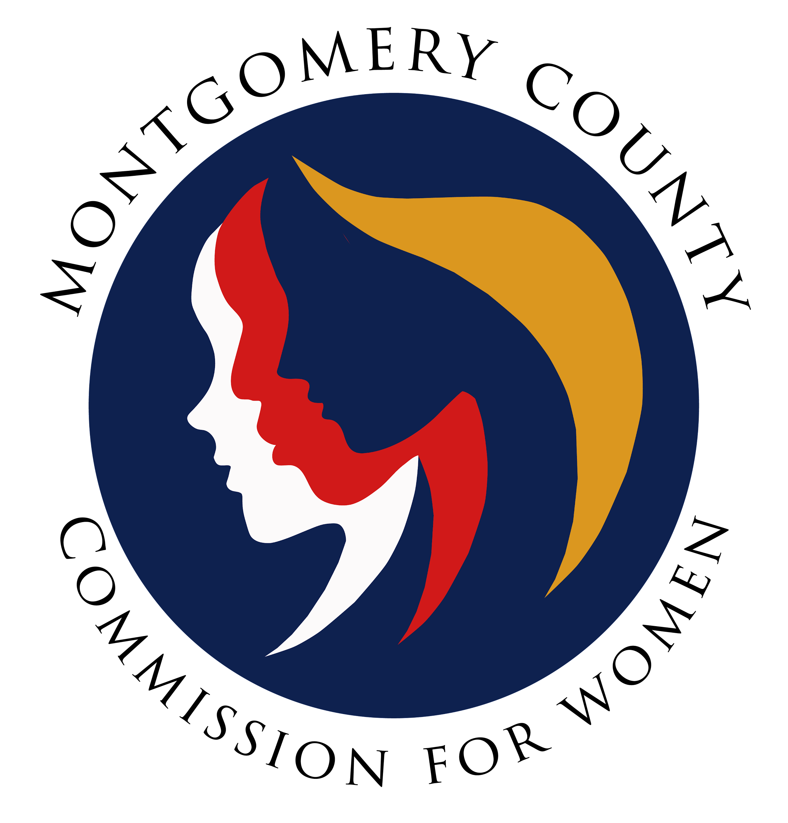
Montgomery County Commission for Women
General Meeting Minutes
December 8, 2022 / 7:00 – 8:30 p.m.

______________________________________________________________________________
“No one can whistle a symphony. It takes a whole orchestra to play it."
H.E. Luccock
______________________________________________________________________________

Attendees
Donna Rojas (Chair)
Betty Romero (2nd Vice Chair)
Jodi Finkelstein (Executive Director)
Commissioners
Isabel Argoti Jodi Danis LaDonna King Janet LaVelle
Helene Meister Kimberly Mouzon Liz Richards Tondalayo Royster
Lindsey Turnbull

Guest
Michael Baskin, Chief Innovation Officer

SUMMARY

The Commission for Women held a closed meeting on Thursday, December 8, 2022 pursuant to Section 3-305 of the Annotated code of Maryland, (b) (i) and (ii). The session was facilitated by Michael Baskin, Chief Innovation Officer for Montgomery County.

