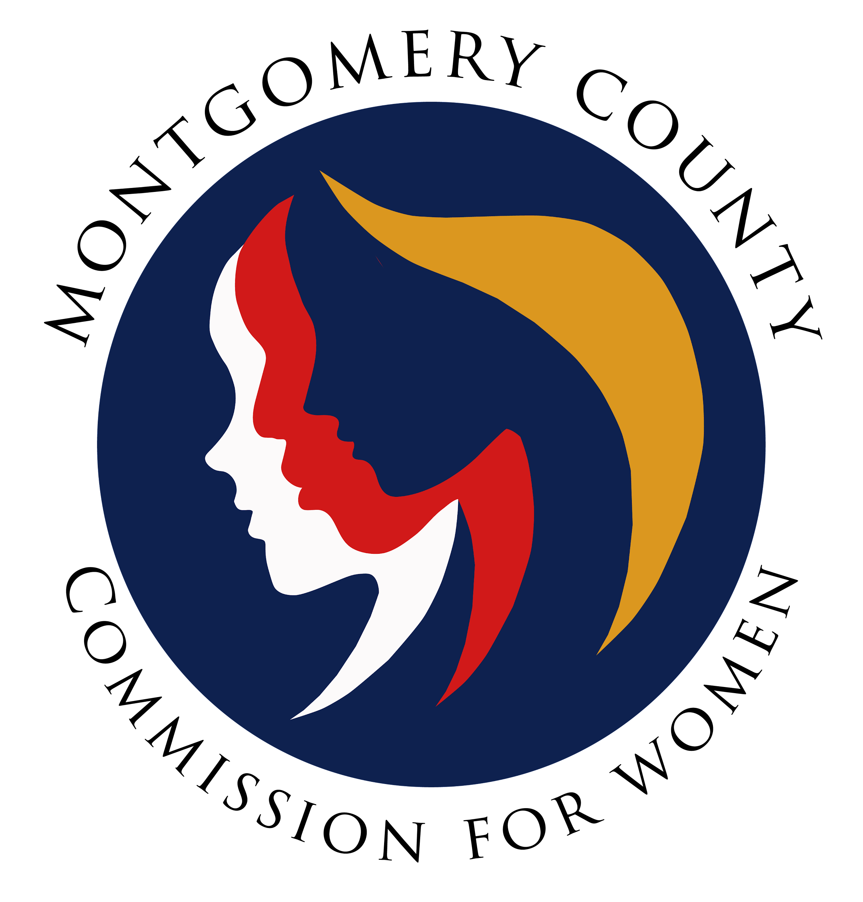
Montgomery County Commission for Women
Monthly Meeting October 13, 2022

Attendance
Attending | Not Attending | Guests
Donna Rojas – Chair  Arlinda Clark—Vice Chair  Betty Romero—2nd Vice Chair  Kimberly Mouzon  Jan Molino  Ijeoma Enendu  Janet LaValle  Staff  Jodi Finkelstein | Isabel Argoti  Tondalayo Royster

- Welcome and Introductions Chair Rojas
Meeting was called to order by Donna Rojas at 7:00pm

- Approval of Minutes and the Agenda Chair Rojas
Unable to vote for the approval of the minutes and the agenda, we did not have a quorum. We now have three sets of minutes and agendas to vote on. Jodi stated we needed 8 for a quorum based on 15 members but the issue is, we do not have 15 members. Jodi and Arlinda will explore further.

- Executive Committee Report Chair Rojas
- Business and Professional Women (BPW) are honoring Isabel for receiving the Shining Star Award. It is anticipated that the CFW meeting will end early so that commissioners can support Isabel at the BPW meeting.
- Onboarding updates of new members: Confirmation of new members is Oct 18 & 25; six names have been submitted to the County Executive.
- Maryland Legislative Agenda for Women (MLAW) Conference sponsorship and tickets: Each year CFW sponsors the MLAW conference Saturday November 12, 2022, at 9:00am, Silver Spring Civic Center, tickets are $35.00 through November 1, $40.00 after. The Maryland Commission for Women is offering two tickets to Commissions and the CFW will have additional tickets depending on the sponsorship level. PALS members will be the first to receive tickets. Determination is due on the October 25, 2022. We are unable to vote tonight we will send a survey to vote yes/no. Jan recommended that CFW sponsor at the Silver Level ($200 and 2 tickets) to promote the CFW brand.
- NAACP tickets: We agreed to support the NAACP Win event October 30th, at the Silver Spring Community Center. We have 4 tickets for the CFW, tickets will be given on first come first serve basis. Donna will send announcement via email. Selection for the tickets will be based on the email time stamp.
- December meeting: The CFW will most likely have a closed meeting in December to focus on team building. The meeting will also include a holiday party and will be in person.
- Maryland Network Against Domestic Violence: 2022 Annual Meeting is, October 27, 2022. Supporting families through their programs, earlier we voted to not support their biannual conference financially because they waited until the last minute. This year we will conduct a survey for sponsorship as we have done with other programs seeking support. We will emphasize the need for timely submission from this organization.

- Executive Director Report Executive Director Finkelstein
Jodi will not be at the November 10th meeting; Carman will be taking her place. Jodi will send an email regarding the Maryland Women Hall of Fame. The Maryland Commission for Women will host Hall of Fame and Emerging leaders and will be looking nominations.
- Committee Reports

- Policy and Legislation Committee Commissioner Molino
Jenny provided a presentation on how a bill becomes a law to the committee. The committee also voted to have Lobby Day be virtual. The proposed Lobby Day date is December 12. The committee is also considering Lobby Day a keynote speaker who can focus on advocacy, and provide an overview of the upcoming legislative session. Suggestions are welcome.

- Programing Committee Commissioner Enendu
Committee decided to do a virtual career exploration in partnership with Montgomery Women. Program involves young girls and high school students, provide an opportunity to explore careers, including nontraditional and STEM careers. November 17, 2022, at 7pm virtual and she will send the link.

- Budget Committee Chair Rojas
Reviewed procedure for submitting a request (form) for funds to the Budget committee. Form to be utilized for all future funding request.

- SPRE Committee Commissioner Molino
Committee met on Oct 11 and developed a vision statement based on the activities worked on at the October 8th strategic planning session. Revised Vision statement draft: The Commission for Women, a premiere organization where women and girls have equal and full participation in every aspect of community living and access to education, health care, work advancement and or with political and economic power. The Mission Statement revised: To advance women’s equal and full participation in the benefits, responsibilities and opportunities of society and enable women’s equal participation through the acquisition of skills competencies, information resources while harnessing the economic power of women, promoting social inclusion, changing perception and influencing politics and enhancing health and safety of women in the community. Corrected both Vision and Mission statements to read better. Per Donna, both statements to be voted on in November. The values derived from the strategic planning session held October 8, 2022. provided via email by Jan and Betty.
e. Emerging Leaders: No report
f. Public Relations: No report
g. Women Legislative Briefing Commissioner Clark
Programing committee met on October 6, 2022, discussed keynote panel instead of keynote speaker to insure balanced representation. The committee decided to have organizations (government, nonprofits, for profit) for equal representation on the breakout session panels. Decided on the Keynote panel topic, Empowerment through Action and Advocacy. Break out session will be two sessions running simultaneously. Topics are 1. Empowerment through Economic Equity 2. Empowerment in Health 3. Empowerment in Safety and 4. Empowerment through Education. The programming committee is considering including the new female county councilpersons on the panels/sessions. Needs: facilitators, help with Emerging Leaders and panelist.
- Liaison Reports
- MLAW Commissioner Molino
Two prospective Bills for review for next meeting; Marriage is Not a Defense and Gun Safety Law.

- Human Trafficking Prevention Committee Executive Director Finkelstein
Determining what legislation the committee would like to support and invited to train community resource officers on human trafficking. Jodi will attend a human trafficking prevention conference for professionals.

- Domestic Violence Coordinating Committee Chair Rojas (for Commissioner Royster)
Currently partnering with the Family Justice Center for Domestic Violence Committee (DVCC) “Walking in their Shoes”. This is a county wide effort. October has been proclaimed Domestic Violence Month.

- Choose Respect Commissioner Mouzon
Committee is discussion when Respectfest will occur, possibly April 16, 2023
- Health Needs Assessment: No report
- CFW scholarships: No report
VII: Ad Hoc Committees
a. Social Committee: No report
b. Committee on Hate Violence: No report. Donna discussed next steps for committee and the CFW will have to determine if the committee will remain. There is currently no chair and no one on the committee. November meeting will discuss if committee is needed.
VIII. Old Business: None
IX. New Business /Announcements: Commissioner Molino shared that she is stepping down as co-chair of the SPRE Committee since she is chairing PALS. The By-Laws committee still needs a chair.
Adjourned: 7:46pm

