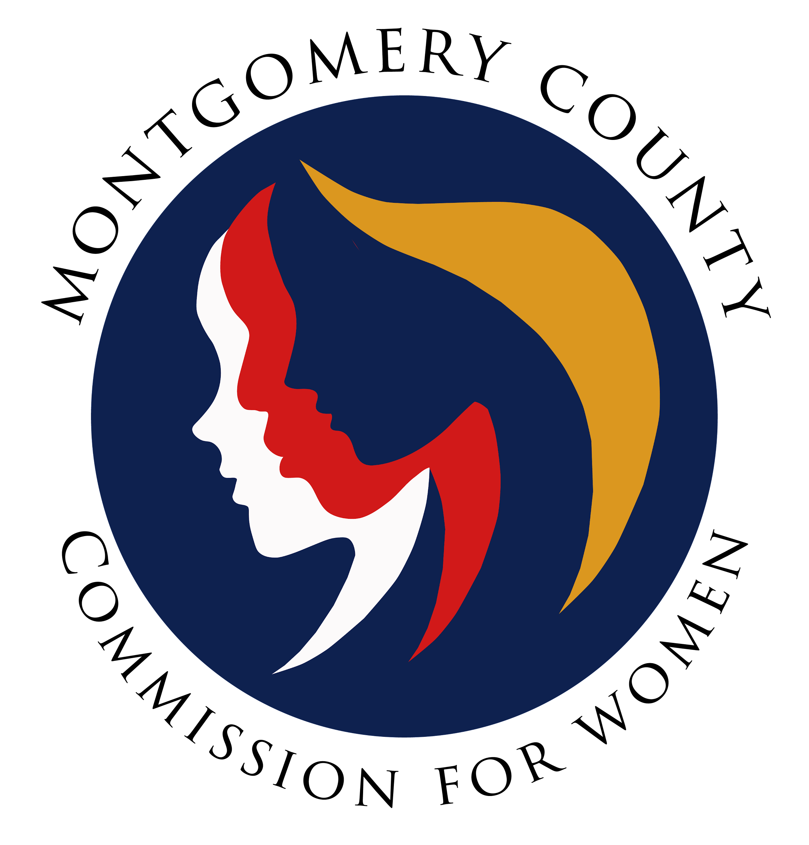
Montgomery County Commission for Women
Monthly Meeting May 12, 2022

Attendance
Attending | Not Attending | Guests
Donna Rojas – Chair  Patricia Maclay – 1st Vice Chair  Tonia Bui – 2nd Vice Chair  Isabel Argoti – Secretary  Betty Romero  Ijeoma Enendu  Kimberly Mouzon  Tondalayo Royster  Janet Lavalle  Nicole Drew  Arlinda Clark  Chai Shenoy  Staff  Jodi Finkelstein | Angela Whitehead Quigley  Diana Rubin  Jan Molino  Oyin Thompson

MEETING MINUTES
May 12, 2022

I. WELCOME AND INTRODUCTIONS Chair Rojas
- Meeting started at 7:03 p.m.
- Introductions to welcome new Commissioner Kimberly Mouzon!

II. APPROVAL OF MINUTES AND AGENDA Chair Rojas
- May Agenda
  - Commissioner Argoti’s name should be added under the 50th Anniversary item.
  - Commissioner Lavelle moves to accept the agenda with the amendment to include Commissioner Argoti’s name under the 50th Anniversary agenda item. Commissioner Bui seconds. All in favor. Agenda passes.
- April Minutes
  - Commissioner Maclay moves to approve the minutes as it. Commissioner Royster seconds. All in favor. Passes.

III. EXECUTIVE COMMITTEE REPORT Chair Rojas
- Avery House Speaking Event - Chair Rojas was asked to speak at their Mother’s Day event last Thursday and it went very well! This is a sober house for mothers with their children and she has been involved before.
IV. EXECUTIVE DIRECTOR REPORT Executive Director Finkelstein
- CFW Team update
  - Currently have no interns. Please send suggested individuals to Executive Director Finkelstein. She will also be out 24-26.

V. COMMITTEE REPORTS
d. SPRE Commissioners Romero
- The committee is moving forward with the strategy session planning. All commissioners received an email to complete a Doodle poll to conclude a date.
- They are also asking for input from the commission on committee descriptions.
- Our facilitator Brit Houve will hopefully be attending our commission meeting next month (June).
f. Public Relations Commissioners Argoti
- Commissioner Argoti shared the final versions of our CFW brochure and one-pager that the committee has been working on for some time to finalize and get printed. She shared that this has been part of our rebranding as we rolled out our logo last year and have been slowly rolling out since then on new materials. The one-pager was created to have a virtual PDF format for our information and could also be easily printed. Both documents share the same information.
- Commissioner Romero questioned whether this is good timing to print since we are holding a strategy session in the Fall where things may change. Commissioner Bui agrees with this point on timing but also notes that we will need something immediate and should maybe just print less to have enough for this year.
- Chair Rojas also clarifies that this is generic information and not specific that should necessarily change drastically.
- Commissioner Romero asks which budget this is coming from. Executive Director Finkelstein confirms that printing of these materials comes from the county budget.

g. WLB Commissioners Maclay/Argoti
- Chair Rojas apologizes for not making the live event, but she shared her welcoming as a recorded video segment which was played at the event.
- Commissioner Maclay shares about the successful event with Senator Susan Lee as the speaker. Great topics of priority were brought up from attendees including youth, civic education, green action, and police reform.
- The theme of “Be Women of Action” was suggested as a WLB theme for next year.
VI. LIAISON REPORTS
c. Domestic Violence Commissioner Drew
- The Domestic Violence Coordinating Council (DVCC) meets every other month. We have done great work in supporting their initiatives including with Choose Respect, sponsoring bus ads to share Family Justice Resource Center information, and distribution of palm cards.
- Commissioner Drew shared that there will be vacancy in this liaison position as her term will soon be up. Perhaps Commissioner Royster will be a good fit as she is already involved and was endorsed by DVCC.
- Commissioner Drew also shared the Office of Legislative Oversight’s Report along with the legislation followed. The legislation to allow protective services to be handled virtually was passes but there is no funding behind it, so this is an ongoing challenge and could maybe be explored next session.
- She suggests that the commission take a tour of the Family Justice Center to fully understand their services and resources.
e. Choose Respect Commissioner Royster
- Commissioner Drew shares

VII. AD HOC COMMITTEE REPORT(S)

c. 50th Anniversary Commissioners Enendu/Maclay/Rubin/Argoti
- Commissioner Argoti and Maclay share about the 50th Anniversary events including the family picnic on June 5 at Wheaton Regional Park and the formal time capsule event on July 17 at Sandy Spring Museum. The flyer and link for the picnic was shared with the commission and is almost ready to share out publicly.
- Commissioner Clark wants to ensure that WLB sponsors are invited and share this information. Commissioner Argoti agrees.
- Commissioner Romero asks if this information was shared as she has not received information. Commissioners Argoti and Maclay share that this was discussed last time and included in the minutes. Public registration has not been sent out.
- Commissioner Romero asks what is the budget for this event and if this needed a vote, especially on deciding how we wanted to celebrate our 50th Anniversary. Commissioner Argoti shares that it is a $20,000 budget and voting was not needed as this was a county budget designated for this event.
- Executive Director Finkelstein shares that this was a designated budget for special events which meant the 50th Anniversary celebration. The County Budget can be viewed online and anyone can attend the county budget meetings to make suggestions.
- Commissioner Argoti reminds everyone that people should join the committee if they want to be more involved on specific details. The committee has discussed options, dates, and working towards this celebration. A call was made to join this committee where now four members are working on this.
- Commissioner Clark shares that we should still vote on any matters of where we are spending money as a commission to ensure everyone is in the know. Commissioner Drew shares that we should have transparency across any money spent and we have lacked tracking of our money. Commissioner Romero agrees and emphasizes the need for this strategic planning meeting. Another item to consider, recommended by Commissioner Argoti, would be when is the appropriate time for that with rotation of commissioners and other changing items?
- Commissioner Clark emphasizes that any budget funds should be documented and that what is missing is the Commission monitoring and administering the monies it has been provided to create specific line items for suggested spending from its allocation.
- Chair Rojas agrees and underscores that we need standardized operating procedures for all programs and administrative duties so that all Commissioners are on the same understanding and that is well-documented.
- Executive Director Finkelstein wants everyone to feel informed and understand our budget breakdown. She reminds commissioners that the commission does not have the same fiscal role as a non profit board and everyone should also read the charter and the bylaws.

IX. OLD BUSINESS
- NONE

X. NEW BUSINESS/ANNOUNCEMENTS
- Chair Rojas wants all committees to review committee descriptions to ensure that it describes what committees are doing. A revised copy should be reviewed and ready for the Strategic Planning Meeting.
- Commissioner Clark asked about the Girl Power Contest. There were delays in the judging and the announcement should be coming out early next week.
- Complete the SPRE Doodle Poll.
- Please sign up to proctor remaining CFW programs. This is a shared duty among all commissioners where we serve as logistics facilitator for these virtual programs.
- RSVP for MD CFW Roundtable by tomorrow to attend on May 19 at 6 p.m.

XI. Adjourn

Meeting adjourned at 8:28 p.m.

