M E M O R A N D U M

UPDATED – February 2010

To: Volunteer Fire and Rescue Personnel

From: Division Chief Wm. Alan Hinde

Subject: Annual Physicals

I am pleased to report that the Fire and Rescue Service has successfully made it through the initial wave of periodic medical exams. Volunteer fire and rescue personnel are now being scheduled for their second yearly physical based on the date that the initial screening was conducted or assigned month due. This memorandum provides information to make this process as easy as possible.

The safety and health of every fire and rescue provider in the Montgomery County Fire and Rescue Service is of paramount concern to your peers, the leadership of the local fire and rescue departments, Chief Bowers and myself. I trust that you will continue to embrace the annual physical program since it is a benefit to you. This has been clearly demonstrated by a number of cases in which career and volunteer personnel have identified serious health issues early that could have resulted in a compromise to their quality of life if they had not been discovered. Keeping you healthy so you can continue to volunteer is a benefit to you and to Montgomery County.

It is important to mention that the FROMS process is managed using the principles of strict medical confidentiality. With the exception of scheduling of appointments, and receipt of the final ratings on individuals for distribution to the LFRD Chiefs, the Volunteer Division does not participate in the physical process. All questions about your physical results and follow-up appointments should be directed to FROMS. Under no circumstances should you be sending or discussing medically privileged information with the Volunteer Division office.

The following step-by-step instructions will assist you in scheduling and completing your annual physical:

- Attain a Annual Physical Packet from your LFRD Chief. This package should include four forms in addition to a map to Fire/Rescue Occupational Medical Services: (1) Employee Medical History; (2) Interval Medical History Form; (3) Medical Determination of Readiness for Respiratory Fit-Testing; and (4) Tuberculin Skin Test. (If you received this notice electronically they are included as part of this document or as an attachment.)

- Fill out the online Annual Physical Information request. Ruthie Wills will schedule your physical and will email you a confirmation of your assigned appointment. Morning and Saturday appointments fill quickly and may not be available for the times you request. We require 72 hours to cancel an appointment in order to let the remainder of the service know an open appointment has come up in an effort to get the most done with the time we have. The Physical Request form can be found on the quicklinks website (shown below) at:

Go to www.montgomerycountymd.gov/firerescue/quicklinks

Hover over Division of Volunteer Services and select DOVS Quicklinks

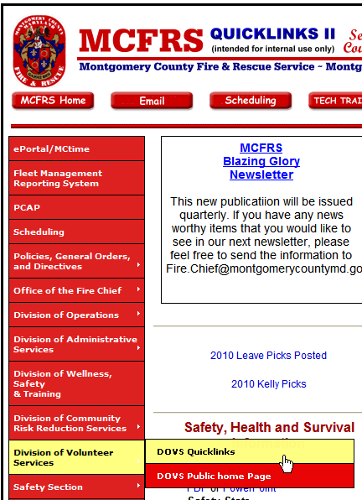

Then from the DOVS Quicklinks page, select the link that says “Click Here to schedule your Annual Physical”

- Complete all forms in the package to the best of your ability. These forms should be hand carried to FROMS on the day of your physical. The medical history forms are NOT faxed. The FROMS staff will answer any questions about the medical history, fit testing or tuberculin testing paperwork on the day of your physical.

- If possible, go to FROMS (Fire Rescue Occupational Medical Services) to get your blood work done at least two weeks prior to your physical date. No appointment is required. Hours are Monday through Friday 7:30 a.m. to 7:00 p.m. and every other Saturday from 7:00 a.m. to 12:00 p.m. Please plan to arrive at least 30 minutes prior to closing. Remember that you need to fast (except clear fluids) for 12 hours prior to completing the blood work. In addition, be prepared to give a urine sample during the blood work appointment.

- When you go to FROMS, please be on time and bring a photo ID with you. Parking is available in the garage at 255 Rockville Pike entering off Rockville Pike. During the Monday through Friday hours there is a fee for parking. During Saturday hours there is no charge for parking in the garage. There are also parking meters on the street, as well as a surface lot just behind 255 Rockville Pike on Monroe Place or Middle Lane. After 1700 hours parking meters are free. If personnel are going to FROMS on apparatus you may park on Truck Street just south of FROMS.

- Make sure to clarify with FROMS during your physical appointment if you need to complete any follow-up after the appointment. This could include getting documentation from a personal physician, having a TB test read or possibly returning to FROMS for a follow-up appointment. It is essential that you follow up on any instructions given by FROMS. Failure to do this will result you receiving a rating that does not allow you to ride an apparatus.

I hope this information has been helpful. I encourage you to address any concerns you have about the process to me through your local fire and rescue department chief. We are always looking for ways to improve this process.

Thank you for everything you do to improve our combination fire and rescue service in Montgomery County, Maryland.


