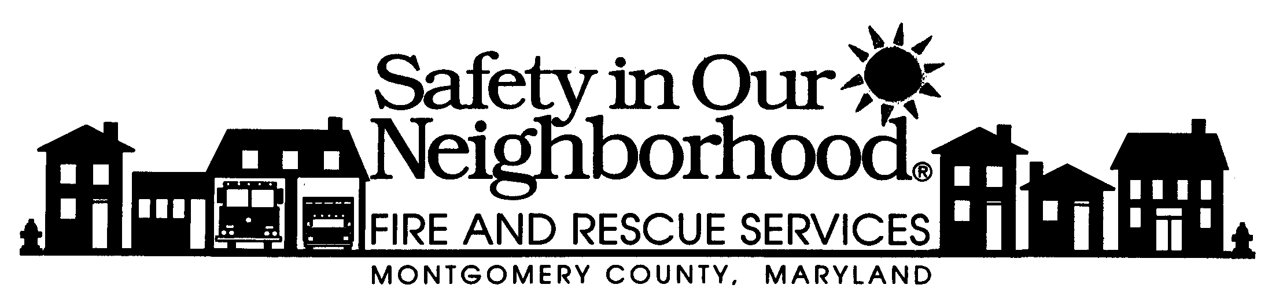
Isiah Leggett Scott Goldstein
County Executive Fire Chief
Fireplace and Wood Stove Safety
Wood stoves and fireplaces are becoming a very common heat source in homes. Careful attention to safety can minimize fire hazards.
To use them safely:
- Be sure the fireplace or stove is installed properly. Wood stoves should have adequate clearance (36 inches) from combustible surfaces and proper floor support and protection.
- Wood stoves should be of good quality, solid construction and design, and should be UL listed.
- Have the chimney inspected annually and cleaned if necessary, especially if it has not been used for some time.
- Do not use flammable liquids to start or accelerate any fire.
- Keep a glass or metal screen in front of the fireplace opening, to prevent embers or sparks from escaping, unwanted material from going in, and to help prevent the possibility of burns to occupants.
- The stove should be burned hot twice a day for 15-30 minutes to reduce the amount of creosote buildup.
- Don't use excessive amounts of paper to build roaring fires in fireplaces. It is possible to ignite creosote in the chimney by overbuilding the fire.
- Never burn charcoal indoors. Burning charcoal can give off lethal amounts of carbon monoxide.
- Keep flammable materials away from your fireplace mantel. A spark from the fireplace could easily ignite theses materials.
- Before you go to sleep, be sure your fireplace fire is out. NEVER close your damper with hot ashes in the fireplace. A closed damper will help the fire to heat up again and will force toxic carbon monoxide into the house.
- If synthetic logs are used, follow the directions on the package. NEVER break a synthetic log apart to quicken the fire or use more than one log at a time. They often burn unevenly, releasing higher levels of carbon monoxide.
“Together We Can Save Lives And Prevent Injuries”

