This document will be updated after each session of Managers and Supervisors Role in Ensuring Accountability in Timekeeping to add participant questions, as well as any items that were placed in the “Parking Lot” where the answers could apply more broadly.
Questions will be formatted in italics, and the date of the session when posed. Answers will follow.

MCtime POC/SME
How do I identify my departmental MCtime Point of Contact (POC) or Subject Matter Expert (SME)? (10/3/16)
The MCtime Point of Contact List is available on the MCtime Informational Website (www.MontgomeryCountyMD.gov) under the Resources tab. This document is updated three to four times a year. Updates and corrections can be submitted through the MCtime Mailbox.

How can I coordinate for other managers in my division to get customized training that for a specific timekeeping issue that is unique to our department? (10/3/16)
MCtime offers a Department Specific Pay Period Close Checklist training. You should make the request through your departmental MCtime Point of Contact (POC) or Subject Matter Expert (SME) who will coordinate the content of the session. The department POC should make the request through the MCtime Mailbox. MCtime will work with your Department’s POC to coordinate questions, identify scenarios and schedule the appropriate time and location.

Online Resources
Where can I find a Glossary of MCtime Terms? (10/3/16)
The MCtime Glossary is available on the MCtime Informational Website under Resources Tab under General Guidance.

Where can I find the Montgomery County Personnel Regulations? (10/3/16)
The Montgomery County Personnel Regulations (MCPR) are available on the OHR Website (www.MontgomeryCountyMD.gov) under Policy under Regulations.
http://www.MontgomeryCountyMD.gov/HR/LaborRelations/PersonnelRegulation.html

Where can I find the Collectively Bargained Agreements? (10/3/16)
All three Collectively Bargained Agreements (CBAs are available on the OHR Website (www.MontgomeryCountyMD.gov) under Policy then Regulations.
MCGEO - Collective Bargaining Agreement
IAFF - Collective Bargaining Agreement (Fire Rescue)
FOP - Collective Bargaining Agreement (Police)
http://www.MontgomeryCountyMD.gov/HR/LaborRelations/LaborCollectiveBargaining.html#1

Multilingual Pay (ML)
Where can I find employees certified and eligible for Multilingual Pay? (10/3/16)
The Certified Employee Language Database is available on the OHR Website under Workforce then Multilingual Program.
http://www.MontgomeryCountyMD.gov/HR/MultilingualProgram/LanguageCompetency.html#1

Leave Codes

When should I use the Sick Leave – unscheduled Pay code? (10/24/16)
Generally any –Unscheduled Pay code is used for “Same Day Call Out.” Consult your department’s attendance policy for specifics.

What is Family Sick Leave? (10/3/16)
From the Pay Code Descriptions Document on the MCtime Informational Website, under the Resources Tab.
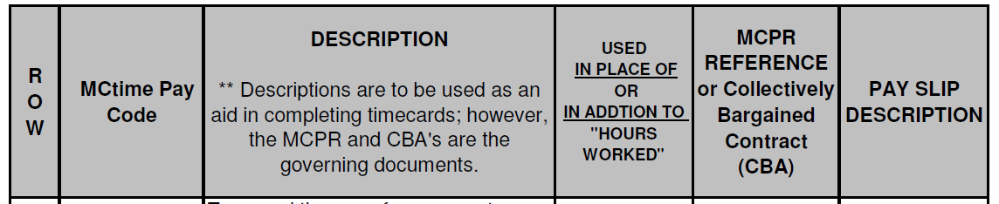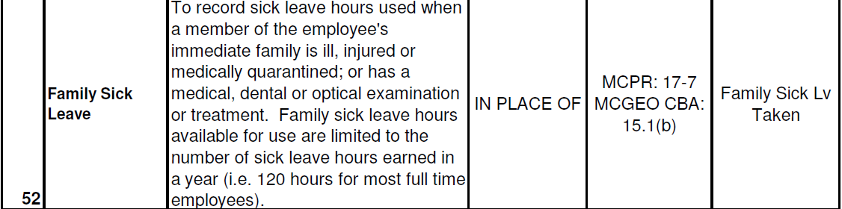

What is Earned Sick & Safe Leave? (10/3/16)
View Earned Sick and Safe Leave Memo and Guidance for Earned Sick and Safe Leave - FAQs Documents on the MCtime Informational Website under Resources Tab then Leave Guidance.

Is there a limit to how much Administrative Leave may be awarded? (10/3/16)
There is no County directive that sets a limit, but individual departments may have policies in place. If you have employee specific concerns, consult with OHR Labor Relations.

Holidays
An employee works a Compressed Schedule and the next holiday falls on the Friday that is her Regularly Scheduled Day Off (RSDO). Should I do something so she gets a holiday credit? (10/3/16)
The Holiday Guidance for Regular, Full-time and Part-time Employees Document on the MCtime Informational Website, under the Resources tab, provides instructions. Within the document, there are hyperlinks to provide guidance. In this case, since the employee is Full Time, the holiday fell on the employee’s scheduled day off and the employee did not work, Scenarios 3A, 3B or 3C may by appropriate, depending upon employee’s position and departmental budget.
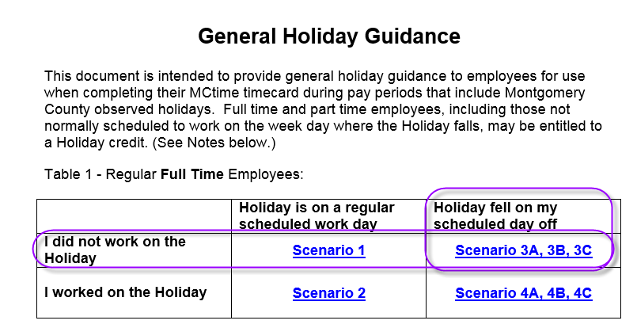

MCtime Pay Rule Assignment
What does FLSA Exempt Mean? (11/1/16)
Employee in a position/job class that is not eligible for excess (overtime) compensation under the Fair Labor Standards Act (FLSA) because of an exemption in the law. The employee may be eligible for excess hour compensation under the County’s personnel regulations and/or labor agreements. See Overtime Thresholds Resource.

What does FLSA Non-exempt Mean? (11/1/16)
Employee in a position/job class that is eligible for excess (overtime) compensation under the FLSA. Employee Weekly Threshold is forty (40) hours per week.

What are the factors that are used to configure the MCtime Pay Rules? (11/1/16)
Factor | Source | Options | Codes | Direct Questions to:
Employee Positon Type | Oracle | Regular Temporary Temp Seasonal | R  T  Seas | OHR Staffing
Union Status | Oracle | Unrepresented  Rep Police  Rep Fire Rescue  Rep Gen Gov’t | NON  FOP  IAFF  MCGEO OPT  MCGEO SLT | OHR  Labor
Full Time Equivalency (FTE) | Oracle | Full Time  Part Time | F  P | OHR  Records Management
FLSA Status | Oracle | Exempt  Non-exempt | E  N | OHR Classification
Grade | Oracle | See OHR Classification  Tables | Grades 5-40  MLS/Director  Special Police, Fire, Sheriff, Medical, etc. Grades | OHR Classification
Job Class | Oracle | See OHR Position Descriptions | See OHR Position Descriptions | OHR Classification
Multilingual Status | OHR  ML Database | ML Advanced  ML Basic  ML Expert (FOP) | ML1 – ML8  MO1 - MO8 | OHR Multilingual
Schedule Group | Managers | Various | See Pay Rule Assignment Genie | MCtime

