General Holiday Guidance

This document is intended to provide general holiday guidance to employees for use when completing their MCtime timecard during pay periods that include Montgomery County observed holidays.

Table 1 - Regular Full Time Employees:

 | Holiday is on a regular scheduled work day | Holiday fell on my scheduled day off
I did not work on the Holiday | Scenario 1 | Scenario 3A, 3B, 3C
I worked on the Holiday | Scenario 2 | Scenario 4A, 4B, 4C

Table 2 - Regular Part Time Employees:

 | Holiday is on a regular scheduled work day | Holiday fell on my scheduled day off
I did not work on the Holiday | Scenario 5 | Scenario 7
I worked on the Holiday | Scenario 6 | Scenario 8

Questions regarding this document should be directed to the IT Help Desk at 240-777-2828.

Note: This information does not apply to employees covered by the IAFF or FOP contract language.

Note: When an actual holiday falls on a Saturday or Sunday, a substitute or “observed” is designated by the Chief Administrative Officer (CAO). In these instances, employees scheduled to work on both the actual and observed holidays need only record hours worked for the holiday hours worked. Employees that are scheduled off on both the actual and observed holidays should schedule an alternate day off (Scenario 3A). MCtime will perform an additional review after sign-off to apply any holiday pay adjustments.

Instructions on how to use the charts above:
Step 1 – based on your employment status:
choose Table 1 for Full Time employees or
Table 2 for Part Time Employees

Step 2 – based on your schedule, choose the column that applies:
choose the left column for Holiday is on a regular scheduled work day
choose the right column for Holiday fell on my scheduled day off

Step 3 – based on your work status on the holiday choose the row that applies:
choose the top row for I did not work on the Holiday
choose the bottom row for I worked on the Holiday

Step 4 – within the box that applies to you, choose the scenario based on your circumstances and hold the Ctrl key and click on the scenario.
Scenario 1

For Regular Full-time Employees:
I did not work on the Holiday -AND- Holiday is on a regular scheduled work day.

Explanation | When a holiday falls on a regular work day, regular full-time employees will be released from attendance where practical and where eligible, will receive regular pay for the holiday.
MCtime Action | No action is necessary in MCtime. The holiday should automatically appear on the employee’s timecard.
Result | MCtime will automatically credit the employee with HOL – Holiday Leave based upon the total number of regular hours scheduled for the day.

Timecard
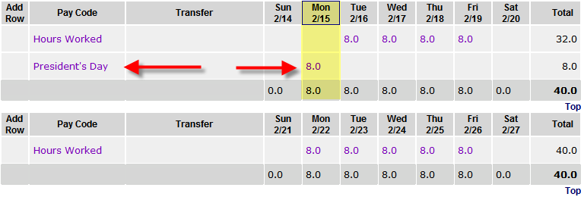

Totals Summary Report
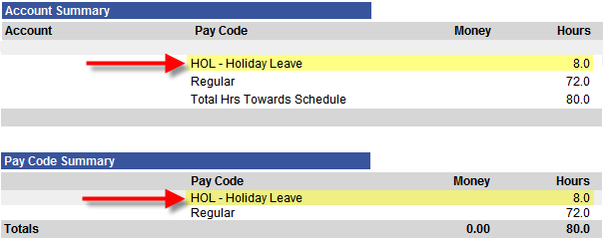

Error: Reference source not found

Scenario 2

For Regular Full-time Employees:
I worked on the Holiday -AND- Holiday is on a regular scheduled work day.

Explanation | An employee is required to work on the holiday.
MCtime Action | Record the actual hours worked for the day as Hours Worked.
Result | - Holiday leave hours will be reduced by the actual number of hours worked and eligible employee will receive Regular pay and HP1 – Holiday Premium Pay at 1.5.  - Overtime or compensatory leave will be calculated for any overtime hours worked on the holiday  Note: MLS employees are not eligible for holiday premium pay or overtime for hours worked on a holiday.

Timecard
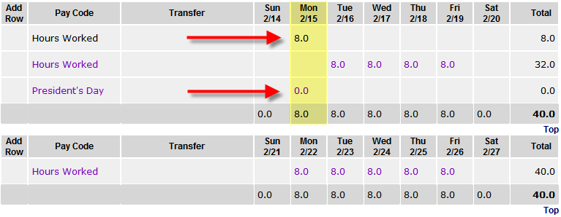

Totals Summary Report
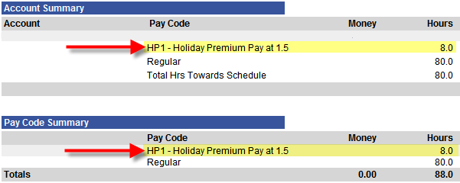

Error: Reference source not found
Note: there are three options for this Scenario 3 (Scenario 3A, 3B & 3C)

Scenario 3A

For Regular Full-time Employees:
I did not work on the Holiday -AND- Holiday fell on my scheduled day off.

Explanation | A holiday falls on an employee’s scheduled day off a department director should assign the employee an alternate day off within the same pay period.
MCtime Action | Employee should record the alternate day off in the same pay period by using the pay code HOL – Holiday Leave.
Result | MCtime will apply the proper Holiday Leave compensation automatically for that employee for the alternate day off.

Timecard (Note: in the example below, the employee works a Compressed Schedule)
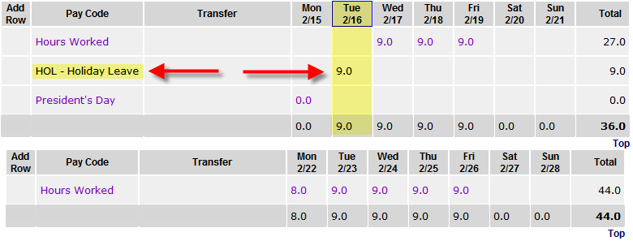

Totals Summary Report
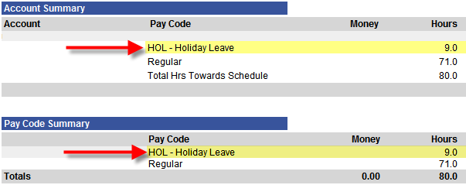

Error: Reference source not found

Scenario 3B

For Regular Full-time Employees:
I did not work on the Holiday -AND- Holiday fell on my scheduled day off.

Explanation | Instead of an alternate day off, the department director may offer the employee an equivalent amount of compensatory time as the holiday benefit.
MCtime Action | An equivalent amount of compensatory leave should be entered by the employee using the pay code CLH – Comp Lv Earned for Holiday. This entry should display on the observed holiday.  Note: MLS employees are not eligible for Compensatory Leave
Result | MCtime will credit the employee with the amount of compensatory leave earned entered by the employee. Generally, the comp leave will be available for use in future pay periods and will not be available for use in the current pay period if the employee’s comp leave balance prior to this entry was less than a full day.

Timecard
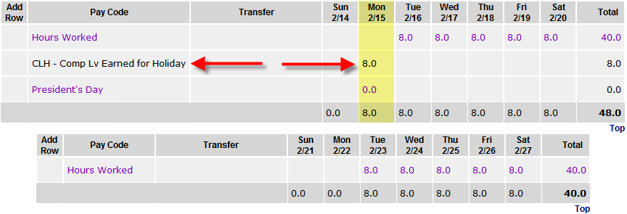

Totals Summary Report
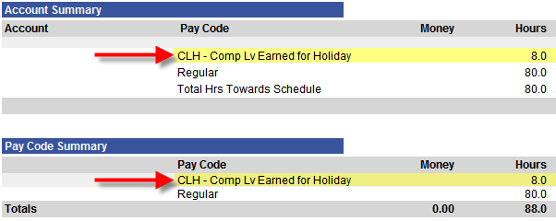

Error: Reference source not found
Scenario 3C

For Regular Full-time Employees:
I did not work on the Holiday -AND- Holiday fell on my scheduled day off.

Explanation | The department director may offer the employee pay as the holiday benefit ONLY if the department director would have to pay overtime to another employee to replace the employee if the employee took an alternate day off.
MCtime Action | An equivalent amount of hours should be entered by the manager or supervisor using the pay code HDP – Holiday Pay.  Note: MLS employees are not eligible for Holiday Pay.
Result | The employee will receive Holiday Pay for the holiday in lieu of a day off from work.

Timecard
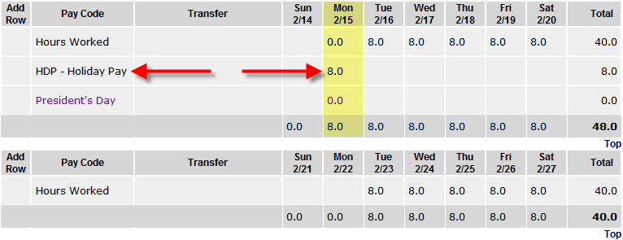

Totals Summary Report
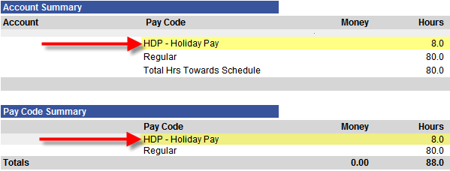

Error: Reference source not found
Note: there are three options for this Scenario 4 (Scenario 4A, 4B & 4C)

Scenario 4A

For Regular Full-time Employees:
I worked on the Holiday -AND- Holiday fell on my scheduled day off.

Explanation | A holiday falls on an employee’s scheduled day off & the employee was required to work, the department director should assign the employee an alternate day off within the same pay period.
MCtime Action | The employee should record –  - Hours Worked for all hours worked on the holiday  - Record the alternate day off by using the pay code HOL – Holiday Leave, limited to the total number of hours normally scheduled to work in a day, i.e. 8, 9 or 10.
Result | The employee will receive:  - HP2 - Holiday Premium Pay at 2.0 calculated at 2 times the normal pay rate for all hours worked on the holiday (limited to the duration of the scheduled shift of 8, 9 or 10 hours)  - Holiday Leave as entered for the alternate day off in the pay period.  - Overtime pay or compensatory leave earned for any hours worked in excess of the normal work day.  Note: MLS employees are not eligible for Holiday Premium Pay

Timecard (Note: in the example below, the employee works a 4/10 schedule. Monday, 9/6 is the employee’s regular day off.

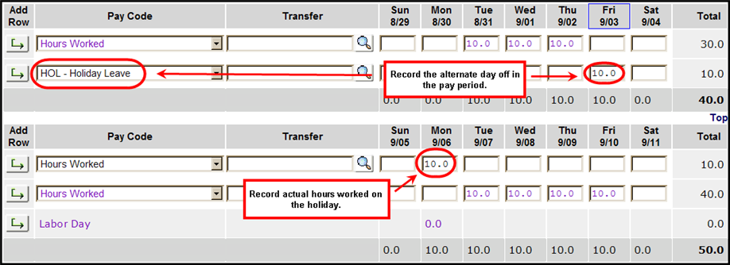

Totals Summary Report

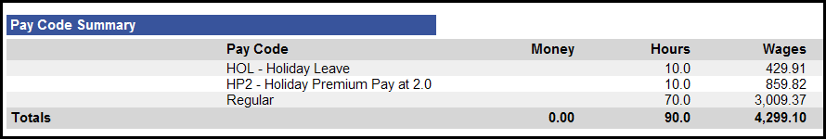

Error: Reference source not found

Scenario 4B

For Regular Full-time Employees:
I worked on the Holiday -AND- Holiday fell on my scheduled day off.

Explanation | A holiday falls on an employee’s scheduled day off & the employee was required to work. In lieu of another day off in the pay period, the department director may offer the employee an equivalent amount of compensatory time as the holiday benefit.
MCtime Action | The employee should record –  - Hours Worked for all hours worked on the holiday  - Compensatory leave using the pay code CLH – Comp Lv Earned for Holiday. Limited to the total number of hours normally scheduled to work in a day, i.e. 8, 9 or 10.
Result | The employee will receive:  - HP2 - Holiday Premium Pay at 2.0 calculated at 2 times the normal pay rate for all hours worked on the holiday (limited to the duration of the scheduled shift of 8, 9 or 10 hours).  - Compensatory leave earned (CLH) as entered by the employee. The comp leave will not be added to the employee’s comp leave balance until the next pay period and will not be available for use in the current pay period if the employee’s comp leave balance prior to this entry was less than a full day.  - Overtime pay or compensatory leave earned for any hours worked in excess of the normal work day.  Note: MLS employees are not eligible for Holiday Premium Pay or Compensatory Leave

Timecard (Note: in the example below, the employee works a Compressed Schedule)

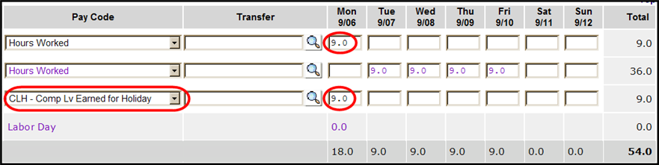

Totals Summary Report

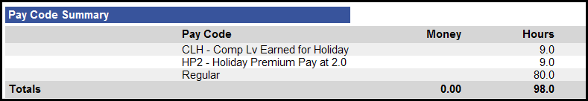

Error: Reference source not found
Scenario 4C

For Regular Full-time Employees:
I worked on the Holiday -AND- Holiday fell on my scheduled day off.

Explanation | A holiday falls on an employee’s scheduled day off & the employee was required to work. The department director may offer the employee pay as the holiday benefit ONLY if the department director would have to pay overtime to another employee to replace the employee if the employee took an alternate day off.
MCtime Action | The employee should record –  - Hours Worked for all hours worked on the holiday  The supervisor must record –  - HDP – Holiday Pay limited to the total number of hours normally scheduled to work in a day, i.e. 8, 9 or 10.
Result | The employee will receive:  - HP2 - Holiday Premium Pay at 2.0 calculated at 2 times the normal pay rate for all hours worked on the holiday (limited to the duration of the scheduled shift of 8, 9 or 10 hours).  - Holiday Pay as entered by the supervisor. Holiday Pay is calculated at 1 times the normal pay rate for the hours worked in a normal day  - Overtime pay or compensatory leave earned for any hours worked in excess of the normal work day.  Note: MLS employees are not eligible for holiday premium pay or overtime for hours worked on a holiday.

Timecard (Note: in the example below, the employee works a Compressed Schedule)

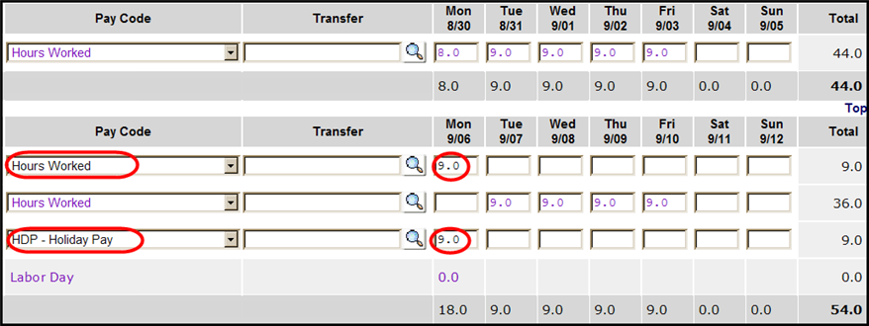

Totals Summary Report
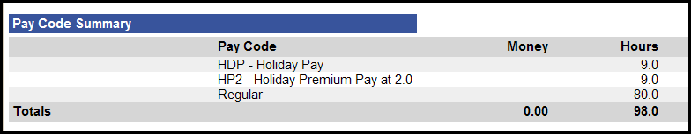

Error: Reference source not found

Scenario 5

For Regular Part-time Employees:
I did not work on the Holiday -AND- Holiday is on a regular scheduled work day.

Explanation | When a holiday falls on a regular work day, regular part-time employees will be released from attendance where practical and where eligible, will receive regular pay for the holiday.
MCtime Action | No action is necessary in MCtime.
Result | - The holiday benefit will display as HOL – Holiday Leave.  - The pro-rated holiday benefit is automatically added to the employee’s timecard in MCtime and is based upon the scheduled hours in MCtime for the pay period that includes the holiday.  Note: The timecard will be updated to include the holiday credit on the first Monday of the pay period that includes the holiday.

Timecard
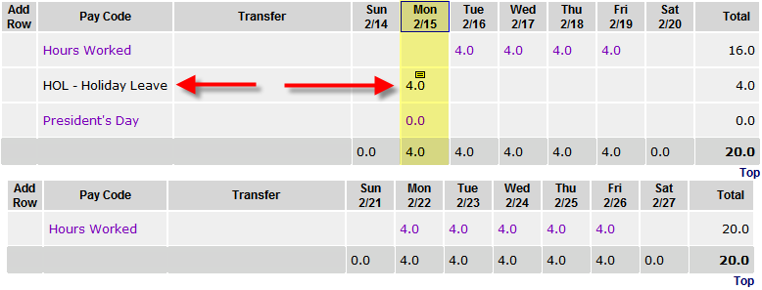

Totals Summary Report
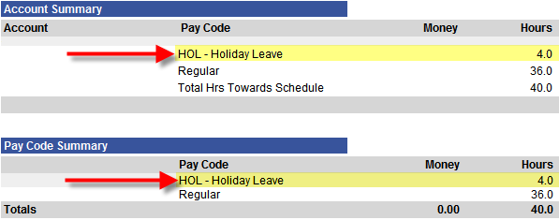

Error: Reference source not found

Scenario 6

For Regular Part-time Employees:
I worked on the Holiday -AND- Holiday is on a regular scheduled work day.

Explanation | An employee is required to work on the holiday.
MCtime Action | Record the actual hours worked for the day as Hours Worked.
Result | MCtime will automatically calculate the appropriate regular pay and holiday premium pay; however, this calculation is not performed and reflected in the timecard totals in MCtime until after noon on the Monday following the close of the pay period that includes the holiday.

Timecard
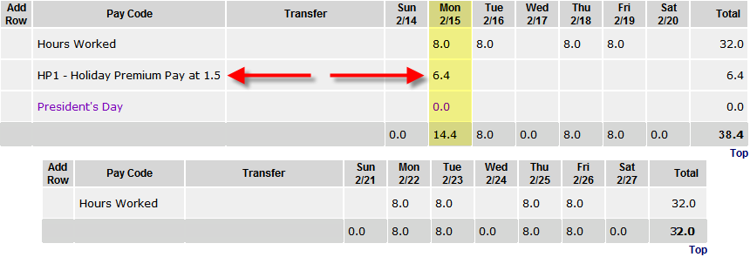

Totals Summary Report
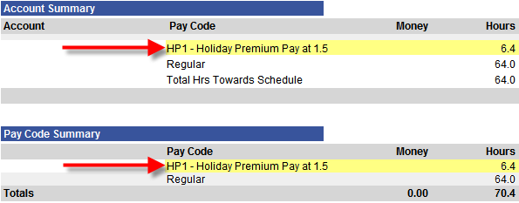

Error: Reference source not found

Scenario 7

For Regular Part-time Employees:
I did not work on the Holiday -AND- Holiday is on my scheduled day off.

Explanation | When a holiday falls on a regular work day, regular part-time employees will be released from attendance where practical and where eligible, will receive regular pay for the holiday.
MCtime Action | No action is necessary in MCtime.
Result | - The pro-rated holiday benefit is automatically added to the employee’s timecard in MCtime for all part-time employees and is based upon the scheduled hours in MCtime for the pay period that includes the holiday.  - The holiday benefit will display as CLH – Comp Lv Earned for Holiday when the holiday falls on a part-time employee’s regular day off.  Note: The timecard will be updated to include the holiday credit on the first Monday of the pay period that includes the holiday.

Timecard
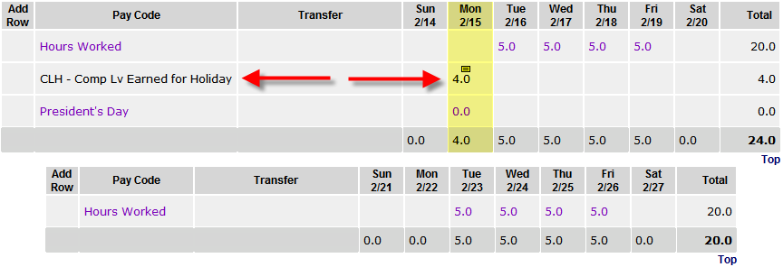

Totals Summary Report
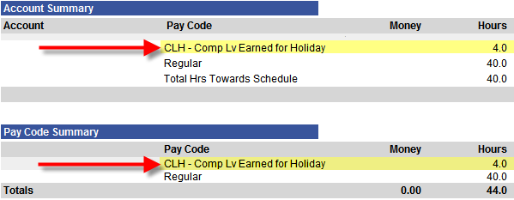

Error: Reference source not found

Scenario 8

For Regular Part-time Employees:
I worked on the Holiday -AND- Holiday is on my scheduled day off.

Explanation | An employee is required to work on the holiday.
MCtime Action | Record the actual hours worked for the day as Hours Worked.
Result | MCtime will automatically calculate the appropriate regular pay and holiday premium pay;  Note: The timecard will be updated to include the holiday credit on the first Monday of the pay period that includes the holiday.

Timecard
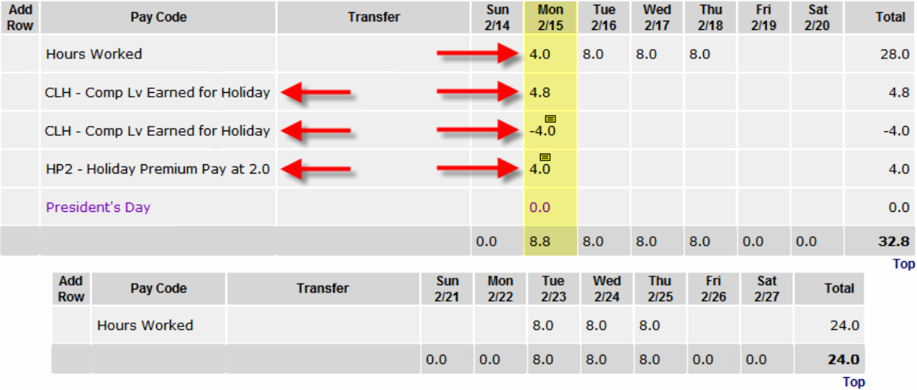

Totals Summary Report
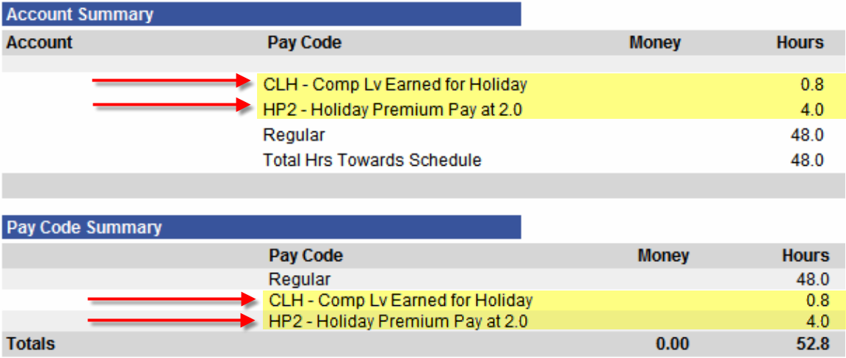

Error: Reference source not found

