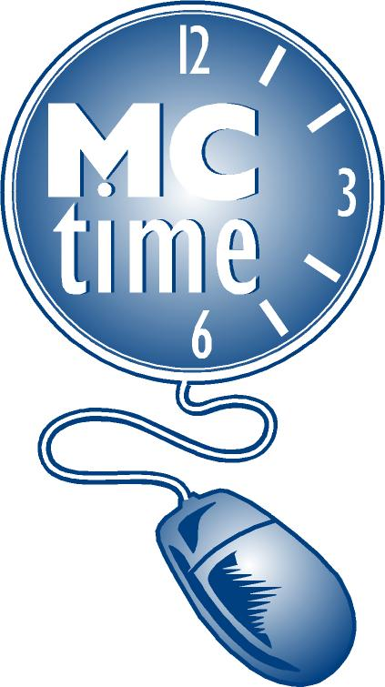 Timecard Correction Request
for Previous Pay Period
 |  | Date Request Submitted
Employee Name (Last, First) |  | Employee #:
Department Name: |  | Department #:
Manager Name: |  | Phone #:
*Battalion Chief (FRS Only): |  | Phone #:
Pay Period Begins: |  | Pay Period End:
Manager’s Signature:
Describe Change Required:

 | Add or Delete Reported Hours for a Specific Date(s)
 |  |  |  | Transfer Codes to Be Charged***
Add/ Delete | Date | Pay Code | Hours | Cost Center | Project Task & Exp Org | Activity Code
EX: Add | 01/04/09 | Hours Worked (should be paid as Overtime) | 1.5 | CC 32590 | PT 2001927-Gen001 50660 | A20
EMAIL to: Finance, Payroll (financepayroll@montgomerycountymd.gov ) Or FAX: 240-777-8843

*** Note: Timecard correction(s) should not be submitted for accounting purposes. A journal entry should be submitted to General Accounting Section.
NOTE: The correction will appear on the Historical Edit tab (Manager View only) in the Pay Period in which it was processed and in the grid of the original pay period as a shaded transaction. Employees can view the information in Totals Summary.

FOR PAYROLL TEAM ONLY
- Date Processed Effective Date: ___________________________ By: ___________________
- Include in MCtime totals for:
__ Totals for effective date, current pay rate equals historical pay rate
__ Impact Accruals (use only when Leave codes are affected)
Leave boxes blank if the correction was made in HRMS, and just updating MCtime
__ Sent confirmation email: Correction Completed

