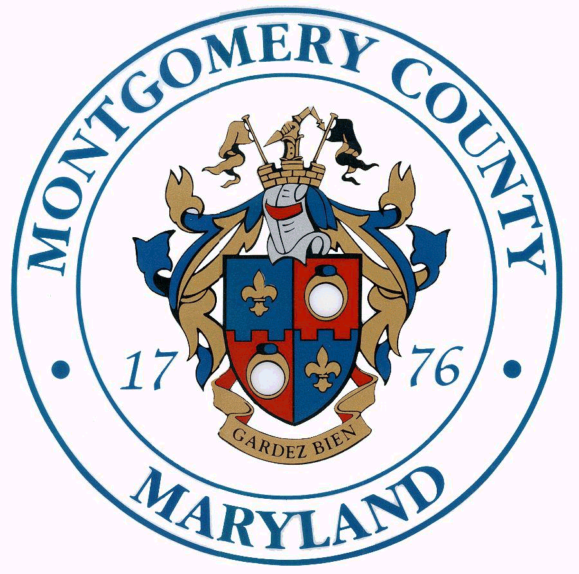
MID-COUNTY CITIZENS ADVISORY BOARD
Isiah Leggett Ana L. van Balen
County Executive Director
FY-13-18 Capital Improvements Priorities
Mid-County Citizens Advisory Board Recommendations
Approved at the July 19, 2011 Meeting

Implementation of Bus Rapid Transit (BRT) – The MCCAB has previously voted support for BRT between Glenmont and Olney via Georgia Avenue and Wheaton and Rockville via Veirs Mill Road.
Wheaton Redevelopment – coordination of Wheaton Projects to go through the Wheaton Redevelopment program and the Mid-County Regional Center. All County-funded projects should be vetted and coordinated through the appropriate Regional Center.
Grade separated interchange at Georgia Avenue/Randolph Road – Keep project at top of County’s priority list.
Fire Station #18 Relocation – Keep construction on schedule in preparation for Georgia Ave./Randolph Rd. grade separation project. Prepare for possible temporary relocation to Glenfield Park on Layhill Rd. prior to completion of permanent location if Georgia Ave./Randolph Rd. grade separation project begins in the next few years.
Combined Wheaton Library/Community Recreation Center – Continue to work with the community to develop the combined facility.
Olney Multi-Function County and Community Services Center – Funding for a multi-function county and community services center.
Kemp Mill Urban Park – Support expedited renovation of the Kemp Mill Urban Park by M-NCPPC.
Olney Town Commons/Green Space – Funding for a town commons/green space area with a pavilion and suitable accommodations for the Olney Farmers Market.
Extend the Matthew Henson Trail to the Trolley Museum – Extend the trail from its present terminal at Alderton Rd. to the Trolley Car Museum.
CIP Process Review – Review current procedures for capital project design, procurement and construction management for greater efficiency.
School capacity should be below 105% -- There is concern about overcrowding in Mid-County region.
Redevelopment/revitalization of Glenmont Shopping Center – Create public-private partnership to incentivize, make economically attractive, provide redevelopment credit to owners. Attract better store to shopping center, rid area of vagrants, better markings in parking lot for traffic flow.

