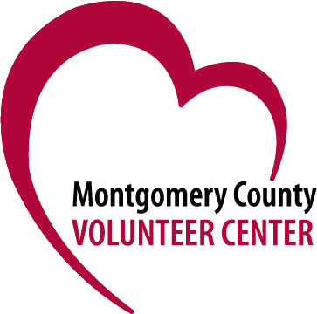

50+ Volunteer Network Agency Registration

The 50+ Volunteer Network connects skilled volunteers with nonprofit and government organizations that need help with:

- Direct service to clients (such as tutoring, mentoring, or teaching)

- Organizational support (may include administrative tasks, intake services, or program management)

- Pro Bono Consulting Project (short-term projects requiring professional expertise such as strategic planning, grant writing, accounting, IT assistance, marketing or public relations)

- Board Positions

To register, please complete the form below and return it to 50plus@montgomerycountymd.gov. Feel free to add any other information that will help us find you volunteers who will be a good fit.

Name of Organization:

Address:

Contact Name and Title:

Contact Email:

Contact Phone number:

Issue Area/Population Served:

Does your organization provide training for volunteers? Yes __ No __

How many volunteers do you hope to recruit?

Is there a designated staff person to manage volunteers? Yes __ No __
Is volunteering on-site, virtual, or other?

Please include a separate description of each 50+ volunteer opportunity. If you already have these opportunities listed on the Volunteer Center database, please indicate so below unless you want to add additional information. For any opportunities not currently listed, please provide or attach a brief description of each, including required skills, availability, time commitment, and other specifics.

While the 50+ Volunteer Network will actively recruit, and advise potential volunteers about opportunities, it is the sole discretion of the individual volunteer whether to pursue an individual activity, thus we cannot guarantee that all requests for volunteers will be filled. We may require references for certain positions, but the agency is responsible for background checks, confidentiality agreements, or any other required documentation for volunteers. Organizations must be currently registered with the Montgomery County Volunteer Center.

