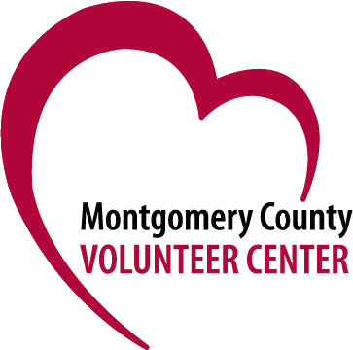

50+ Volunteer Network Volunteer Application

The 50+ Volunteer Network can connect you with a variety of opportunities, based on your experience, interests and availability. To register, complete and submit this form.

First Name:

Last Name:

Address:

Phone number:

Email:

Birthdate:

Gender: M___ F___

Ethnicity (optional):

Education (highest level completed):

High School
College
Graduate
Professional certifications

Languages spoken:

Do you want to use this in your volunteer work?
Check the areas where you have skills and/or interest which you would like to use as a volunteer:

___ Accounting/finance

___ Administrative

___ Artistic design/graphic

___ Computer

___ Event Planning

___ Grant writing/fundraising

___ Legal

___ Marketing/Public Relations

___ Program/Project Management

___ Research

___ Strategic Planning

___Tutoring/Mentoring

___Writing/Editing

___ Other

Please indicate if there is a cause, such as animal welfare, immigration, poverty, or social justice that you are interested in:

How did you hear about the 50+ Network?

How much time do you want to spend volunteering? (Please include significant periods of time that you know you are unavailable)

Do you prefer to work primarily on-site at an agency or virtually?

Please provide a description of your educational, professional and volunteer experience or send a current resume to 50plus@montgomerycountymd.gov

While the 50+ Volunteer Network will advise volunteers about potential opportunities with nonprofit and government agencies, we cannot guarantee specific placements, as some organizations have their requirements and screening processes. Similarly, it is the sole discretion of the volunteer whether or not to pursue a position that has been suggested by the 50+ Volunteer Network.

