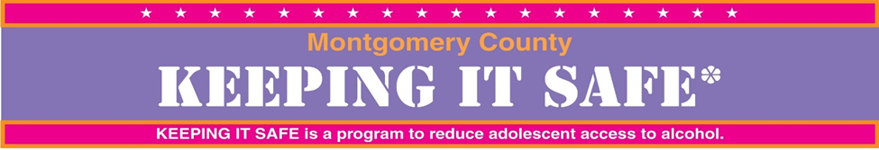
Under 21 Alcohol Prevention Coalition
2019-2020 Video Contest Application Form
Montgomery County, Maryland

Entries are due February 28, 2020 by 4:00pm

- School Information
School Name ………………………………………………………………………………………………………………………………………
School Phone #……………………………………… Federal Tax ID Number ………………………………………………………

- Adult Sponsor/Advisor for Contest
Name…………………………………………………………………………………………………………………………………………………
Phone # ………………………………………………….. Email ……………………………………………………………………………..
Class or Period # ………………………………………………..……………………………………………………………………………..

Participating Students’ Information:
Student’s Name | Grade | Home Phone | Parent/Guardian Email Address

- Please check the topic you selected for your message:

- How social media influences teens about underage drinking
- Decision: to drink vs. not to drink. What are the effects of alcohol and who influences you (Example: friends, family or your surroundings)
- Helpful tips for peers to avoid the consequences of alcohol use

- Reflection Statement
Please submit a reflection paragraph describing the purpose of your project. When writing your paragraph, think about the following questions:
- What need did your video entry address?
- Who benefitted from your video entry?
- What did you learn about yourself and working with others?
- How did you think your message will influence your peers?
Contest winners will be asked to read their reflection paragraphs at the awards event. Make a copy of this form including your reflection below so that you can practice if called upon to read at the awards event.

- Media Consent Statement (sponsor/advisor to complete)
Members of the press might be interested in contacting the winners of this contest. Please initial one of the following:
_________ Yes, I agree to have my name and contact information released to the press.
_________ No, I do not want my name and contact information released to the press.

Signature (sponsor/advisor) ……………………………………………………………………………………………….

