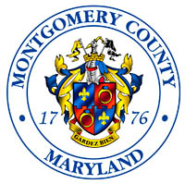 | Montgomery County  Department of Environmental Protection  Energy, Climate and Compliance Division  2425 Reedie Dr, 4th Floor, Wheaton, MD 20902  Open Burning General Permit | 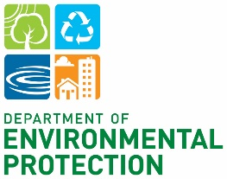

This permit is issued pursuant to Montgomery County Code Chapter 3 and the Code of Maryland Regulations 26.11.0

Permit Effective Date: February 23, 2026
Permit Expiration Date: March 25, 2026
Permit Number: ECCD Case #20261261

Address of Burn: River Road Shale Barrens Conservation Park
On Site Contact: Ryan J. Colliton, (301) 962-1359

This permit authorizes:

To burn a preset section of vegetation on the property known as River Road Shale Barrens Conservation Park in accordance with the permit issued by the Maryland Forest Service. The property is owned by Montgomery County and managed by Maryland National Capital Park and Planning Commission. The property may be accessed at approximately 21300 River Road.

This permit is subject to the following conditions:

- Burning is prohibited during the period from June 1, through August 31 of each year.

- Prior to ignition of the fire:

  - Call Montgomery County Customer Service at 240-777-0311 to provide a “day of burn notice for permit number 20261261”
  - Call Montgomery County Fire and Rescue Services at 240-683-6520 to provide a “day of burn notice for permit number 20261261”
  - Call neighboring properties as set in the attached Maryland Forest Service permit to provide a “day of burn notice.”

- The burn must not cause a hazardous condition, or an air pollution nuisance.

- When burning is in progress, this permit and fire extinguishing equipment, including water in sufficient quantity to extinguish the fire, must be readily available on site.

- Designated representatives of the Department of Environmental Protection shall be granted access to the property at reasonable times for the purpose of determining compliance with this permit.

- No fires may be started prior to 7:00 a.m. nor new fires started after 4:30 p.m.

- There may be no burning on weekends or holidays recognized by the Montgomery County Government unless specifically authorized by Montgomery County Department of Environmental Protection.

- Fire control laws or regulations of other governmental agencies must not be violated.

- You may not burn when the Governor or the Secretary of the Maryland Department of the Environment declares an air pollution episode.

- You may not burn when NOAA declares a “red flag” warning. “A red flag warning means that critical fire weather conditions are either occurring now or will shortly. A combination of strong winds, low relative humidity, and warm temperatures will create explosive fire growth potential.” Weather information may be found at: http://www.nws.noaa.gov/.

- You may not burn during a temperature inversion, when the ground temperature is lower than the air mass above it. Fog is an indication of a temperature inversion. The burn may not occur when fog is forecasted or present. Weather information may be found at: http://www.nws.noaa.gov/.

If weather conditions change during the burn, you are required to act to mitigate the nuisance conditions.

Violations of any condition of this permit or any laws or regulations will constitute cause for revocation of this permit and fines of $500 per violation, per day may be imposed.

