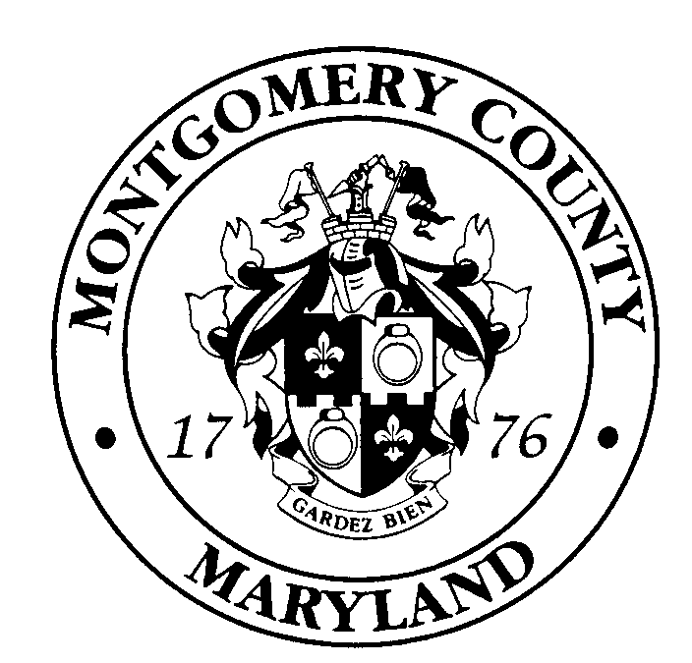
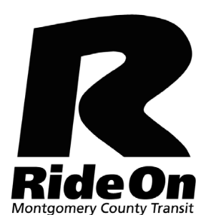
Montgomery County / Ride On
Notice of Public Forum
On Proposed
Service Changes
December 12, 2019

Montgomery County Department of Transportation, Transit Services would like to receive comments on proposed changes to Routes 75, 79 and 90 in the Clarksburg community. The changes being proposed redistributes the coverage area by discontinuing service on some roads and introducing new service to other roads. For additional information prior to the public forum regarding these proposed changes, please access the Ride On web site at www.rideonbus.com.

Montgomery County hereby notifies the general public and other interested parties that a public forum will be held on December 12, 2019 starting at 6:30 p.m. and ending after the last speaker at the Rocky Hill Middle School
22401 Brick Haven Way, Clarksburg, MD, US 20871. In the case of inclement weather, the public forum will be held December 17, 2019. There will be map displays available for review of the changes before the meeting.

Individuals and representatives of organizations who would like to speak at the public forum are requested to furnish in writing or by email, on or before December 9, 2019, their name, home address, telephone number, e-mail address and organization to Division of Transit Services, Ride On Public Forum, 101 Monroe Street, 5th Floor, Rockville, Maryland 20850. Individuals who have signed up to speak must bring two (2) printed copies of their testimony for the record. Sign language interpreter services will be provided only upon request with notice as far in advance as possible but not less than 3 business days prior to the date of the forum. Large print format is available upon request. All comments will be considered before any changes are finalized.

Comments may be written, faxed or e-mailed on the proposed service changes to the Division of Transit Services by December 18, 2019. Send your comments to:
Division of Transit Services
Ride On Public Forum
101 Monroe Street, 5th Floor
Rockville, Maryland 20850
(240) 777-5800 (phone)
(240) 777-5801 (fax)
mcdot.rideonpublicforums@montgomerycountymd.gov

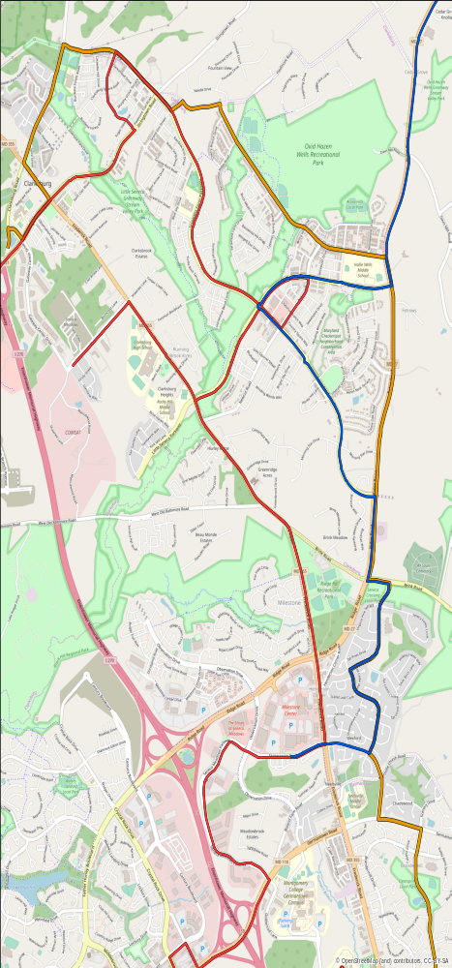

LEGEND

Route 79
Route 75
Route 90

Title VI: Montgomery County assures that no person shall, on the grounds of race, color, or national origin, as provided by Title VI of the Civil Rights Act of 1964 and the Civil Rights Act of 1987, be excluded from the participation in, be denied the benefits of, or be otherwise subjected to discrimination under any program or activity.
_______________

