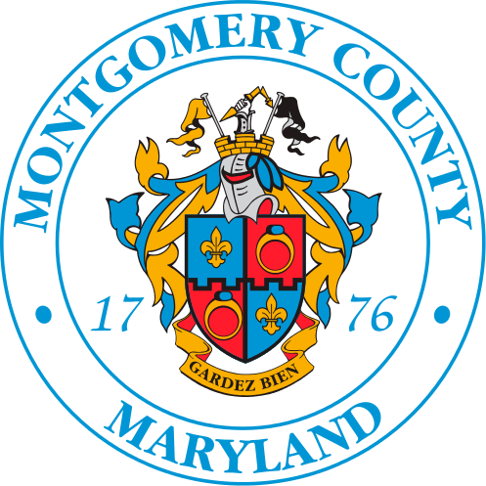
EAST COUNTY CITIZENS ADVISORY BOARD (ECCAB)
Wednesday, October 1, 2025 Meeting Summary
Board Members Present: Fisseha Adugna, George Brown, Radwan Chowdhury, BJ Dawkins, Sheala Durant, Porsche Vanderhorst, Ken Flemmer, Peter Myo Khin, Mark Pharaoh, Calandra Tate Moore, Tina Oyeniya, Kimberly Price-Evans, Metassebia Kefelegn, Len Newman,
Board Members Absent: LaTonya Brooks, Dan Wilhelm, and Susan Price.
Guests Present: Eric Copland, Chris Wilhelm, Sierra Gray, Ed Weiler, Rob Richardson, Abdul Kamus, and Sharon Brown.
County Regional Office Staff Present: Jewru Bandeh and Ayanna King
Welcome and Introductions. The meeting was called to order at 7:10 p.m. by chair Peter Myo Khin. Board members, government officials, and public members introduced themselves.
Approval of Meeting Summary: The meeting summary for the September 3, 2025, meeting was approved without any objections.

Police District 3: Commander Capt. Jason Cokinos gave the following update:
- That MCPD officers do not wear masks unless they are needed for environmental or weather protection, not identity hiding. Cokinos said Montgomery County Police had nothing to do with a recent ICE intervention in East County.
- Eric’s Law ID, named after Eric Carpenter-Grantham, allows people with developmental and mental health issues to have a butterfly on their license plate as a notice to police. Carpenter-Grantham received his Maryland ID with a butterfly emblem at the MVA White Oak branch in Silver Spring, October 1, 2025.
- The District plans to make public safety investments for “precision policing, not random stops.”
- Police want to increase resources in White Oak and Briggs Chaney.

Presentation:
Anthony Featherstone, Executive Director for WSM and Jessica Issoufou, Deputy Executive Director for WSM discussed Mobilize Montgomery Federal Work Career Center and Worksource Montgomery’s efforts to Assist Dislocated Federal Workers and Contractors and its General Employment and Training Services County-Wide.
- The Federal Government has eliminated 15,000 jobs since January 2025 (Check this fact). This is a significant loss, specifically for Montgomery County.
- The county has created a website, www.mobilizemontgomery.com, to consolidate information for Federal workers
- Prior, there were several disparate, state and county sources.
- Featherstone also talked about ALICE (Asset Limited Income Constrained Employees). This represents people “right above the poverty line.”
- Thirty-six percent of Montgomery County residents are part of the ALICE population. Note: Forty-one percent of East Montgomery County is in the ALICE demographic.
- Minority households have higher disparities.
- Featherstone also gave a youth update to talk about the County’s CAP initiative for grades 6-12. The goal is to create a “more career-conscious classroom.” Additionally, 67% of students said they had a good view of careers aligned to the economy
The presentation ended at 8:05 p.m.

ECCAB Board Elections:
We elected ECCAB officers by nomination, acceptance, and paper ballot: The 2025-2026 East County Citizen Advisory Board’s Executive Committee is Radwan Chowdhury, Chair; Metassebia Kefelegn, Vice Chair; Dan Wilhelm, Secretary; and Fisseha Adugna, Parliamentarian.
Elections ended at 8:25 p.m.
ECCAB Committees Chairs Elections:
Chair Chowdhury proceeded over the committee chair nominations and selections.
- Planning and Economic Development – Peter Myo Khin (self-nominated)
- Quality of Life – Mark Pharoah (self-nominated)
ECCAB Letter to Montgomery County Executive, Erlich: VIVA White Oak (VWO):
- The Board ratified the letter with suggested changes (omitting a duplicate paragraph on page two [“Treat the intersections at US 29-Industrial Blvd-Old Columbia Pike and those at Old Columbia Pike-US29-Tech Road-Prosperity Drive as integrated nexus points that need to be considered as unfinished intersection entities within themselves”])
- Jewru mentioned that the level of support from the District 5 office for Viva White Oak Development has been tremendous.
- VIVA Provisional APF was heard/approved by the Planning Board on Sept. 25.

County Reports/Updates-Regional Services. Other County Depts. :
Jewru, do you have any of the reports from the council representatives? Did you give out any updates on the regional office?
Chair Chowdhury ratified that the Board would combine the two committee meetings to accommodate the FY 27 Operating Budget Community Conversation Forum with County Executive Mark Erlich, which will be held on Monday, October 6, 2025.
Adjournment: 9:01 p.m.

