September 7th, 2021
Montgomery County Board of Elections
18753 N. Frederick Ave, Suite 210
Gaithersburg, MD 20879

Members of the Montgomery County Board of Elections,
Thank you for your service to our community and your ongoing work to ensure Montgomery County voters have an opportunity to exercise their most fundamental right, the right to vote. We commend you for conducting an open and transparent process for selection of early voting sites for the 2022 election. Recent state legislation increasing the number of early voting sites in Montgomery County gives our community a wonderful opportunity to expand access to voting for our citizens.
As members of the General Assembly representing District 14, we appreciate that the Board has in the past placed three early voting sites in our district. The district is geographically extensive, with significant distances between its three major population centers: the Burtonsville, Olney, and Damascus areas. Having an early voting site in each of those locations has been vital to ensuring that our constituents have access to the vote. As a consequence, we would urge the Board to continue providing for at least one early voting site in each of those regions.
The current sites at the Marilyn Praisner Recreation Center, the Sandy Spring Volunteer Fire Department, and the Damascus Community Recreation Center have been adequate to the task. We understand the Board is also considering alternative sites at the Longwood Community Recreation Center and the East County Community Recreation Center, and would urge that if the Board chooses these sites as alternatives to the existing sites at Sandy Spring and Praisner, provision be made for notifying the local communities of the change so they know where to go to vote early.
Finally, while the location itself is outside our district, we would strongly urge the Board to select the White Oak Community Recreation Center as one of the two additional sites mandated under state law. Like Briggs Chaney in our district, White Oak has historically been underserved by county government and has a significant number of residents who are dependent on public transit to access voting sites. The provision of an early voting site within the White Oak community is important for ensuring equitable access to the ballot for all county voters.
Again, thank you for the work you do on behalf of the residents of Montgomery County.

Sincerely,
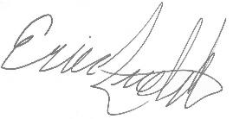
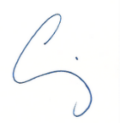

Senator Craig Zucker Delegate Eric Luedtke

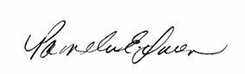

Delegate Anne Kaiser Delegate Pam Queen

