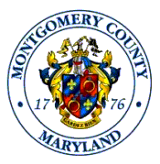
MONTGOMERY COUNTY ETHICS COMMISSION
Agenda for Public Meeting
September 9, 2025

- Call to Order
- Approval of August 2025 meeting minutes
- Program and Training Updates
- Outside Employment Conditional Language
- New Business

Adjourn to Administrative Meeting

Administrative Meeting Agenda

- Outside Employment Requests
- Advisory Opinion/Waiver requests
- New Business

