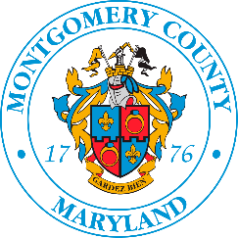
LiveWell

Take
5
Earn 100
Virgin Pulse Points!

Virgin Pulse Voucher Log
Movement
Classes, & Webinars

Date: ___________________

Name: __________________________
Department: _____________________
Email: __________________________

Track Participation and Earn Virgin Pulse Points

- Employees will receive 20 points for each LiveWell Movement Class or webinar attended. Vouchers are only issued in increments of 100 points (i.e., complete 5 movement classes or webinars to receive 100 points).
- Logs can be submitted when 20 activities have been completed. Any combination of Movement Classes, Guidance Resources webinars or UnitedHealthcare webinars may be used to reach the minimum 100 points.
- Employees must sign the attendance sheets in each Movement Class they attend or register for each webinar. Attendance sheets will be used to verify participation.
- Employees must track their classes using this form to receive their Virgin Pulse points.
- Logs should be submitted when sheet is complete.
- Submit Voucher Logs to LiveWell@montgomerycountymd.gov. Once participation has been verified, log will be returned to participant with a Voucher Code to redeem electronically through the Virgin Pulse website.

Class Name | Location | Date | Time | Instructor
Voucher: |  |  | Date Issued:
Voucher: |  |  | Date Issued:
Voucher: |  |  | Date Issued:
Voucher: |  |  | Date Issued:

