SCHOOL EMERGENCY PLAN

School Name:  Main Office Phone #:  FAX #:  Physical Address of School: | Principal/Main Point of Contact:  Cell Phone #:  Secondary Point of Contact:  Cell Phone #:  Student Start Time : a.m.  :  Student Dismissal Time p.m.
Name of the person who completed this plan:
Date plan was submitted to Montgomery County Police for review: ____/____/_____
(It is recommended that schools submit their School EOPs and Floor Plans with MCPD annually. Plans will not be approved by MCPD, rather, they will be stored in such a manner to assist police with public safety response. School EOPs and Floor Plans can be emailed annually to: PrivateSchoolPlans@montgomerycountymd.gov
Security Coordinator:

Cell Phone #:
Number of students: | Number of staff:
Campus size in acres: | Building square footage:

School Year 20XX–20XX

BEHAVIOR THREAT ASSESSMENT
The Maryland Center for School Safety (MCSS) has developed a model policy for Behavior Threat Assessment. Non-Public Schools in Montgomery County should consider this model policy and if appropriate develop a school specific policy that complements this school safety plan.

COMMAND POST
Indoor and outdoor command post locations should be determined. The indoor command post is a securable location/room from which the command function/incident management will operate during the emergency. Access to computer(s), printer, phone(s), fax, and emergency kit is recommended. Also, it is imperative that the emergency kit, and a laptop computer, if available, are brought to the outdoor command post.
Indoor Command Post Locations (i.e., main office, workroom, principal’s office):
Primary Location Alternate Location

Outdoor Command Post Location (i.e., parking lot, athletic field, stadium):

ICS CHAIN OF COMMAND, COMMAND TEAM, AND OSET POSITIONS
The Incident Command System (ICS) is a nationally recognized organizational and management tool that is utilized by many organizations when responding to an emergency that identifies an incident commander and on-site emergency team (OSET) members who are assigned specific duties/responsibilities to respond to an emergency. Command team members will follow the structure of the ICS and coordinate emergency efforts with OSET members. Staff should be identified in advance due to the critical nature of these positions.

It is recommended that schools train administration/teachers/staff on ICS. See the OEMHS/MCPD site for further details.

Assignment | Full Name of Team Member | Full Name of Back-Up Team Member(s)
Incident Commander (principal/designee) | 1. Name __________________________________ Cell Phone #:_____-_____-______ | - Name __________________________________ Cell Phone #:_____-_____-______  - Name __________________________________ Cell Phone #:_____-_____-______
Operations Team Leader | 1. Name __________________________________ | 2. Name __________________________________
Planning Team Leader | 1. Name __________________________________ | 2. Name __________________________________
Logistics Team Leader | 1. Name __________________________________ | 2. Name __________________________________
Finance/Administration Team Leader | 1. Name __________________________________ | 2. Name __________________________________
Recorder/Tracking Coordinator | 1. Name __________________________________ | 2. Name __________________________________
Student/Staff Accountability Coordinator | 1. Name __________________________________ | 2. Name __________________________________
Parent/Child Reunification Coordinator | 1. Name __________________________________ | 2. Name __________________________________

MULTI-HAZARD ASSESSMENT
Multi-hazards in and around the school must be identified. Identify factors that may put students, staff, and/or visitors at risk. These areas may include, but are not limited to, railroad tracks, highways that transport hazardous materials, large underground gas lines or storage tanks.
Hazard  (i.e. Route 495) | Location  (i.e. north side of school) | Description  (i.e. transport of hazardous materials)

TASKS TO BE CONSIDERED BEFORE, DURING, AND AFTER AN EMERGENCY
During the school year, a staff member will be responsible for the following:
Responsibility | Names of Responsible Staff Members
Maintain emergency kit.
Maintain the NOAA weather radio.
Bring the emergency kit, when the school evacuates.
Location of Emergency Kit
Location(s) of First Aid Kit(s)

TYPES OF EVACUATION
Fire: Evacuate at least 50 feet from the building.
Bomb Threat or Multi-hazard Threats: Evacuate at least 300 feet from the building. Do not evacuate to one central location, i.e. the stadium.

EVACUATION SITES
On-Campus Multi-hazard Evacuation Locations (i.e., athletic field, stadium, parking lot, playgrounds)
Primary Location
Alternate Location
Off-Campus Multi-hazard Evacuation Locations (i.e., church parking lot, shopping center, another school, vacant field, cul-de-sac). During inclement weather, OTLS should be contacted regarding special needs.
Primary Location (location/address/phone)
Alternate Location (location/address/phone)

STUDENT/STAFF ACCOUNTABILITY
Students/staff must be accounted for during an emergency. Staff with computer access should use the Outlook private folder. If there is no access to a computer, other means should be employed to report attendance.
Open Lunch? o No o Yes Start Time : o a.m. o p.m. End Time : o a.m. o p.m.

SAFE LOCATIONS
If outdoor activities are in progress when a Lockdown is activated in the school building, students and staff who are outdoors should be notified by public address system or portable radio and move away from the threat to a predetermined safe location(s). Staff should first visually scan, if practical, the safe locations for potential danger. Staff should, if possible, notify the school of their location. Depending on the circumstances of the emergency, the safe location(s) may need to be reconsidered. Please identify at least one and up to three safe locations for use by students and staff who are outdoors when a Lockdown is activated.
1.
2.
3.

MEDIA STAGING AREA
This area must be separate from any multi-hazard evacuation location or parent/child reunification area.

Off Campus (i.e., nearby street, park, open area, commercial area) location/address:

SCHOOL FLOOR PLAN (8½” x 11”—one page per floor)
Each emergency plan must include the building’s floor plan indicating the following information: classroom numbers; weather-safe areas; gas; main electric, water, and HVAC emergency cut-off locations. Please ensure all maps are clear, legible, and include designated room numbers with no staff names, all exit door numbers.
Have there been any physical changes in your building and/or relocatable classrooms since last school year? o Yes o No If yes, submit an updated floor plan with this year’s emergency plan.
Does your school have an emergency generator? o Yes o No If yes, location?

PARENT/CHILD REUNIFICATION (PCR) PROCESS
Your school’s parent/child reunification (PCR) process should include the details of reuniting children with their parents/guardians. The methods of communicating the PCR process to parents/guardians also should be included in the emergency plan (i.e., principal’s newsletter, school web page). The PCR process is an integral part of the emergency plan. Procedures for completing the PCR process are included in the attached instructions.
Name of Parent/Child Reunification Coordinator
Method(s) to Inform Parents/Guardians About the PCR Process
Name of Staff Person Who is Responsible for the PCR Box
The PCR box is a file box, paper box, or similar container that can be easily recognized and labeled and should be kept near the school’s emergency kit. The contents should include student schedules, Student Emergency Information, preprinted PCR process logs, clipboards, pens, pencils, directional signs, and tape for hanging the signs. Additional materials may be needed for reunification, such as portable two-way radios, tables, and chairs. It is recommended to have both physical and virtual copies of all materials.
Guidelines for Implementing the Parent/Child Reunification Process
- Post signs on entrance doors and hallways to direct parents/guardians to the PCR area.
- Use available staff members to assist with the implementation.
- Assign available staff members and OSET members to locate and release students.
- Implement the three-step approach:
Step 1: Use a parent/child reunification process log to sign in parents/guardians and check identification.
Step 2: Use the current student database/schedule cards to locate the student’s current teacher and room number.
Give the assisting staff member the student’s name, current teacher, and location.
Staff member will retrieve the student and direct/escort him/her to the PCR area.
Step 3: Release student to the authorized guardian.
- The Student Information System will have information for students with custody concerns.
Location of Indoor, On-campus PCR Area
Location of Outdoor, On-campus PCR Area
Location of Off-campus PCR Area
Name of Contact at Off-campus PCR Area ____________________________________________ Phone number - -
Address

 |  | Step 1: Assignments/Tasks
 | Name | Assignment
1.
2.
3.
 |  | Step 2: Assignments/Tasks
 | Name | Assignment
1.
2.
3.
 |  | Step 3: Assignments/Tasks
 | Name | Assignment
1.
2.
3.

Students/Staff Who Require Special Assistance
This page must be attached to the school’s emergency plan.
School Name _______________________________________________________________________________________________________
Please list all students and staff who require special assistance during an emergency. Please check the box if the student listed below has an Individualized Education Program (IEP) or Section 504 Plan. MCPS Form 336-2, Emergency Evacuation Accommodations, must be completed for each of these students, kept on file at the school, and stapled to the hard copy of this School Emergency Plan.
Name of Student/Staff | Type of Assistance that is Required | Name of Staff Member Assigned to Assist | Name of Back-up Staff Member
o
o
o
o
o
o
o
o
o
o
o
o
o
o
o
o
o
o
o
o
o
o
o

School Staff Trained to Render First Aid and/or CPR
This page must be attached to the school’s emergency plan.
School Name _________________________________________________________________________________________________________
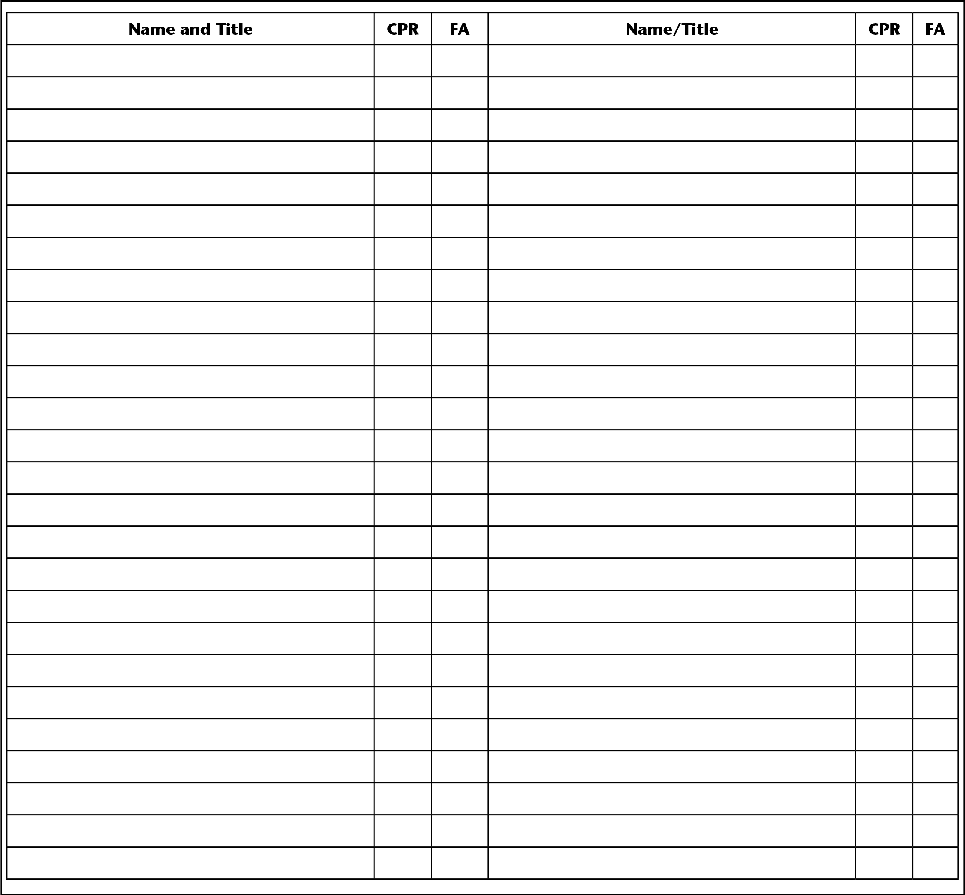

Joint Occupancy Users
This page must be attached to the school’s emergency plan. Include day and evening Joint Occupancy Users.
School Name _________________________________________________________________________________________________________

Organization’s Name
Name of Person in Charge
Phone Number
Location in Building
Days/Times on Site
Organization’s Name
Name of Person in Charge
Phone Number
Location in Building
Days/Times on Site
Organization’s Name
Name of Person in Charge
Phone Number
Location in Building
Days/Times on Site
Organization’s Name
Name of Person in Charge
Phone Number
Location in Building
Days/Times on Site

Communications
This page must be attached to the school’s emergency plan.
School Name _________________________________________________________________________________________________________
INTERNAL COMMUNICATIONS
Communication between Staff/Faculty Members
Telephone Tree, Morning Faculty Meeting, End of Day Faculty Meeting, Outlook Email, PA Announcements, Two Way Radios, and
Text Messages
EXTERNAL COMMUNICATIONS
Communication with Parents and School Community
Connect Ed, PTA Meeting, PTA Listserv, School Newsletter, email from the School, Back to School Night, and Face-to-Face The Department of Communications should be consulted regarding parental notification of a school-related emergency or crisis.
OTHER CONSIDERATIONS
Location of Automatic External Defibrillators (AED)
Location of Bleeding Control Kits
Location of Access Control System (ACS) doors

Debrief
A debrief should occur after any emergency, life-threatening incident, and completion of an emergency drill. The purpose of the debrief is to objectively assess what occurred, how did it happen, and what could be done to improve the outcome of the incident or drill. The debrief should include those who were actively involved in the incident to include school staff, public safety officials i.e. law enforcement, fire, and EMS.

Functional Annexes

Please consider creating specific procedure for these types of scenarios.
FIRE EVACUATION—When there is evidence of fire or smoke in the building, or the fire evacuation alarm has activated, the building must be evacuated in an organized manner.
DIRECTED EVACUATION—Evacuation directions communicated over the PA system and the two-way radio concerning the proper way to exit the building avoiding the area of concern.
REVERSE EVACUATION—A reverse evacuation is used when a dangerous situation outside requires students and staff to be directed back into the building.
DROP, COVER, AND HOLD—Is the appropriate action to reduce injury or death during an earthquake.
LOCKDOWN—When there is life-threatening imminent danger lockdown and lockdown with option procedures are viable response options to implement. If the extent /severity of the danger, threat, or location of the same on school property is unknown, principals/administrators may elect to activate a school-wide Lockdown for the safety of all, which will override implementation of Lockdown with Options procedures.
LOCKDOWN WITH OPTIONS—When a school is faced with an active assailant intending to do harm against a school, staff, or students a Lockdown with Options should be initiated.
AVOID—If safe and practicable to do so, AVOID the area by quickly moving/fleeing as far away from the threat as possible.
DENY—When you cannot safely AVOID, or it is impossible to do so, lock and barricade your room to DENY access to an assailant, following lockdown procedures.
DEFEND—When you cannot safely AVOID, or it is impossible to do so, lock and barricade your room to DENY access to an assailant, following lockdown procedures.
PUBLIC SAFETY SHELTER—This is a term used to alert staff that an emergency exists near an MCPS facility. (i.e. police chase, barricade, large fire, or any ongoing act of violence occurring off school property, but in close proximity to the school.)
SEVERE WEATHER SHELTER—When a severe thunderstorm or tornado warning is activated for the area near the school.
OUTSIDE HAZARDOUS MATERIALS SHELTER—This is a term used to describe a specific shelter
alert due to an outside air contamination emergency at or near the building. This could be the result of a suspected chemical, biological, or radiological incident or a nearby hazardous material spill.
MODIFIED SHELTER—There may be a time when there’s a medical emergency or law enforcement
investigation/action taking place in the hallway and there’s a need for students/staff to remain clear of that area. If that is the case, the Incident Commander/Administrator can call for a Modified Shelter. It may require holding the bells or redirecting students/staff down a different hallway.
BOMB THREAT—A bomb threat is defined as a threat to detonate an explosive or incendiary device to cause property damage, death, or injuries, whether or not such a device actually exists. A bomb threat assessment must be conducted to determine the appropriate course of response action.
School Name _________________________________________________________________________________________________________
Principal/School Administrator/School Safety Officer Signature
Principal Name: (Please Print) ____________________________________________________________________________
Principal Signature _______________________________________________________________ Date _____/_____/______

Additional Instructions/Concerns/Details
This page must be attached to the school’s emergency plan.
School Name _________________________________________________________________________________________________________

