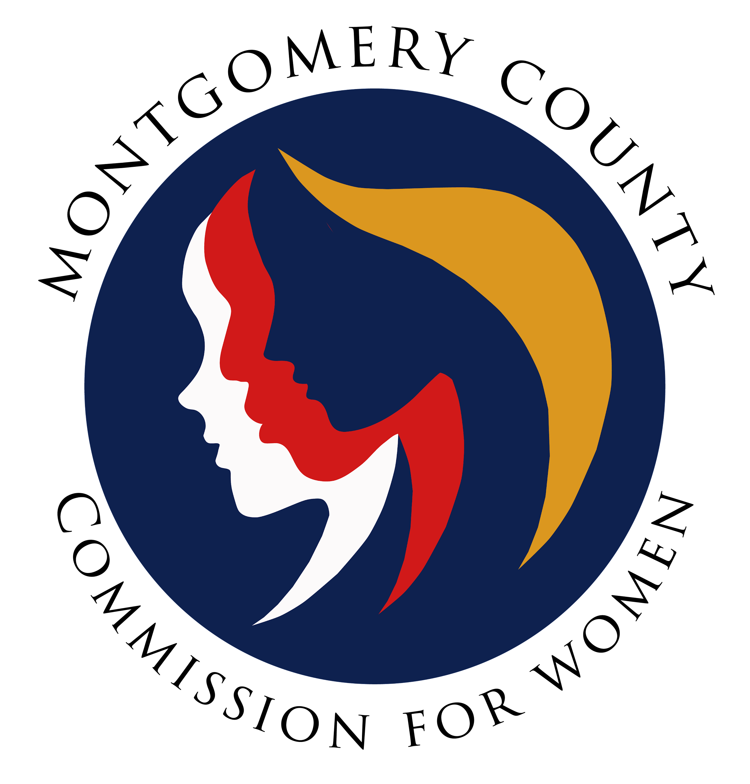
Montgomery County Commission for Women
Monthly Meeting November 11, 2021

Attendance
Attending | Not Attending | Guests
Donna Rojas – Chair  Patricia Maclay – 1st Vice Chair  Tonia Bui – 2nd Vice Chair  Isabel Argoti - Secretary  Arlinda Clark  Angela Whitehead Quigley  Ijeoma Enendu  Meredith Weisel  Betty Romero  Diana Rubin  Staff  Jodi Finkelstein  Holly Mancuso | Nicole Drew  Jan Molino  Chai Shenoy

CFW MEETING MINUTES
November 11, 2021

I. WELCOME AND INTRODUCTIONS Commissioner Maclay
- Meeting called to order at 7:00pm.

II. APPROVAL OF MINUTES AND AGENDA Commissioner Maclay
- October Minutes
  - Clarify bullet under PALS about “keep community”.
  - Spelling errors with Commissioner names in sections I, II, IV, and X.
  - Correct name for speaker Adrienne Jones.
  - Commissioner Enendu moves to approve minutes as corrected. Commissioner Bui second motion.
- October Agenda
  - Commissioner Weisel amended the agenda to remove Commissioner Rubin from the Ad Hoc Hate Violence committee.
  - Commissioner Bui moves to approve the agenda. commissioner Whitehead Quigley seconds the motion.

III. EXECUTIVE COMMITTEE REPORT Chair Maclay
- On boarding update: Confirmations were on November 9 by County Council.
  - Newest commissioners are Janet LaValle and Tondalayo Royster!
- Maryland Hall of Fame: Nominations due November 22, 2022
  - Please send Executive Director Finkelstein any nominations by Friday, November 12 or latest by Tuesday, November 16.
  - Executive Director Finkelstein previously recommended Nancy Kopp and Dr. Kizzmekia S. Corbett.
- Please sign up to proctor CFW programs: https://www.signupgenius.com/go/20f054eafab2ba3fd0-fall1

IV. EXECUTIVE DIRECTOR REPORT Executive Director Finkelstein
- Executive Director Finkelstein will be on leave Thanksgiving week.

V. COMMITTEE REPORTS
a. PALS Commissioner Rubin
- This Saturday, November 13 is the MLAW conference.
- PALS will be meeting on Monday to discuss priorities that they will be recommending to the full commission. Be prepared to respond quickly and vote in preparation for Prep Call on December 7.
- CFW Lobby day will be Tuesday, December 14 at 9am -12pm. Ariana Kelly is confirmed as a speaker as Adrienne Jones could not confirm.
- Expected Lobby Day attendance is four (4) commissioners: Commissioner Rubin, Maclay, Romero, and Whitehead Quigley. Commissioner Rojas is a maybe. Please do your best to attend!
- The CFW Team will do an extra push to remind neighboring commissions.
b. Program Planning Commissioner Enendu
- Confirmed Sexual Health and Wellness for Women on November 18 and, Financial Planning for Families with Special Needs on November 17.
- All series are up and running with good attendance.
- By December, we will begin soliciting nominations for our Women Making History event in March 2022.

d. Strategic Planning, Research and Evaluation Commissioner Romero
- Committee is still navigating through information given.
- An idea was presented to have a strategic brainstorming session for a few hours based on findings from research.
- Also presented an idea to bring more collaboration and partnerships for our programs. The goal would be to reach more of our intended audience through co-branding a program and create a lasting relationship following a previous collaboration the CFW has done with the Department of Corrections and Rehabilitation.
- Commissioner Maclay asked for clarification about what is meant by “partnerships”. Commissioner Romero clarified that perhaps these have been mentioned as “sponsors” in the past but these organizations have great audiences and we could partner with to enhance our programs.
- Commissioner Rojas questioned: how could this potentially overload the commission? It was clarified that these partnerships would be for the CFW to hand over programs to our partners to execute for us. A concern was brought up that this would take away from our existing programs and committee. Commissioner Romero ensured that no work would be done without input from the Programming Committee.
- Commissioner Rojas proposes that we understand our current programs by conducting an evaluation and planning process before attempting partnerships.
- Commissioner Romero emphasized we already have a lot of information and research. We need to take action on this information to improve programs.
- Commissioner Rubin brought up that this idea is likely not fully formed so that we should revisit this once it is better developed.
- Commissioner Enendu agrees that this idea needs to be fleshed out. She brought up a concern that by handing off our programs, it could take away from the work that the commission has been tasked to complete. We should not be giving partners the tasks of the commission.
- Commissioner Romero asked for clarification about the partnership we have with the Department of the Corrections & Rehabilitation. Commissioner Rojas clarified that we have a budget line to hire something to work with the correctional facility.
- Commissioner Clark recommends having a brainstorming session to flesh out ideas and have chairs send out questions or areas where they need ideas.
- Commissioner Maclay agrees that we could have a designated time to have a strategic planning session.
g. WLB Commissioner Maclay and Argoti
- Theme of the event is Voting Women Change Everything.
- Keynote Speaker is Melanie Campbell with four breakout sessions: Voting to Protect, Voting to Access, Voting for your Health, Educating the Vote.
- The event will be held on Zoom Events.
- Registration and sponsorships will be handled on Eventbrite. Save the date will also be sent out soon.
- The Chair’s Networking Reception (CNR) will be held on April 30, 2022 at 4-5:30pm virtually.
- Commissioner Rojas suggested survey evaluation be done in real time at the event rather than after as feedback was done after last year’s event. Commissioner Argoti expressed that this was not talked about before but they will look at what was done last year to streamline processes and what might be the best method of delivery.

VII. LIAISON REPORTS

b. HTPC Commissioner Maclay
- Committee is planning for Human Trafficking (HT) Awareness Month in January 2022 with signage, bus campaign, and special cards containing help access for victims.
- Part of MCPS curriculum is now teaching about human trafficking and it will continue in Spring.
- A poster contest with MCPS will be fleshed out soon with award amounts and SSL hours.
- Commissioner Maclay and ED Finkelstein attended a seminar in Ocean City, MD covering various HT topics, case studies, bank partnerships, and survivor stories.
- Next week’s HT meeting will have a special guest speaker Detective John Witherspoon to talk about missing children cases related to HT. We encourage all to attend virtually on November 17 at 12-1:30pm.

VIII. AD HOC COMMITTEE REPORT(S)

c. Ad Hoc Committee on Hate Violence Commissioner Bui and Weisel
- From the last meeting, it was agreed that having a liaison on the Commission on Hate and Violence will be very helpful. The committee is also considering bringing in an external presenter to talk about racial lens and bias in relation to our initiatives and mission. The goal is to end this work in June 2022.
- Commissioner Weisel confirmed that comments from the last meeting were deeply considered. The goal is to understand what is happening in the community related to discrimination and to establish a long term structure and guidelines.
- It was emphasized that this committee and report outs are not meant to be forever.
- Commissioner Maclay suggested reaching out to the Montgomery County Hate and Violence Commission to formally have a seat to bring a woman's perspective into that issue. The committee has not yet reached out as they wanted to bring this to the commission first to then take advantage of county resources.

d. CFW 50th Anniversary Commissioners Maclay and Argoti
- Draft agenda was sent for an outdoors event on Sunday, June 5, 2022 at Wheaton Regional Park. Before the large outdoor event, we would like to host an education event with a guest speaker or panel. The rest of the event will be family friendly and outside with partners. This will make it flexible for past commissioners to join with their families.
- Commissioner Argoti clarified that this draft agenda has not yet been reviewed but the goal is to make our 50th anniversary a natural message throughout all of next year.

IX. OLD BUSINESS
- Commissioner Maclay brought up that we still need to order the CFW Shirts which will get done soon.

X. NEW BUSINESS
- Commissioner Whitehead Quigley shared that the PSA Contest for Choose Respect has now rolled out and will share information. The contest was already shared on our social media. Deadline is February 28, 2022.
- Commissioner Romero suggested that we attach committee reports and the dates and agenda for all Committee meetings in case anyone would like to review and attend those meetings. This will be discussed at the next Executive Board meeting.
- CFW Intern Gaby’s birthday is on November 17!
- Please sign up to proctor a program: https://www.signupgenius.com/go/20f054eafab2ba3fd0-fall1

XI. Adjourn
Meeting adjourned at 8:03pm.

