CFW MEETING ATTENDANCE
September 9, 2021

Attending | Not Attending | Guests
Donna Rojas – Chair  Patricia Maclay – 1st Vice Chair  Tonia Bui – 2nd Vice Chair  Arlinda Clark  Nicole Drew  Jan Molino  Diana Rubin  Chai Shenoy  Tricia Swanson  Angela Whitehead Quigley  Staff  Jodi Finkelstein  Ashlyn Davis – Intern  Holly Mancuso – Intern  Gabriela Tomasi - Intern | Isabel Argoti - Secretary  Ijeoma Enendu  Betty Romero  Meredith Weisel | Tondalayo Royster

CFW MEETING MINUTES
September 9, 2021

I. WELCOME AND INTRODUCTIONS Chair Rojas
- Meeting called to order at 7:05 PM
- Guest introduced - Tondalayo Royster.

II. APPROVAL OF MINUTES AND AGENDA Chair Rojas
- Commissioner Swanson motioned to approve the August, 2021 meeting minutes and the September meeting agenda. Motion was seconded and approved by a unanimous vote.
- President Rojas discussed that individual Commissioners did not need to keep their cameras on in order to be considered as attending the Zoom meetings.

III. EXECUTIVE COMMITTEE REPORT Chair Rojas
- The CFW has commenced with the onboarding process for the single open position on the Commission. There are 9 candidates.
IV. EXECUTIVE DIRECTOR REPORT Executive Director Finkelstein
- Interns: Our summer interns, Ethan Schenker and Isabella Gunther have returned to school but will assist with Commission work when possible. Our three new interns are Gabriela Tomasi, a recent Montgomery College graduate soon to be enrolled in Social Work at UMD, Ashlyn Davis, a UMD social work student, and Holly Mancuso, working toward her Masters in Social Work at UMD – Baltimore.

V. COMMITTEE REPORTS
a. PALS Commissioner Rubin
- The date for Lobby Day is not yet set due to a possible conflict with a Redistricting meeting in early December. With the MLAW Conference being held on November 13th it leaves limited time to prepare issue briefs. Adrienne Jones, Speaker of the Maryland House of Representatives, is a possible speaker and invitations would be sent to all Commissions for Women in Maryland.
b. Programming Commissioner Enendu (reported by Exec. Dir. Finkelstein)
- Many old and new programs are planned for 2021 – 2022 with a diverse number of speakers. Examples of new programming include: Women’s Sexual Health over 50, Car Care, Women Traveling Solo, and Caring for Children with Special Needs. Commissioners were asked to signup as proctors.
- Commissioners with individual professional expertise are asked to lend their skills to programming
- Calendar of events will be released soon to share on all social media.
- Commissioner Rubin asked about her suggested speakers for financial literacy, and financial planning tor individuals with special needs. The speakers have not been finalized as yet, but her recommendations were appreciated.

c. Strategic Planning, Research, and Evaluation (SPRE) Commissioner Molino

- At the August 10, discussion focused on the history of the committee, the Status of Women Report, and the Listening Tour results.
- The full name for the committee was revived and their research will be titled the “Women’s Empowerment, Gender Equity, and Inclusivity Project. “ Three priorities will be formulated and presented to the full CFW. Commissioner Clark asked about the source of the committee’s charge. Commissioner Molino explained that they were charged in a previous meeting to review a number of sources and create a possible Strategic Plan for the CFW.
- Chair Rojas asked for a move to adopt the revived name. Commissioner Molino moved that the updated name be called Strategic Planning, Research, and Evaluation Committee (SPRE). The seconded motion was approved unanimously

d. WLB Commissioner Maclay

- Date: January 30, 2022.
- The consensus of the WLB Planning Committee is that the event will be virtual using the same platform as last year’s WLB and the theme will focus on voting. The Chair’s Networking Session (CNR) will be in the same format used last year. Commissioners were invited to attend either or both the Programming and Planning Committees’ virtual meetings slated for the first Thursday of the month (October, 2021 - January, 2022) at 6:00 PM and 7:00 PM respectively.
- Commissioner Clark asked about the CNR and Chair Rojas answered that it will be on a separate day, possibly the weekend following the WLB.

.

VI. LIAISON REPORTS

a. DVCC Commissioner Drew

- Commissioner Drew explained the DVCC’s bus signage campaign which covers that County. The signs are placed on County ride-on buses in both English and Spanish, and seem to increase the number of calls to the Family Justice Center. A requested CFW donation was made for $500.00 to help pay for the bus signage campaign. This was moved by Commissioner Drew.
- Commissioners Clark and Molino inquired if the CFW budget supports the suggested amount and a request was made to view the CFW budget. Exec. Dir. Finkelstein stated that the Exec. Comm. would first need to discuss the entire budget and then present it to the CFW in October.
- The Executive Director explained the two categories in the budget: Restricted – (donations, fundraising) of which there are two parts: General Contributions ($20,00) and WLB (donations and sponsorships approx. $20,00) Total: approx. $40,000. The second category is Unrestricted which is budgeted to the CFW by the County government where approx.$50,000 is encumbered for the re-entry program, and approx. $16,500 for CFW programs. We share our budget with the Community Cluster (marketing, admin costs, etc.) and are now working to separate out the CFW’s share. It will take some time for the County to divide the categories and share the resultant data.
- Commissioner Drew asked those who are members of the Budget Committee to have a meeting so as to analyze the budget.
- Chair Rojas clarified that the Executive Committees will meet first and then report out to the Budget Committee and the Commission the needed information concerning the budget.
- Commissioner Clark asked for clarification as it relates to the “restricted” account. Exec. Dir. Finkelstein explained that the term “restricted” applies to the County’s inability to access it, not a restriction on its use by the Commission. The CFW does have its own restrictions on the allocation of certain money, e.g., the WLB.
- Commission Drew requested, acknowledging the known budget amounts, if the CFW could financially support the bus campaign since the decision is time sensitive.
- Commissioner Quigley pointed out that the precedent has been to support this donation to DVCC. She asked if the vote could be done by email.
- Chair Rojas requested that we should consider a vote at this meeting due to the time-sensitive nature of the request. On request by Chair Rojas, Exec. Dir. Finkelstein screen shared the present restricted budget and explained the categories.
- With the amount in the restricted budget known, Chair Rojas called for a second to the motion to donate $500 in support of the DVCC’s bus campaign. The motion passed unanimously.

b. Healthy Montgomery Commissioner Maclay

- Commissioner Maclay announced that the Montgomery County Health Officer and Co-Chair for Healthy Montgomery, Travis Gayles, resigned his position. Future reports will be available once the group holds its next meeting.

VII. AD HOC COMMITTEE REPORT(S)

- Ad Hoc Committee on Hate Violence Commissioner Rubin and Shenoy

- A meeting was held with Lisa Taylor, Chair of the County’s Hate Violence Committee.
- Commissioner Weisel has been added to this committee due to her depth of knowledge on the issue. She will write and forward her recommendations.
- Discussion is ongoing about “Bystander Training.”

VIII. OLD BUSINESS

- CFW face masks Executive Director Finkelstein
  - Exec. Dir. Finkelstein shared that we have quotes. Moving forward, the PR Committee will handle the recommendation for the mask choices to put before the Commission.

IX. NEW BUSINESS

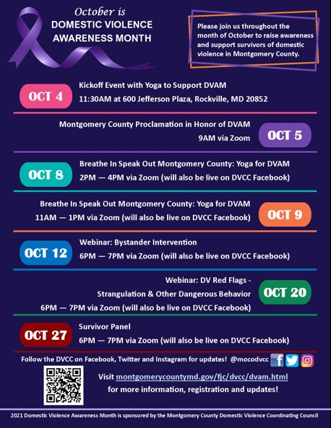
- Commissioner Drew reported that the DVCC has set October as Domestic Violence Awareness Month (DVAM) and will share the DVCC social media sites with the Commissioners so they can then share them on their own social media. October 5th will be the date for the Proclamation against DV and associated press conference. Commissioners are encouraged to attend the DVCC events being held throughout October.

- Exec. Director Finkelstein announced an event of potential interest and a thank you to the interns who created the talking points for the County Exec and county officials attending this event.

September 19 (Sunday, 2:00 PM) Suffrage Marker unveiling at Sandy Spring Museum

Birthday congratulations were extended to Commissioners Diana Rubin and Meredith Weisel

Chair Rojas encouraged all Commissioners to remain focused on our mission and goal of representing the women of Montgomery County.

XI. Adjourn
Meeting adjourned at 8:06 PM by Chair Rojas.

