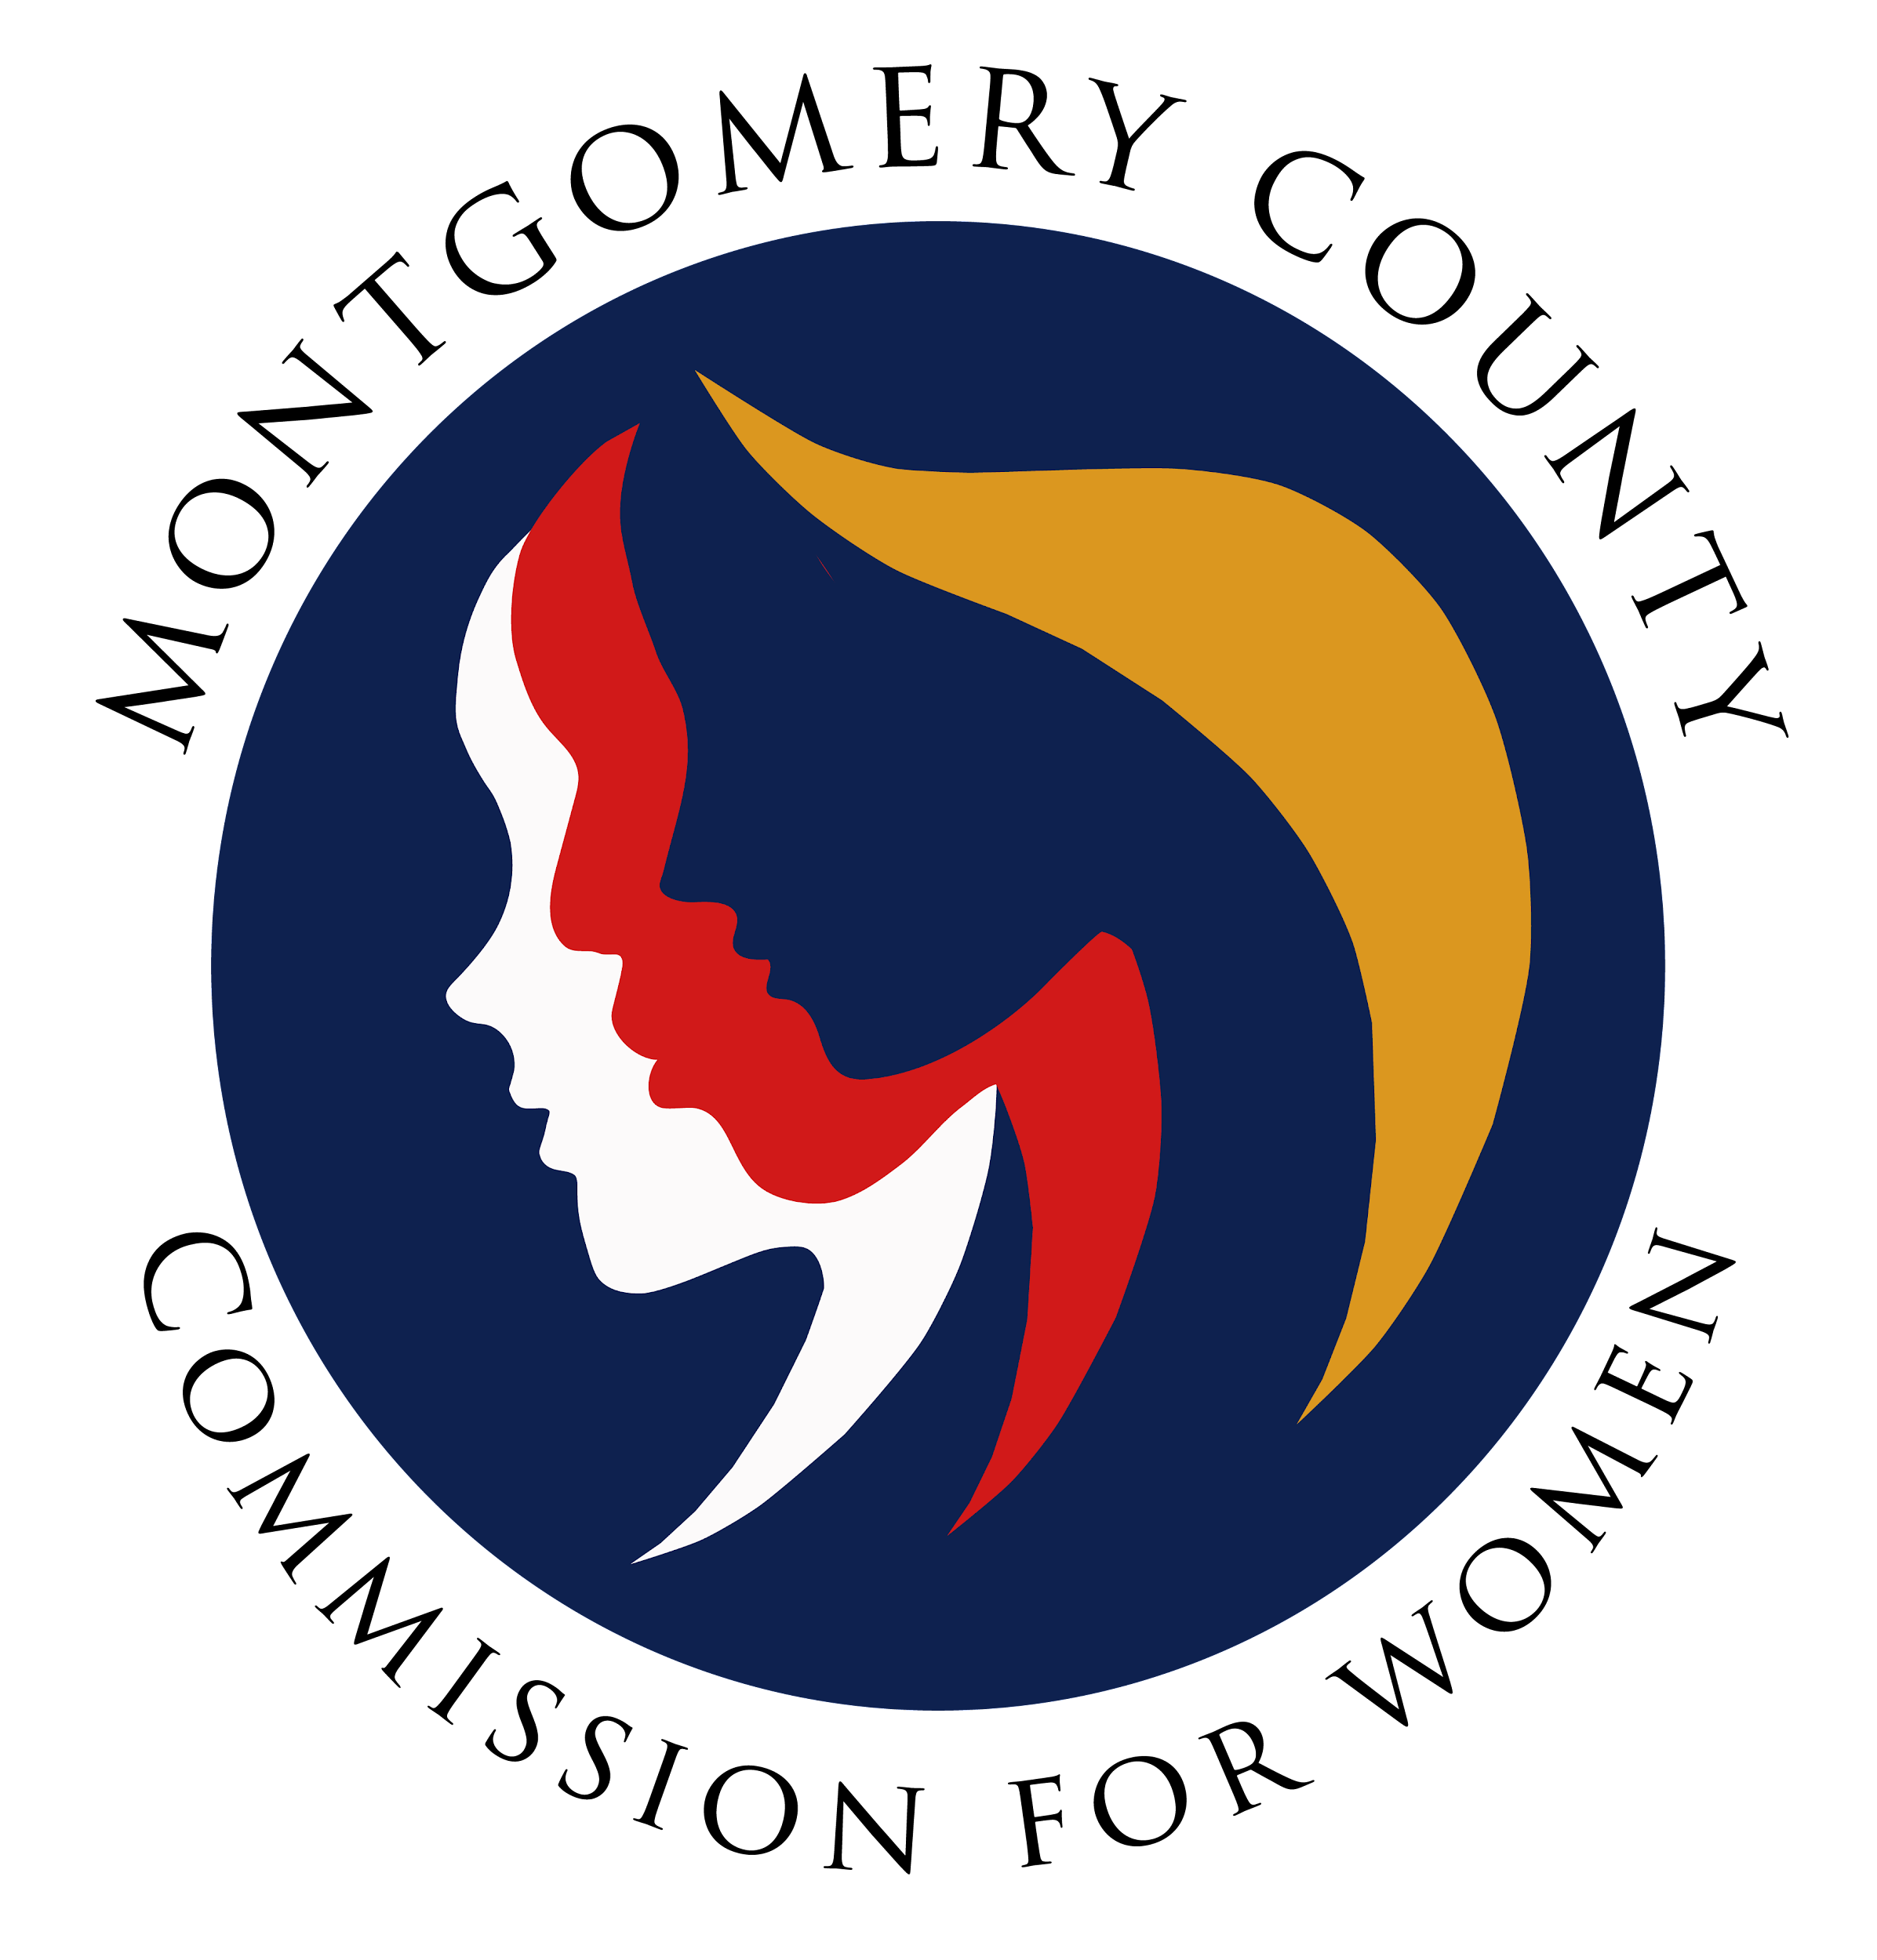
Montgomery County Commission for Women
General Meeting Minutes
November 10, 2022 / 7:00 – 8:30 p.m.

______________________________________________________________________________
“It’s only after you stepped outside your comfort zone that you begin to change, grow, and transform.”
Roy T. Bennett
______________________________________________________________________________

Commission Attendees
Donna Rojas (Chair)
Betty Romero (2nd Vice Chair)
Isabel Argoti Jodi Danis LaDonna King Janet LaValle
Helen Meister Kimberly Mouzon Liz Richards Tondalayo Royster Leah Wade

GENERAL MEETING MINUTES

I. WELCOME AND INTRODUCTIONS / CHAIR ROJAS
- Commissioners introduced themselves and new commissioners were welcomed by Chair Rojas

II. APPROVAL OF MINUTES AND AGENDA / CHAIR ROJAS

- Approval of meeting agenda
Commissioner Tondalayo Royster moved for approval
Commissioner Betty Romero second the motion
Motion approved and agenda approved

- Approval of August 11, 2022 minutes
Commissioner Betty Romero moved for approval
Commissioner Janet LaVelle second the motion
Motion approved and August 11, 2022 minutes approved

- Approval of September 8, 2022 minutes
Commissioner Janet LaVelle moved for approval
Commissioner Kimberly Mouzon second the motion
Motion approved and September 8, 2022 minutes approved

- Approval of October 13, 2022 minutes
Commissioner Kimberly Mouzon moved for approval
Commissioner Betty Romero second the motion
Motion approved and October 13, 2022 minutes approved

III. EXECUTIVE COMMITTEE REPORT / CHAIR ROJAS
- National Association for the Advancement of Colored People
(NAACP) Conference (Montgomery County Branch)
- Commissioner Donna Rojas attended the conference
- Theme: Status of Black Women in Montgomery County
- CFW sponsored this year
- CFW Status of Women report statistics were referenced at the conference
- Copy of conference presentation will be emailed to Commissioners

- Maryland Network Against Domestic Violence (MNADV)
- CFW sponsored this year
- Annual meeting included keynote speaker and presentation of awards to individuals in honor of domestic violence awareness month which is in October
- Video of event will be sent to Commissioners via email

- The Maryland Commission for Women Hall of Fame
- Commissioner Donna Rojas nominated Nancy Navarro as she was the one female voice for women on the Montgomery County Council /awaiting selection status
- First in the history of the council to have six new female members, first time council is majority female

- CFW General Meeting
- December 8th meeting will be in person at 6:30 p.m./early start (Rockville Office)
- Meeting will be a team building session and holiday gathering
- Executive Committee will discuss future in person meetings to occur at least quarterly; information forthcoming when confirmed

- Executive Director Report/ Carmen Kaarid, Senior Executive Administrative Aide
- Marc Elrich, County Executive hosting upcoming Public Budget Forum
- Six forums to discuss FY24 Operating Budget throughout the county
- Community conversation to receive their input on budget allocation
- First forum is this Monday, 11.14.22 at Mid-County Regional Service Center in Wheaton (7:00 - 8:30 p.m.)
- All forums will be hybrid and scheduled 7:00 – 8:30 p.m./link emailed & in chat
- FY24 Budget due to Council by March 15th will be effective July 1, 2023

IV. COMMITTEE REPORTS

- Strategic Planning & Research Evaluation (SPRE) / Chair Romero

- Commissioner Betty Romero gave an overview of the SPRE Committee
- Values and mission statement were introduced, reviewed and moved for approval
- Some Commissioners suggested edits/changes to the mission statement
- Commissioners Betty Romero/Donna Rojas moved to approve the edits to the mission statement and values as seen on the screen. Commissioners voted and approved. No second motion required
- Mission statement will be re-visited at December’s general meeting for re-work
- Commissioners encouraged to email suggestions for mission statement to Commissioner Betty Romero

- Policy and Legislation (PALS) / Chair Rojas Reported

- Maryland Legislative Agenda for Women (MLAW) conference is on Saturday, November 12, 2022 (Silver Spring Civic Center/ 9:00 a.m. – 1:00 p.m.)
- MLAW conference shares new bills that impact women in Maryland
- PALS committee host Lobby Day for the bills the commission supports
- MLAW Conference link for conference provided on chat

- Programming / Chair Rojas Reported

- Partnering with Montgomery Women to host Career Exploration Career Fair
- Event is scheduled November 17th for the emerging leader’s population
- Focus on non-traditional careers and professionals in the field providing insight
- Students will receive SSL hours for participating

- Budget Committee / Chair Rojas

- Committee will be meeting soon to provide budget report at future meeting/January 2023
- Potential information to be shared will be sent via email

- Emerging Leaders / No Report (Chair Pending)

- Emerging Leaders (middle school/high school students)
- Engage them during events (Women’s Legislative Briefing and RespectFest, etc.)
- Commissioners encouraged to explore this committee/Chair pending

- Public Relations / Chair Argoti

- Committee did not meet in order to include new Commissioners that join
- Committee will work on updating roster and meeting schedules for committees
- Commissioner Isabel Argoti provided overview of committee responsibilities (social media, brochures, swag items, newsletter input, promoting programs, etc.)
- GREAT NEWS: 20K subscribers to the CFW Newsletter!

- Women’s Legislative Briefing (WLB) / Commissioner Clark
- Video report by Commissioner Arlinda Clark
Theme: Empowered Women Protect Democracy
Sunday, January 29, 2023 (virtual)
Time: 12:30 p.m. – 5:00 p.m.
Registration:
$23.00 (through Jan. 27th)
$30.00 (Jan. 28th & 29th)
$5.00 (Students)

*Commissioners must purchase tickets to attend event.

Chairs Reception will be in person (January 28, 2023/ 10:00 a.m. 12:00 p.m.)
- Commissioners needed to serve on the following committees:
Programming: 1st Thursday of the Month/6:00 p.m.
Planning: 1st Thursday of the Month/7:00 p.m.
Emerging Leaders, Evaluation and Public Relations committees

V. LIAISON REPORTS

- Human Trafficking Prevention (HTP) / Carmen Kaarid, Executive Admin.

- No report

- Domestic Violence Coordinating Council (DVCC) / Commissioner Royster

- October was Domestic Violence Awareness Month
- Theme: Walk in their Shoes Campaign was a success
- 10 anonymous survivors shared stories (displayed on posters) with a pair of shoes to express their experience
- Displays were throughout Montgomery County (All libraries, recreation centers and police departments)

- RespectFest / No Report / CFW Liaison Pending
- Commissioner Mouzon reported on upcoming RespectFest:
April 16, 2022 / 1:00 p.m. – 4:00 p.m.
Wheaton Recreation Center
- Community Health Initiative / No Report / Chair LaVelle

- No report

VI. AD HOC COMMITTEE REPORT(S) – No Reports
IX. OLD BUSINESS

- None

X. NEW BUSINESS/ANNOUNCEMENTS
- None

XI. GOOD NEWS
- None
XII. Meeting Adjourned (8:12 p.m.)

