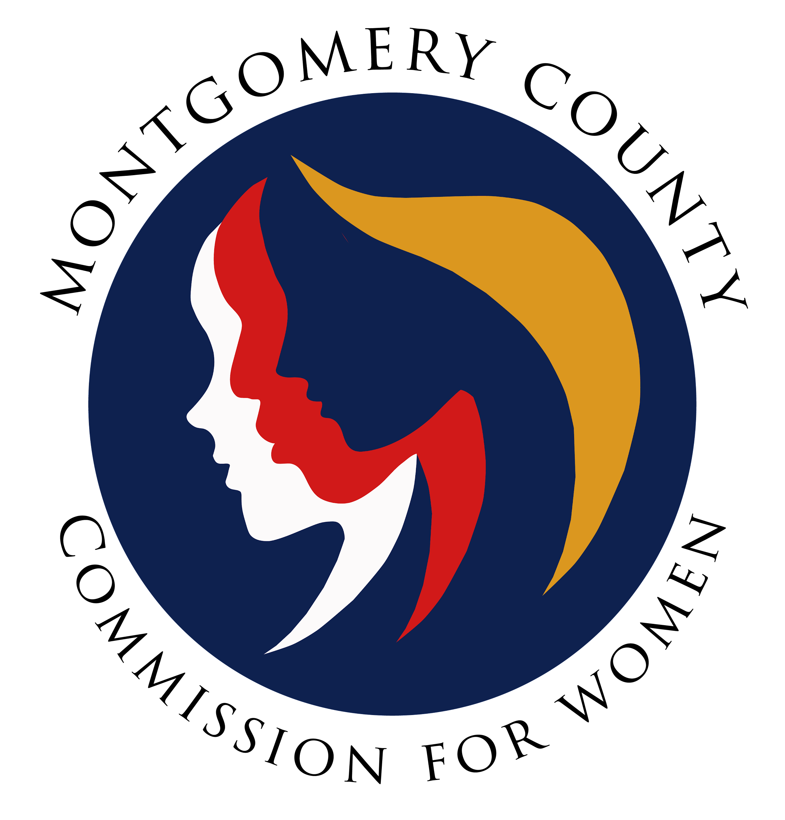
Montgomery County Commission for Women
Monthly Meeting April 14, 2022

Attendance
Attending | Not Attending | Guests
Donna Rojas – Chair  Patricia Maclay – 1st Vice Chair  Isabel Argoti – Secretary  Ijeoma Enendu  Betty Romero  Chai Shenoy  Janet Lavalle  Diana Rubin  Nicole Drew  Tondalayo Royster  Jan Molino  Arlinda Clark  Staff  Jodi Finkelstein  Oyin Thompson | Tonia Bui – 2nd Vice Chair  Angela Whitehead Quigley | Dr. Daryl Thorne  Jennifer Dickens

MEETING MINUTES
April 14, 2022

I. WELCOME AND INTRODUCTIONS Chair Rojas
- Meeting called to order at 7:00 p.m. by Chair Rojas.
- Introduction of guests: Daryl and Jennifer join us from Delta Sigma Theta local chapters.

II. APPROVAL OF MINUTES AND AGENDA Chair Rojas
- April Agenda
  - Commissioner Romero amends to add the Revision of Committee Descriptions to the agenda under New Business.
  - Commissioner Drew moves to approve the amended agenda. Commissioner Molino seconds. 10 voted in favor. Motion passes.
- March Minutes
  - Commissioner Argoti amends minutes for formatting errors under Executive Report and adding bullets for Public Relations Committee.
  - Commissioner Maclay amends to correct the spelling of “Commission Hogue” under New Business and unfinished sentence under Emerging Leaders.
  - Commissioner Rubin motions to accept the amended minutes. COmmissioner Molino seconds.

III. EXECUTIVE COMMITTEE REPORT Chair Rojas
- Bethesda Magazine Article linked here. Chair Rojas was interviewed for this article and it has now been published.
- CFW statement on SCJ Brown Jackson
  - A statement went out to congratulate SCJ Brown Jackson on her nomination.
  - Commissioner Drew moves to ratify the statement to include that this was on behalf of the entire commission instead of just the Executive Committee. Commissioner Maclay seconds. Commission votes 10 in favor.
- CFW Sponsorships
  - MNADV
    - MD Network Against Domestic Violence has asked for us to sponsor their upcoming conference once again. The event is on May 18 -19 and the lowest level is Bronze at $250. Due date is May 9.
    - Commissioner Drew asked when the last time we sponsored an event for them. In 2016, we sponsored at $125. Executive Director Finkelstein clarified that we did fund under the Montgomery County Commission for Women but unsure as to which budget it came out of –this is something that we need to decide as a commission and potentially vote upon.
    - Chair Rojas and Commissioner Drew emphasized that the CFW needs to create parameters around sponsorships. Commissioner Shenoy suggested that the Budget Committee take charge of this and help create a sponsorship system. Commissioner Argoti agreed and suggested that a chart be made to understand our different types of accounts and how next steps for each bucket would move forward.
    - It was suggested that commissioners will make a final vote by email to look through links.
    - Commissioner Clark suggested that things that require a vote be brought to commissioners before an actual meeting so that things are not being presented the night that it needs a vote. This was not sent before.
    - Commissioner Molino expressed that this should not even be voted via email given that there is a time constraint.
    - Commissioner Rubin suggests that the Budget Committee look at how much we have to spend on sponsorships.
    - Commissioner Shenoy suggests that we wait until our new fiscal year (July 1) to have a full set of procedures and not completely cut this out of voting. Commissioners can vote via email based on their best judgements.
    - Discussion ended and no motions or votes were made. The MNADV can no longer be considered.
  - Up2Us Foundation
    - The Up2Us Foundation approached the commission to sponsor the inaugural Gala at the end of this month. The Executive Committee met, without Commissioner Drew, about this and asked Executive Director Finkelstein for clarity around sponsorships. According to county protocols, we are approved to support organizations like this.
    - Commissioner Drew then expressed concerns over having a current and past commissioner relationship to this organization. The request was then made to not move forward with the sponsorship and bring this to the full commissioner.
    - Executive Director Finkelstein then shared that according to the county guidelines, we can support this and vote, but the commissioner on the organization’s board cannot vote and needs to leave the room.
    - Commissioner Clark asked for sponsorship details.
    - Commissioner Rubin expressed that this should be brought to the full body for any type of sponsorship. Chair Rojas agreed.
    - Commissioner Enendu requests written documentation around the conversation had with the county so we can reference for future instances.
    - Commissioner Drew explained her thoughts around her disapproval of this sponsorship due to the large amount, former commissioner relationship, and current commissioner on the board. This would make us vulnerable to scrutiny around distributing funds.
    - Commissioner Romero expressed that this situation underscores the need for her new agenda item around committee descriptions.
    - Commissioner Shenoy thanks the commission for bringing this up to the full commission as the perception of conflict may be bad for our image. She asks for clarity around making motions on MNADV. Commissioner Clark clarifies that we can no longer discuss this item. Commissioner Royster asked if that means the MNADV can no longer be considered. Commissioner Clark explains that this is correct; the previous agenda item for sponsorship can no longer be considered or voted upon.
    - Commissioner Clark moves to not sponsor the Up2Us Foundation Gala. Commissioner Molino seconds. Commissioner Maclay leaves the room. Commission votes 7 to not sponsor. The commission will not sponsor the Up2Us Foundation Gala.

IV. EXECUTIVE DIRECTOR REPORT Executive Director Finkelstein
- CFW Team update
  - Intern Holly just wrapped up her last week! She was on the call and sent a note in the chat. Intern Gaby also finished up. Intern Ashlyn will be with us through May and volunteering with us 1 day a week
  - The office is taking interviews for summer interns. High school intern, Ethan, will be back volunteering this summer.
  - Oyin is back with us!
  - Commissioner Rubin asked if these were paid internships. Executive Director Finkelstein expressed that it is not. Commissioner Rubin, Argoti, and Shenoy expressed that this should be considered as the federal government has moved to paid internships. This should be handled in the budget committee.
- Campaigns and the Commission/ Hosting Candidate Forums
  - A reminder that commissioners are encouraged and can vote in upcoming polls but we should not be endorsing candidates with our CFW titles.
- Personal Leave: May 14-22
  - Executive Director Finkelstein will be out during these dates. Oyin can be contacted during her time out.

V. COMMITTEE REPORTS
a. Policy and Legislation Commissioner Rubin
- Abortion Care Access - passed.
- Repeal as Spousal Defense - failed in conference.
- Time to Care Act - passed.
- Stalking - passed.
- Safe Harbor Act - failed in conference.
- Report will be sent via email. Thank you Holly for all her work on this!

VI. LIAISON REPORTS
e. Choose Respect Commissioner Royster
- Thank you to Commissioners that attended this event! Commissioners Royster, Rojas, Whitehead Quigley, and Drew attended.
- Overall attendance was 603 people in-person with mainly middle school students. Online, about 2,000 people were touched. They are considering doing this hybrid next year with such an excellent turn out!

VII. AD HOC COMMITTEE REPORT(S)
b. Ad Hoc Committee on Hate Violence Commissioner Shenoy
- Commissioner Maclay has joined the committee.
- Commissioner Shenoy will be attending the county’s Committee against Hate and Violence on her own account but she would like to revisit the idea of working on this from the lens of a women’s inequality.
- Commissioner Enendu asked about the deadline for the committee's work, as this was previously set. Commissioner Drew agreed and added that timeline needs to be set as an Ad-Hoc committee needs a deadline.
- Commissioner Rubin reminded us that the commission is also understaffed and we cannot fulfill existing committees.
- Commissioner Maclay asked for the overall goal of this committee. This should be clarified at the upcoming strategic planning.

c. 50th Anniversary Commissioner Maclay
- We will host a two-part celebration:
(1) an open public picnic at Wheaton Regional Park on Sunday, June 5 for all former and current commissioners, families, and general public as a fun event with games, food, and activities; and
(2) a formal invite-only event on Sunday, July 17 with former and current commissioners and elected officials at the Sandy Spring Museum where we will have speakers and bury our time capsule.

IX. OLD BUSINESS - NONE

X. NEW BUSINESS/ANNOUNCEMENTS

a. SPRE Strategic Planning Commissioner Molino
- SPRE Committee would like to set the date for a strategic planning date and time so they will send out a doodle poll to hold this planning meeting in September/early October along with the venue.
- Commissioner Clark moves to expand the strategic planning committee meeting so that we can have it longer (approx. 4 hours) to resolve our strategic plan. Commissioner Romero seconds. 12 voted in favor. Motion passes.

b. By Law Committee Descriptions Commissioner Molino
- Commissioner Molino wanted to make a motion to have a discussion around description committees in our by-laws for review at the May meeting and June approval.
- It was clarified that this is not in our by-laws but rather in our Orientation Manual so this process is not needed. Committee descriptions can be changed at any time in the manual.
- Commissioner Bui updated these and checked in with the committee chairs. A Google Folder is being worked on for all commissioners to have access to key documents, minutes, and committee schedules.
- Commissioner Drew suggested that any committee descriptions should be included at the strategic planning meeting.

XI. Adjourn

Meeting adjourned at 8:40 p.m.

