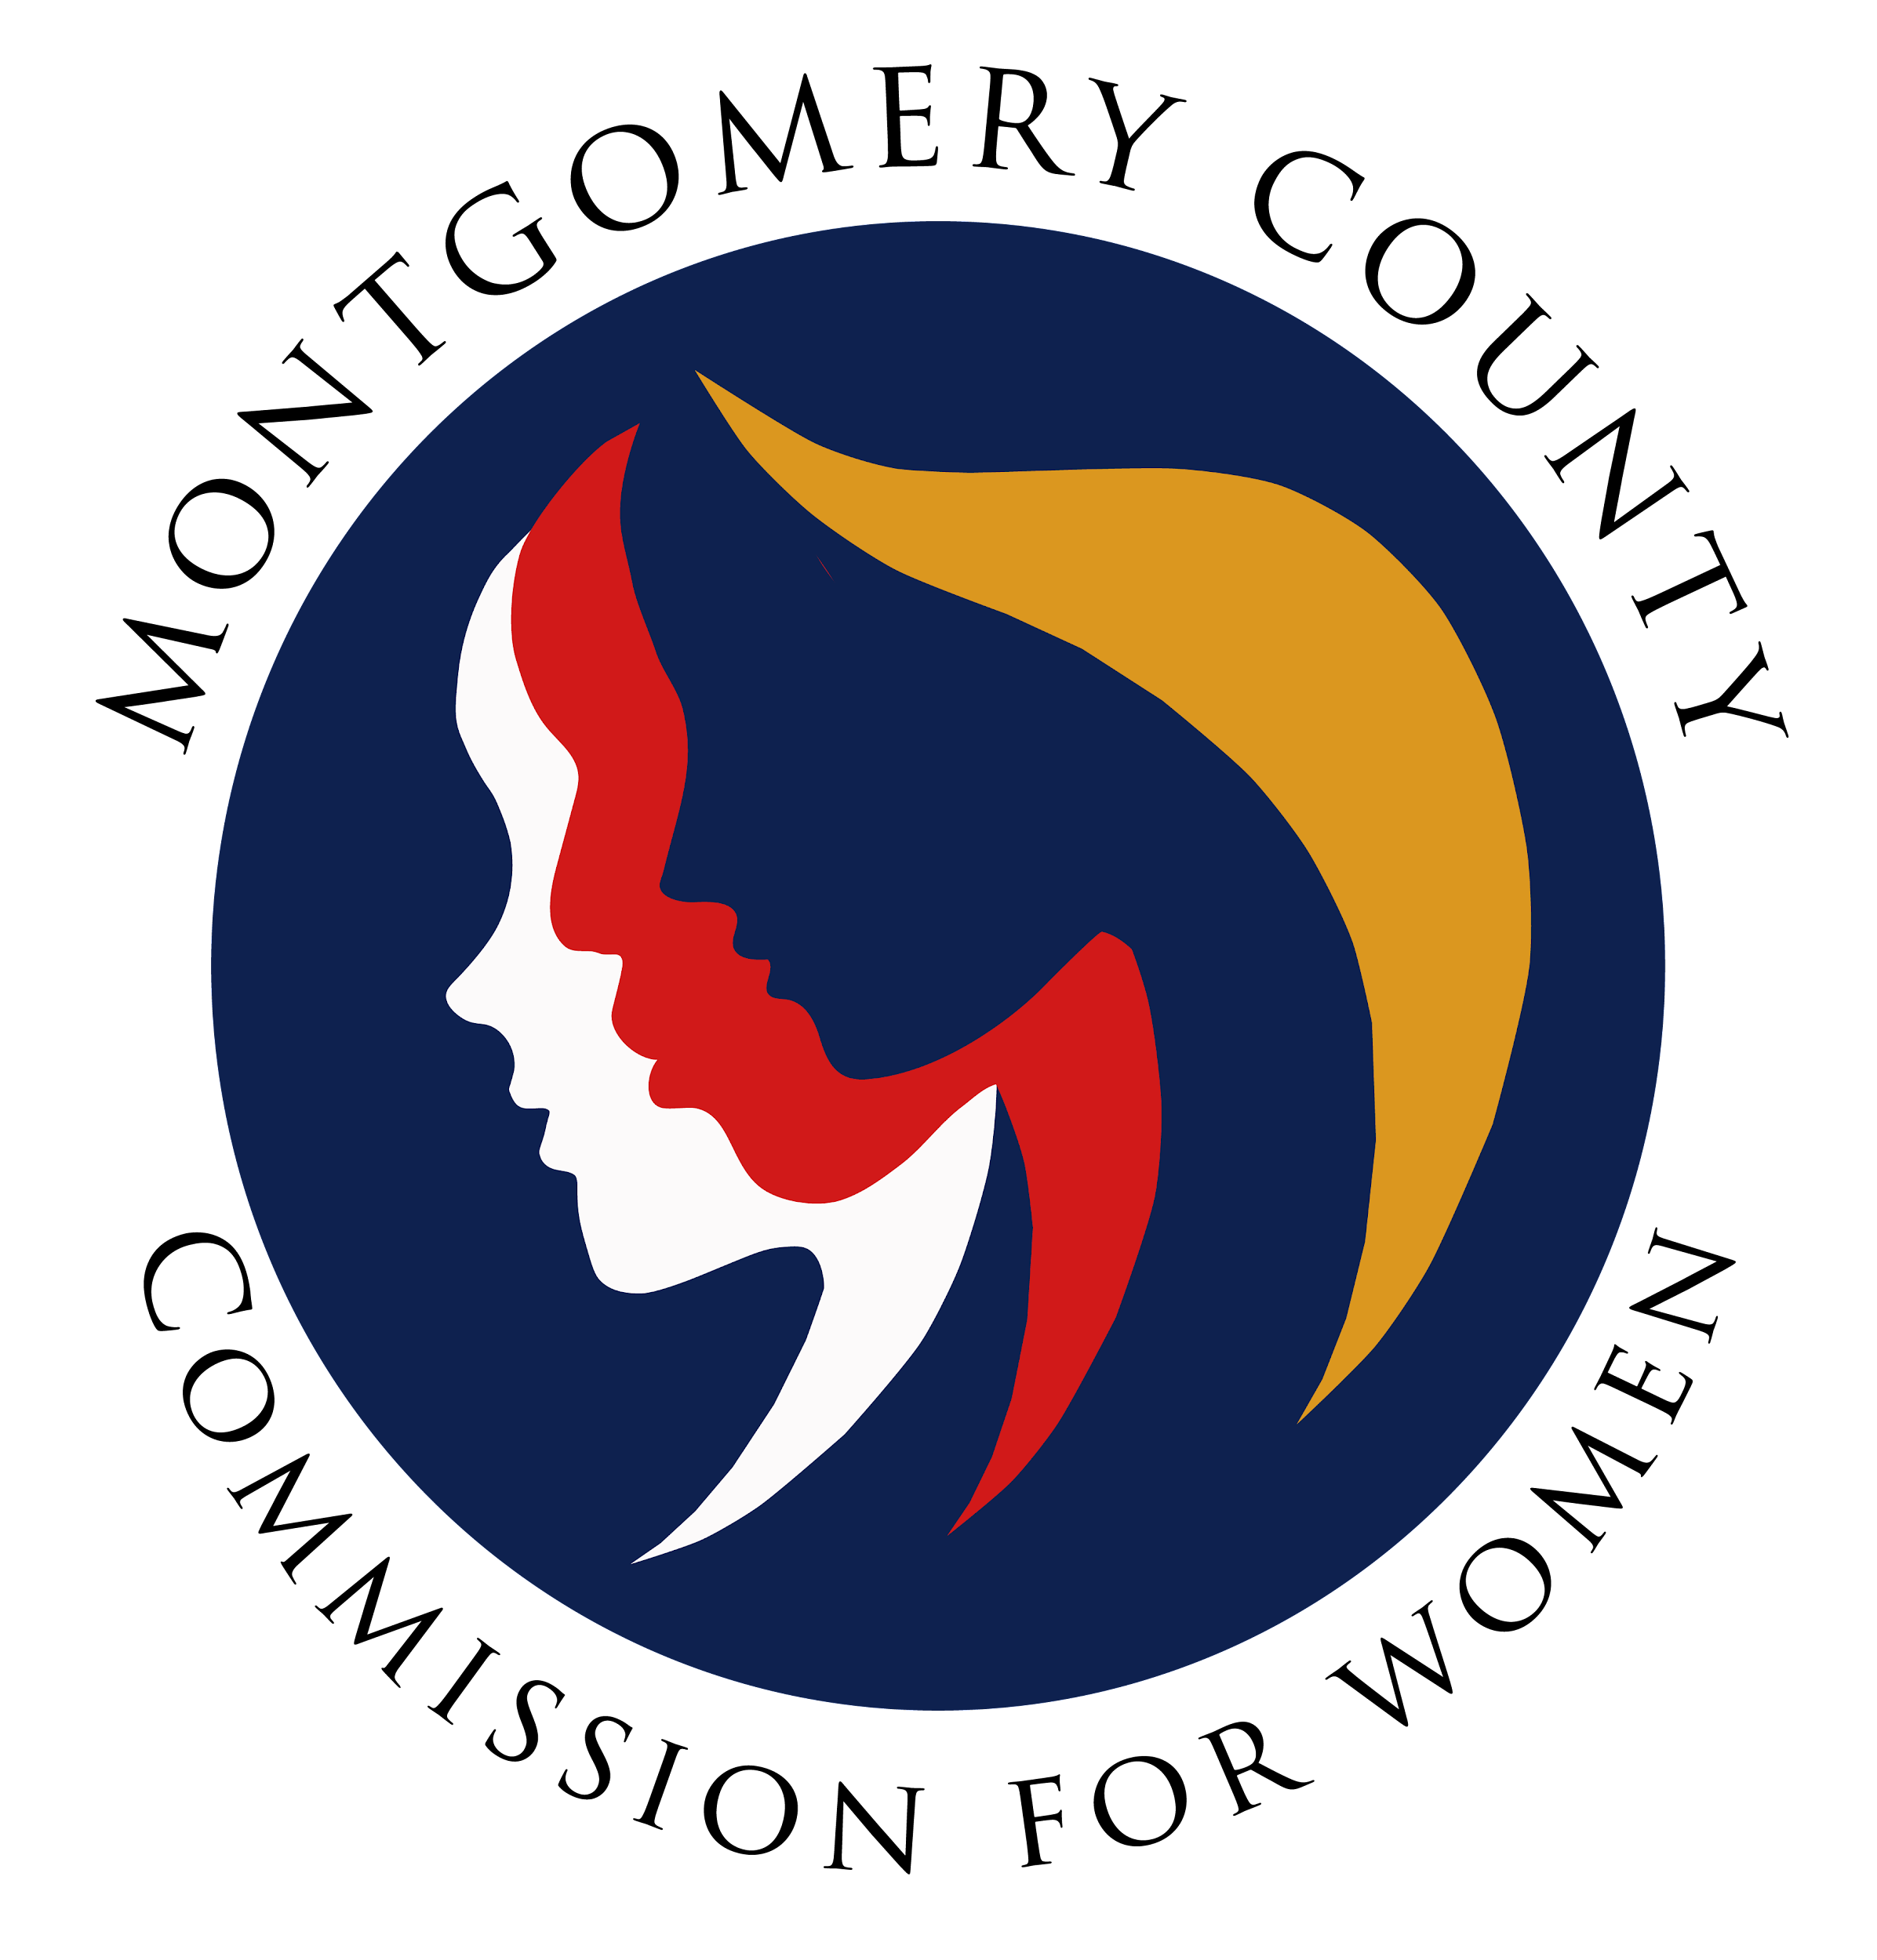
Montgomery County Commission for Women
Monthly Meeting February 10, 2022

Attendance
Attending | Not Attending | Guests
Donna Rojas – Chair  Patricia Maclay – 1st Vice Chair  Tonia Bui – 2nd Vice Chair  Isabel Argoti – Secretary  Arlinda Clark  Angela Whitehead Quigley  Ijeoma Enendu  Nicole Drew  Jan Molino  Janet Lavalle  Betty Romero  Tondalayo Royster  Staff  Jodi Finkelstein | Diana Rubin  Chai Shenoy

MEETING MINUTES
February 10, 2022

I. WELCOME AND INTRODUCTIONS Commissioner Rojas
- Meeting called to order at 7:01 pm.
- We commission reflected on the artwork shared by Commissioner Rojas.

II. APPROVAL OF MINUTES AND AGENDA Commissioner Rojas
- February 2022 Agenda
  - Commissioner Argoti amended the agenda for a date change for February 10, 2022, and the Climate Stories Ambassadors Project under old business. Commissioner Drew moves to adopt the agenda with amendments. Commissioner Molina seconds. Passes unanimously with changes.
- January 2022 Minutes
  - Commissioner Maclay motions to approve minutes. Commissioner Romero seconds. Passes unanimously.
III. EXECUTIVE COMMITTEE REPORT Chair Rojas
- Meeting with Council President Albornoz went really great! He shared the county priorities and issues around the number of women leaving the workforce, economic fallout in the hospitality industry, COVID vaccination efforts, increase in mental health issues (especially for women), the Thrive 2050 plan (county’s land usage planning), and more.
- The Commission sent a congratulatory letter to the new MCPS Superintendant Monifa McKnight for being the first woman and second person of color in this role! Commissioner Royster asked to please share out a copy of the letter.

IV. EXECUTIVE DIRECTOR REPORT Executive Director Finkelstein
- CFW shirts mare here! They are in the office. please pick up Tuesday or Wednesday 9:30 am - 5 pm. Please connect with Executive Director Finkelstein to pick yours up.

V. COMMITTEE REPORTS
a. PALS Commissioner Drew
- Commissioner shared on behalf of Commissioner Rubin that our priority Bills are currently being heard and are hopeful for passage!
b. Program Planning Commissioner Enendu
- Women Making History event is coming up next month with Montgomery Women. A total of 65 nominations were submitted! Last year, we selected women by us, but this year we went with a nomination system. A review committee has been formed and will work through all nominations.
- We highlight all winning nominees and then hold a virtual program with a panel of women. The tentative date is March 24.
- Commissioner Enendu would like to gift CFW and MW branded pens to highlighted women. The estimated cost is $300 total and MW will be able to contribute $150. Typically, these requests should come through the Budget committee first. Commissioner Drew clarified that the committee has not met but this should be affordable.
- This expense will actually be coming out of county funds so no voting is needed.
- Commissioner Romero asked for some background on our relationship with Montgomery Women and the virtual event.
f. Public Relations Commissioner Argoti
- Meeting will restart at the end of the month.

g. WLB Commissioner Maclay and Argoti
- An official report will go out later but the co-chairs would like to get general feedback and thoughts from commissioners.
- Commissioner Clark expressed that the programming was really good and love the virtual programming. She recommends we start planning earlier to get communications out earlier before the holidays.
- Commissioner Molino agreed with Commissioner Clark and would like to see more panelists at the networking portion as none showed up in her session.
- Commissioner Drew gives a shoutout to Commissioner Whitehead Quigley for all her work over the many years for Emerging Leaders. This year, we had the highest number of young people attending!
- Commissioner Romero asked for a little more background on the Emerging Leaders session. Commissioner Whitehead Quigley expressed her gratitude and shared more about the 2022 program. The next event will also need SSL approval but the process should be easier moving forward.
- Commissioner Clark expressed her concern with the tech team that was not professional with the execution of the event and should remain off-camera/audio.
- Commissioner Royster expressed gratitude for all chairs on the great program and really enjoyed the main speaker.
- The WLB 2023 will be on January 29, 2023.

VI. LIAISON REPORTS

b. HTPC Commissioner Maclay
- Wrapped up a series of events and campaigns across the county. They are trying to increase levels of education to students in high schools around sexual assault and trafficking.
- Modeling the Blue Dot Baltimore Program, we are starting our own program with
Montgomery County offices.
e. Choose Respect Commissioner Whitehead Quigley
- Official date will be March 27, 2022, from 1 to 4 pm at the Wheaton Community Center. Activities will primarily be outside and maybe a few events inside, including a resource fair where we have been asked to host a table. A table would have to include an educational content component as students earn SSL hours.
- Commissioner Whitehead Quigley motions that the CFW participate at the RespectFest by hosting a table on March 27. Commissioner Drew seconds. The motion passes unanimously.
- During that same week (March 21), online programming will begin that people can do asynchronously.

VII. AD HOC COMMITTEE REPORT(S) - NONE

IX. OLD BUSINESS

- Climate Stories Ambassadors Project Commissioner Maclay and Argoti
- Commissioner Enendu shared that we should connect with the organizers to ensure that women's stories are amplified in these stories.
- Commissioner Argoti motions for the CFW to be a part of the Climate Stories Ambassadors Project with the county. Commissioner Enendu seconds. The motion passes unanimously.

X. NEW BUSINESS/ANNOUNCEMENTS
- Volunteering for Up2Us Foundation Commissioner Argoti
- Commissioner Argoti shared an idea that stemmed from her and Commissioner Enedu volunteering at Up2Us Foundation, a food distribution center at Wheaton Mall. They proposed that the Commission volunteer during WOmen’s History Month as a way to show support, share resources about the CFW, and give a time for service to the community. open volunteer slots are available on either Saturday, March 5 or 19. Commissioner Argoti clarified that this can be a service opportunity, a way to amplify our resources, bring awareness to the commission, and photo opportunity.
- Commissioner Rojas recommended that an email be sent to coordinate which date commissioners may be able to attend.
- Commissioners Clark, Bui, Drew, and Whitehead Quigley expressed that they cannot attend on either date.
XI. Adjourn
Meeting adjourned at 8:19 p.m.

