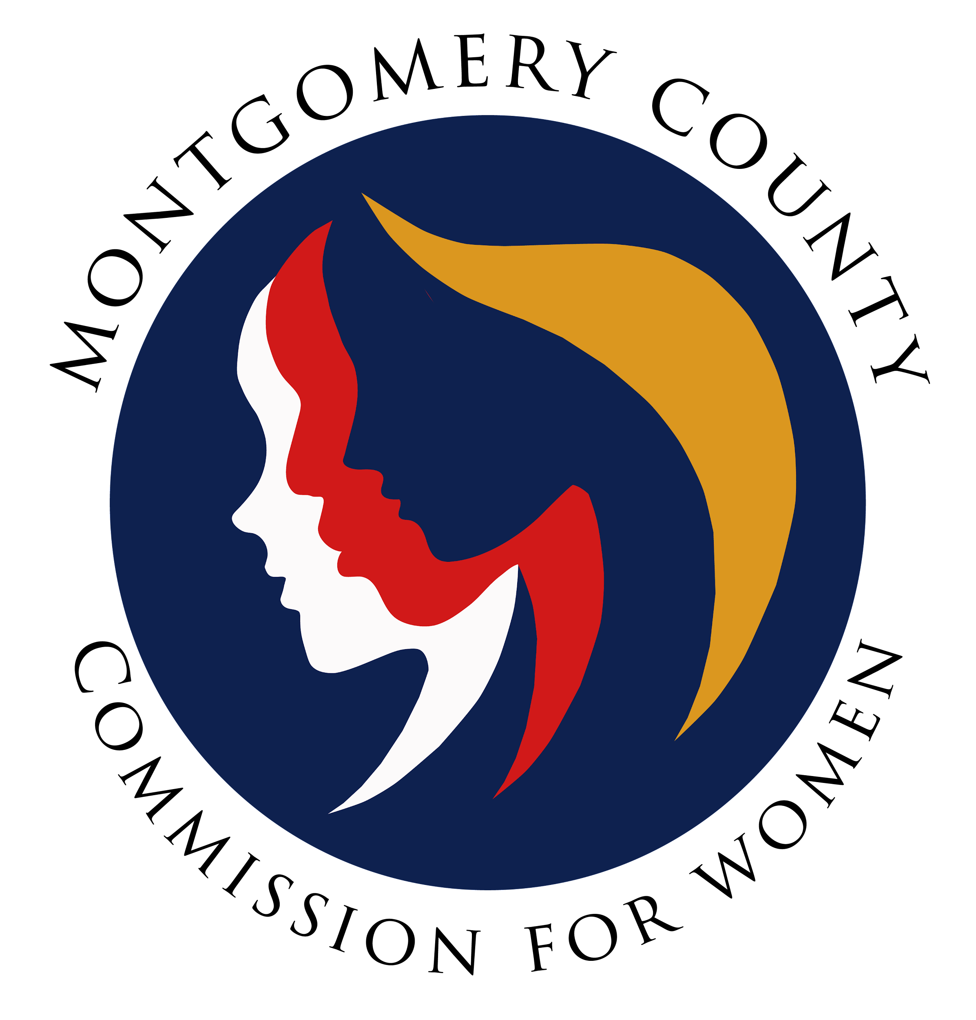
Montgomery County Commission for Women
General Meeting Minutes / Virtual
April 13, 2023 / 7:00 – 8:30 p.m.

______________________________________________________________________________
“Kindness is never wasted.”
Unknown
______________________________________________________________________________

Attendees
Donna Rojas (Chair)
Arlinda Clark (1st Vice Chair)
Betty Romero (2nd Vice Chair)
Isabel Argoti Jodi Danis Ijeoma Enendu
Kathy Estrada Helene Meister Liz Richards
Tondalayo Royster Lindsey Turnbull Leah Wade Janet Lavalle

CFW Team Members
Jodi Finkelstein (Executive Director)
Absent
LaDonna King
Kimberly Mouzon
GENERAL MEETING MINUTES

I. WELCOME AND INTRODUCTIONS / CHAIR ROJAS
- Introduction by Commissioners in attendance and welcome to new Commissioners
- Welcome Commissioner Kathy Estrada!

II. APPROVAL OF MINUTES AND AGENDA / CHAIR ROJAS

- Approval of April 13, 2023 meeting agenda
Correction: Date change from April 16th to April 15th for Prom Dress Event
Agenda approved by Commissioners
- Approval of April 13, 2023 meeting minutes
Agenda approved by Commissioners
III. EXECUTIVE COMMITTEE REPORT / CHAIR ROJAS
- ChooseRespect
- Family Justice Center hosting annual RespectFest on April 16th at Wheaton
Recreational Center (1-4 p.m.) / heightening awareness of teen dating violence.
- Commissioners are needed to manage the CFW table and the parent’s information
table.
- All Commissioners are welcomed to attend.

- GLOW
- Community Bridges hosting Girls Leading Our World (GLOW) Summit
Scheduled: April 15th Montgomery College, Takoma Park Campus (1-4 pm).

- Focus will be on diverse career options.
- CFW will be present and will have a table of information on site.
- Prom Dress Event

- 2nd Annual Prom Dress Give Away
Scheduled: April 15th / Marilyn Praisner Community Recreation Center (All Day)
- All Commissioners are welcomed to attend.

- Six New Council Members / May Meeting
- Six new council member will attend CFW general meeting in May 2023
- Council members will share their priorities, their goals to help women and girls and
how CFW can work with them overall.
- CFW will share our priorities and explore how council members and commissioners can
work together.

- Re-Entry Project
- CFW seeking to revive the re-entry project at the Montgomery County Correctional
Facility.
- Goal was to determine the needs of the women when returning to the community.

- Chair Rojas sent surveys to the Montgomery County Correctional Facility and the Maryland State Department of Public Safety and Correctional Services.

- Surveys will be reviewed and used to determine how programming will be structured.

IV. EXECUTIVE DIRECTOR REPORT / EXEC DIR., FINKELSTEIN

- Summer Internships

- Interviews for summer interns has started. Approximately 3 candidates thus far. Updates will be shared accordingly.
- CFW will host a Summer Rise Student / high school students who want to experience the work world.
- Budget Reports

- County Executive has shared budget with the County Council; Public Hearings are scheduled tonight. Updates will be shared accordingly.

- Leave Dates
- Jodi Finkelstein, Executive Director will be on extended leave (May 10th – May 22nd)
- Carmen Kaarid will be the point of contact in the absence of Jodi Finkelstein

V. COMMITTEE REPORTS

- Policy and Legislation / Executive Director, Finkelstein

- Legislative session ended; all of the CFW priority bills passed and forwarded to the governor.
- Updates of CFW priority bills will be shared on social media and in newsletter.
- PAL’s Chair still needed.
- Program Planning / Chair, Commissioner Enendu

- Women Making History was a wonderful event; surveys reflect the desire to host the event bigger next year.
- Thank you to Commissioners and Carmen Kaarid for helping with reading and ranking the applications and helping with the details of the event.
- Self Defense courses / Separation and Divorce series has been scheduled
- Next Programming meeting scheduled April 24th. Link for meeting will be shared with Commissioners

- Budget / Chair Rojas)

- No Report / Meeting will be scheduled soon once other matters have been finalized

- Emerging Leaders / Commissioners Argoti and Turnbull

- Activity for parents that attend RespectFest scheduled April 16th.
- Activity is in English and Spanish and created in Google Doc

- Public Relations / Commissioner Argoti

- Created a database of community events
- Encouraged to share newsletter / like, share and comment on social media

- Women’s Legislative Briefing / Vice Chair, Clark

- Upcoming Meeting May 4th (First Thursday)

- Strategic Planning and Research Evaluation Committee

- Priorities were reviewed, discussed and clarified
- Priorities identified in October 2022 Meeting with Facilitator:
- 2 priority areas per issue for groups to work on
1. Issue: Health, Safety and Security
Priority: Equal access to healthcare
Goal: access to preventive care to avoid crisis and decrease financial burden
Priority: Increase safety knowledge for women
Goal 1: Info available on community threats
Goal 2: safety tool kit
2. Issue: Leadership, Education and Workforce
Priority: Support increase of women in leadership positions
Goal: Providing tools and networking connections
Goal: Increase women voting engagement
Priority: Education and steer women into non-traditional workforce, esp. STEM
Goal: Increased women into under-represented fields
3. Economic and Financial Security
Priority: Increase financial literacy
Goal: Expand financial fundamentals for women and girls

- Discussion to remain consistent with terminology established in October 22nd to
remain:
- Priorities. Goals and Tasks
- Lengthy discussion on women in leadership and having a seat at the table.
- Committee Chairs to review the spreadsheet and determine FY24 goals.
V. LIAISON REPORTS

- MLAW / Commissioner Meister
- MLAW’s next board meeting scheduled April 24th
⁻ MLAW’s priority bills were approved this legislative session

- Human Trafficking Prevention (HTP) / Executive Director. Finkelstein
- Focus on legislative priority on local bills to enhance body works establishments
- Education and outreach campaign with the Health and Human Services
- Currently focused on on-boarding to fill vacancies
- Next HTP meeting scheduled: May 2023 / Guest Speaker: Cara Grant (sp?)

- Domestic Violence Coordinating Council (DVCC) / Commissioner Royster

- No Report (Next meeting scheduled in May – group meets bi-monthly)

- Maryland Commission for Women
- Chair Rojas attended Governor’s Reception
Recognizing nominations from the Maryland Commission for Women and young
adults.

- RespectFest / Commissioner Mouzon
- RespectFest scheduled April 16th at Wheaton Recreational Community Center

- Community Health Initiative / Commissioner LaVelle

- No report

- CFW Scholarship / Commissioner Argoti
- No report

- Social Committee / Commissioner Rojas

- Stay tuned: Sip and Paint social event in May

VI. AD HOC COMMITTEE REPORT(S)

- By Laws Committee / Vice Chair Clark and Commissioner LaVelle
- Vice Chair Clark will email form for Commissioners to include their comments on
current By-Laws
- Next scheduled committee meeting: May 2023 /recommendations will be reviewed
by the committee
IX. OLD BUSINESS

- N/A

X. NEW BUSINESS/ANNOUNCEMENTS

XI. GOOD NEWS
- Happy Birthday, Commissioner’s Betty and Tondalayo!

XII. Meeting Adjourned

