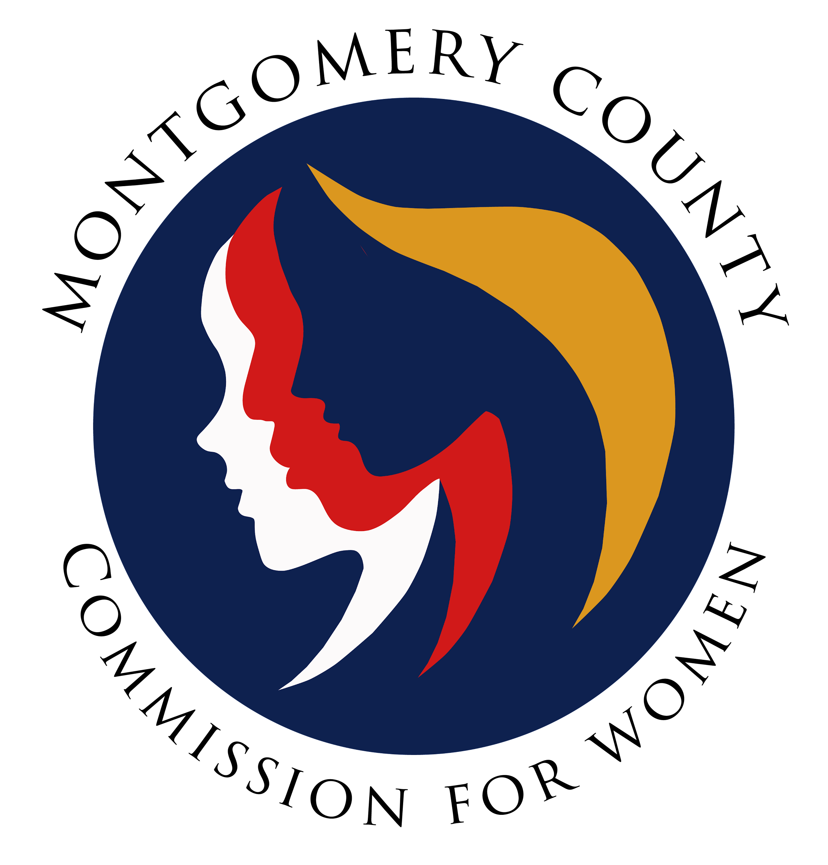
Montgomery County Commission for Women
General Meeting Minutes
February 9, 2023 / 7:00 – 8:30 p.m.

______________________________________________________________________________
“I raise my voice—not so I can shout, but so that those without a voice can be heard.”
Malala Yousafzai.”
______________________________________________________________________________

Attendees
Donna Rojas (Chair)
Arlinda Clark (1st Vice Chair)
Betty Romero (2nd Vice Chair)
Isabel Argoti Jodi Danis Ijeoma Enendu Ladonna King
Janet LaVelle Helen Meister Kimberly Mouzon Liz Richards
Tondalayo Royster Lindsey Turnbull

CFW Team Members
Jodi Finkelstein (Executive Director)
Carmen Kaarid (Program Manager)
Absent Guest
Leah Wade Genevieve Montgomery (Last Name?)
GENERAL MEETING MINUTES

I. WELCOME AND INTRODUCTIONS / CHAIR ROJAS
- Introduction by Commissioners in attendance and welcome to new Commissioners

II. APPROVAL OF MINUTES AND AGENDA / CHAIR ROJAS

- Approval of January 12, 2023 meeting minutes
Agenda approved by Commissioners
- Approval of February 9, 2023 meeting agenda
Agenda approved by Commissioners
III. EXECUTIVE COMMITTEE REPORT / CHAIR ROJAS
- MLAW Conference Overview
- Online conference date: February 1, 2023
- Announced priority bills MLAW will support
- Commissioners received link to review MLAW’s Legislative Agenda

- Proclamation/WTOP Interview
- Human Trafficking Proclamation presented by County Council June 17, 2023
- Kate Ryan/WTOP interviewed Commissioner Rojas on teen dating violence
(February is Teen Dating Violence Awareness Month)
- Family Justice Center is actively involved in teen dating violence awareness

- Future CFW Meetings

- March 9, 2023 and June 8, 2023 will be in person meeting
- Location: Rockville Library (Room #: to be confirmed)

- Women’s Bureau (Mid-Atlantic)

- Quarterly meeting date: February 7, 2023
- Discussed priorities (referred as themes):
- Eliminating Wage gap
- Grants for women and apprenticeship with non-traditional work
- Equal pay day
- Expanding paid leave
- Education grant AKA Fostering Access Rights and Education
- Childcare rates
- Presentation from Hamilton County Commission for Women and Girls (Ohio)
- Teens are apart of their Commission
- Focused on menstrual equity/ensuring free menstrual products in all county schools
- Menstrual Equity Project was funded by county’s general fund

IV. EXECUTIVE DIRECTOR REPORT / EXEC DIR., FINKELSTEIN

- On-Boarding

- One vacancy on Commission pending / interview scheduling in progress
- Interviews to be completed by the end of the month/February 2023
- On-boarding process will take place following selection of Commissioner

- Commissioner Proctoring

- Programming schedule is completed and Commissioners needed to Proctor events
- Link available in Zoom Chat for Commissioners to sign up to Proctor
- Dates to be filled:
- May 3, 2023: Separation and Divorce Seminar (Commissioner Royster)
- May 23, 2023: Financial Wellness (Commissioner Helene Meister)
- June 7, 2023: Separation and Divorce (Commission Jodi Danis)

- County Budget Request
- CFW Budget Request / $10K
- Stipend for interns
- Human Trafficking Prevention Committee / $55K
- CFW met with OMB to further discuss what requests will/will not be funded; will meet with County Executive next week – updates will be shared accordingly

V. COMMITTEE REPORTS

- Policy and Legislation / Executive Director, Finkelstein

- It’s legislative season!
- Thank you to Jennifer Escobar, CFW Intern, for updating PALS on CFW legislative priority; thank you, PALS committee, thank you, Commissioners for testifying
- CFW had numerous hearings to date: Safe Harbor, Reproductive Health/Rights and Repeal of Marriage is no Defense thus far
- Legislative alerts are sent on social media; please share with your networks
- Program Planning / Chair, Commissioner Enendu

- Women Making History in March 2023
- Application deadline: February 7, 2023 / Approximately 55 nominations
- Winners will be honored on March 17, 2023 / Civic Center

- Budget / Chair, Chair Rojas)

- No Report

- Strategic Planning, Research and Evaluation / Chair, Commissioner Romero

- Welcomed Commissioners to join committee
- Strategic planning proposals forthcoming for Commissioners review/input

- Emerging Leaders / Executive Director, Finkelstein

- Pending Chair, Chair Rojas requested group to meet to determine a Chair
- Consensus needed for question to be presented for Girl Power Contest March 2023 for press release

- Public Relations / Chair, Commissioner Argoti

- Request for Commissioner’s to consider joining the committee
- No report

- Women’s Legislative Briefing / Vice Chair, Clark

- Thank you, Commissioners, CFW team members – successful event!
- WLB summary and feedback from surveys thus far
Kudos
- Early register number higher than last year; totals overall was slightly lower than
last year
- Keynote panelist were very well received and engaging
- Panels were diverse, loved the breakout session topics and level of engagement
- Networking sessions were fantastic and went well, even though off topic at times
- Radio button feature to enter the breakout sessions were well received
- Emerging Leaders went well
- Chairs Networking Reception on separate day with small groups was well received

Challenges
- Overall registration numbers decreased slightly from last year
- Some of the videos from politicians were biased
- Registration for Emerging Leaders decreased overall from last year
- Keynote panelist discussions were repetitive
- Include diversity in panelist functions/expertise
- Several comments that breakout sessions were not tied to legislation
- Session with little audience participation / moderator and/or facilitator takeover
- Networking session did not have a moderator and a leader emerged
- Tech challenges / link from Eventbrite didn’t work
- Tech challenge with radio buttons / choosing room to enter breakout sessions
- Attendees were primarily from sponsoring organizations
- Emerging leaders wanted more breakout sessions with opportunities to ask
questions and engage panelist
- Advertising should be earlier and contain more information about the program

Lessons Learned
- Meet separately with facilitators/moderators to review the roles and responsibilities
- Advertise the program earlier and include the breakout sessions and what we are
trying to achieve
- Emphasis the tie to legislation when advertising to the public
- Plan earlier to help with the challenges
Recommendations
- CFW determine the format for the WLB (addressing comments that the legislative
briefing was not really a legislative briefing)
- Include the Emerging Leaders activities early in the process
- Advertise program early and include the breakout session to help with attendance
numbers
- Host WLB in person next year
- Plan WLB 2024 now
- Explore how to engage politicians instead of video approach
- Conduct separate meetings with facilitators/moderators to ensure full understanding
of roles and responsibilities
- Increase engagement with Commissioners throughout the planning process
- Consider keeping Chair Networking in person
Other Comments
- Chair Rojas commented that WLB should remain in Montgomery County as this is a
county event
- Discussion from Commissioners on advocacy training, education on the actual
legislative process, legislative bills, Emerging Leaders track on advocacy, current
legislation tracks, Council members hearing from their constituents, etc.
- Separate Advocacy Session 101 before the WLB
V. LIAISON REPORTS

- MLAW
- MLAW liaison needed; Commissioner Meister expressed interest in this role
- Human Trafficking Prevention (HTP) / Executive Director. Finkelstein

- Montgomery County Police made recent arrest in Human Trafficking sting operation
- Second arrest made in the last 4 months

- Domestic Violence Coordinating Council (DVCC) / Commissioner Royster

Email Highlights
- February is Teen Dating Violence Awareness Month
- February 14, 2023 County Council will declare the month of February as Teen Dating
Violence Awareness Month
- Montgomery County Special Victims Investigation Division along with Montgomery
Police Department promoted the Family Justice Center and Crisis Center with funds
for radio ads (Stations: 95.5; 107.9; 97.1 and 99.5) to increase awareness
- DVCC Chair, Thomas Manion was interviewed by IHeart sharing about the services of
the Family Justice Center
- Expect Respect school presentations are increasing and on the way
- RespectFest / Commissioner Mouzon
- Currently seeking performers for RespectFest (yoga and self-defense)
- RespectFest Date: April 16, 2023 / 1-4 p.m. / Wheaton Recreational Center
- Video Contest on Dating Violence: Submissions Due: March 13, 2023
- Community Health Initiative / Commissioner LaVelle

- No report

- CFW Scholarship / Commissioner Argoti
- No report

- Social Committee / Commissioner Rojas

- Consider once per month volunteer outreach to increase community engagement
- Consider including CFW partners when doing community outreach
- Continue social outings with Commissioners to build relationships
- Commissioners interested in volunteering at the Praisner’s Project Prom Dress should email Executive Director, Finkelstein – Event is scheduled April 15, 2023

VI. AD HOC COMMITTEE REPORT(S)

- Hate and Violence Committee
- No report
IX. OLD BUSINESS

- N/A
X. NEW BUSINESS/ANNOUNCEMENTS
- Commissioner Romero move to have the Hate and Violence committee removed
- Commissioner Clark second the move
- Commissioners approved to remove the Hate and Violence committee from the Ad Hoc
roster

XI. GOOD NEWS
- Happy Birthday, Commissioner King!

XII. Meeting Adjourned (8:28 p.m.)

