Montgomery County Fire and Rescue Apparatus Section
2015
Montgomery County Fire and Rescue Apparatus Specification Review Manual
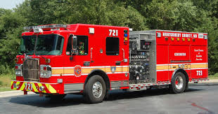
Montgomery County Fire and Rescue Service maintains an large fleet of varying types of apparatus to support the mission of the protecting lives, property, and the environment. A general review of the apparatus specifications is included in this manual.
Montgomery County Apparatus Section
14935 Southlawn Lane
Rockville, MD 20850
240-777-2485

CRIMSON ENGINE:

- Length 32’ 6”, Width 9’ 9”, Height 9’ 6”, Gross Vehicle Weight 47,000 pounds
- Class A engine with Compressed Air Foam capacity
- 750 Gallon Water Tank
- 25 Gallons of Class A foam (Enough for approximately 25000 gallons of finished foam solution)
- 25 Gallons of Class B foam (Enough for approximately 8300 gallons of finished foam solution)
- 1500 Gallon per Minute Hale Q-Max Pump
- 210 Cubic Feet per Minute Compressed Air Foam System (CAFS) Air compressor
- Pre-piped mounted master stream device 500 - 1000 Gallons per Minute capacity
- Mobile Radio, Mobile Data Computer (MDC), 4- Motorola APX Series Portable Radios
- 7.5 Kilowatt Onboard Diesel Generator
- LED lighting package
- 5 person cab designed for rider safety
- Dual auxiliary braking systems for exceptional stopping capability
- Built in Rollover protection devices
- 2000 feet of Large Diameter Hose in dual beds set up for our rural/urban interface
- Drafting ability from 3 sides of the unit via Master Intake Valve’s
- (3) Pre-connected Cross lays
- (3) Pre-connected lines off of the rear step
- (2) Standpipe racks consisting of 200 feet of 2” line
- (2) Standpipe bags consisting of 200 feet of 2 ½” line
- 24’ Extension Ladder, 14’ Ground Ladder, 10’ Attic Ladder
- Standard forcible entry equipment

Tanker:

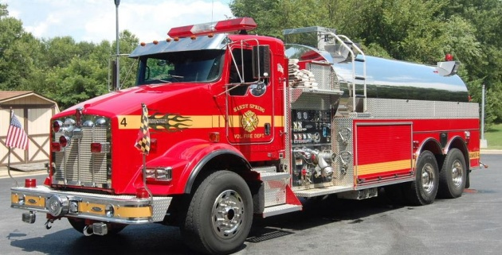

- Length: 34'11", Width: 9’5”, Height: 10’ 7.5”, Gross Vehicle Weight 70,000 pounds
- 3500 gals of water
- 1250 Gallons per Minute pump
- 3 total water dump chutes, 1- 8" dump per side, 1- 10" dump in rear
- 1 - 3500 gal portable folding tank. Deployable via electric lift.
- 2 - 6" x 10' hard sleeves. 2 - 2.5" x 10' hard sleeves
- 235 Gallons per Minute floating pump, 8 Horse Power
- Mobile Radio, Mobile Data Computer (MDC), 2- Motorola APX Series Portable Radios
- 200' 2" crosslay with 175 Gallons per Minute fog nozzle
- 200' 3" crosslay with gated wye
- 2 Self Contained Breathing Apparatus
- assortment of hose adaptors
- 2 - large diameter rear water intakes

Pierce Tractor-Drawn Aerial:
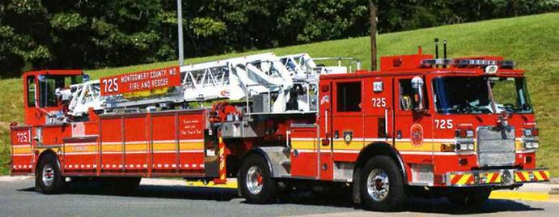
- Length 59’, Width 9’5”, Height 11’, Gross Vehicle Weight 63,000 lbs
- 100 foot Heavy Duty Aerial ladder
- 174 feet of ground ladders
- Mobile Radio, Mobile Data Computer (MDC), 4- Motorola APX Series Portable Radios
- 15 Kilowatt On-Board Generator
- Vehicle Extrication Equipment (Jaws of Life)
- Rope Rescue Equipment-2 rigging bags, 3-200’ lifelines, bag with helmets and harnesses
- Stokes Basket with accessories including ridged backboard
- Pierce anchoring system for stokes basket
- Air Bags: 1 – 1 Ton, 2 – 5 Ton, 2 – 20 Ton; 2 – 40 Ton
- Wood Cribbing and Shoring including Paratech Struts
- Chains and Ratchet Straps for vehicle stabilization
- 500 - 1000 Gallon per Minute capacity elevated master stream
- Portable lighting and power
- Ventilation Fans including 2 -gas fans, 2-electric fans
- Water Rescue equipment including Personal Flotation Devices and Throw Bags
- Downed Firefighter Rapid Intervention Kit and two thermal imaging cameras
- Forcible Entry Equipment
- Elevator Rescue Tools 1 set of elevator keys and elevator pole
- Salvage Equipment - sump pump with 100’ 1 ½” hose
- Overhaul Equipment
- Metro bag and Warning Strobe Alarm Device
- Electric and air cord reels - 2- 200’ on board cord reels. 50’ air hose with regulator
- Gas powered saws for wood, metal, and concrete
- Complete set of Dewalt battery operated hand tools
- Various small hand tools, screw drivers, wrenches, etc. for rescue utilization
- Note: This unit has extreme maneuverability

Pierce All-Steer Aerial Tower:
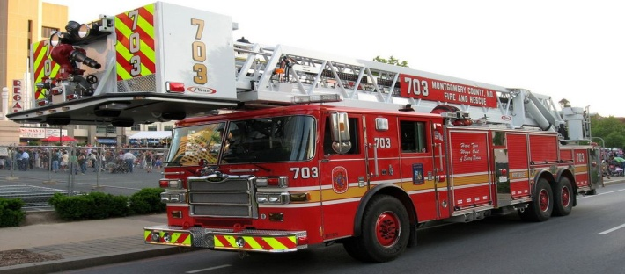
- Length: 47’, Width: 9’5”( with jacks 17’5”), Height: 11’7”, Gross Vehicle Weight 72,000
- 100 foot Heavy Duty Aerial ladder with 1000 pound capacity bucket
- Bucket capacity -3 person no water flowing, 2 person w/1000 Gallon per Minute flowing
- 158 feet of ground ladders-1-14’ 1-16’, 1-20’, 1-28’, 2-35’
- Mobile Radio, Mobile Data Computer (MDC), 4- Motorola APX Series Portable Radios
- Rope Rescue Equipment-2 rigging bags, 3-200’ lifelines, bag with helmets and harnesses
- Stokes Basket with accessories including rigid backboard
- Pierce anchoring system for stokes basket
- Pierce brackets for “life ladder” used with 16’ ladder for parapet operations
- Wood cribbing- 12- 4”x4” and 12-2”x4” for supplemental stabilization for outriggers
- 15 Kilo-Watt on board generator, 2 portable Honda Gen-lights 1000 Watts
- 2000 Gallon per Minute elevated master stream
- Portable lighting 4- 500 Watt lights, 2- 75’ electrical cords, 2-50’ electrical cords
- Ventilation Fans 2- gas fans 18,500 Cubic Feet per Minute , 2-electric fans 12,000CFM
- Forcible Entry 2 complete sets of irons and 2 hydra-rams, misc. hand forcible entry tools
- Downed Firefighter Rapid Intervention Kit and two thermal imaging cameras
- Elevator Rescue Tools 1 set of elevator keys and elevator pole
- Salvage Equipment- sump pump with 100’ 1 ½” hose
- Overhaul Equipment 4 various sized blue tarps and 1 canvas throw tarp
- Metro bag and Warning Strobe Alarm Device (WSAD)
- Electric and air cord reels- 2- 200’ on board cord reels. 50’ air hose with regulator
- Gas powered saws for wood, metal, and concrete. 2 Partner K950 with metal blade and combination blade. 2 Cutters edge saws with carbide tip and Bullitt chains. 1 Sthil saw with carbide tip chain. Saw box with accessories. All saws run on 2 stroke gas 50/1 mix
- Battery Powered Tools- Complete set of Bostch battery operated hand tools

Pierce Rescue Squad:
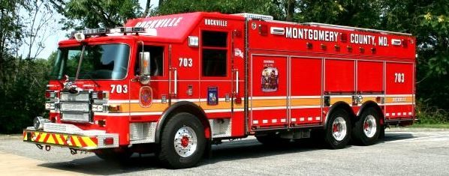
- Length 38’ 2”, Width 96”, Height 10’ 6”, Gross Vehicle Weight 62,000 pounds
- Cummins ISM 450 Horsepower diesel engine, Allison automatic transmission.
- 6- Riding positions all facing forward
- Equipped with Roll Stability Technology, Passenger restraint Technology and Driver/officer side curtain air bags as well as rear outboard side curtain air bags.
- Standard firefighting equipment such as Self Contained Breathing Apparatus, portable hand lights, and hand tools for each of the six (6) riding positions
- A state of the art Hurst hydraulic rescue tool system (Jaws of Life), including six (6) tools pre-connected to reels so that each tool is "hot" and ready to use immediately on arrival. In addition, multiple gasoline powered portable power units assure the tools can be used remote from the apparatus.
- 35 Kilowatt Power Take Off generator and 20 Kilowatt Diesel back-up generator for all lighting, electrical tools, and other electrical power needs.
- 9,000 watt Wilburt light tower
- Paratech Rescue Strut package - use in vehicle, trench rescue, and building collapse
- Heavy rigging equipment component including numerous heavy duty chains, rigging slings, come-a-longs, anchoring devices, portable winches, etc.
- Stationary anchoring points on four (4) sides of the apparatus, top and bottom, for securing unstable vehicles and other objects.
- Water and ice rescue equipment, including dry suits and ice rescue suits to protect personnel from the effects of contaminated flood water, extreme cold water and weather, and icy environments.
- High angle rescue equipment such as ropes, pulleys, harnesses, stokes baskets, etc., for rescue from high-rise buildings, steep embankments, structural power and water towers, rock cliffs, etc.
- A heavy duty air plasma cutting system and Petrogen cutting torch, both for cutting different types of thick structural steel and aluminum.
- Downed Firefighter Rapid Intervention Kit and two thermal imaging cameras
- A 16.2 CFM on-board air compressor and a portable Scott Air Cart to power an assortment of pneumatic cutting, lifting, and burning tools, in addition to ½” and ¾”pneumatic impact guns for dismantling large truck tires and heavy equipment.
- A full complement of high and medium pressure power lifting bags for lifting anything from cars to concrete to trains, and anything in between.
- Concrete cutting and chipping equipment for lightweight structural collapse
- Wood cribbing and shoring materials for stabilization of vehicles, heavy machinery, structural building collapses, etc.
- Confined space rescue equipment such as atmospheric monitoring devices, ventilation systems, patient evacuation systems,
- Hurst Hydraulic Power Lifting Cylinders, lifting capacity 1000,000 pounds
- Various small hand tools, screw drivers, wrenches, etc. for rescue utilization
- Numerous firefighting tools including ventilation fans, fire extinguishers, fire/rescue roofing saws, ladders, interior and exterior lighting units, etc.

Freightliner/International Advanced Life Support (Ambulance):

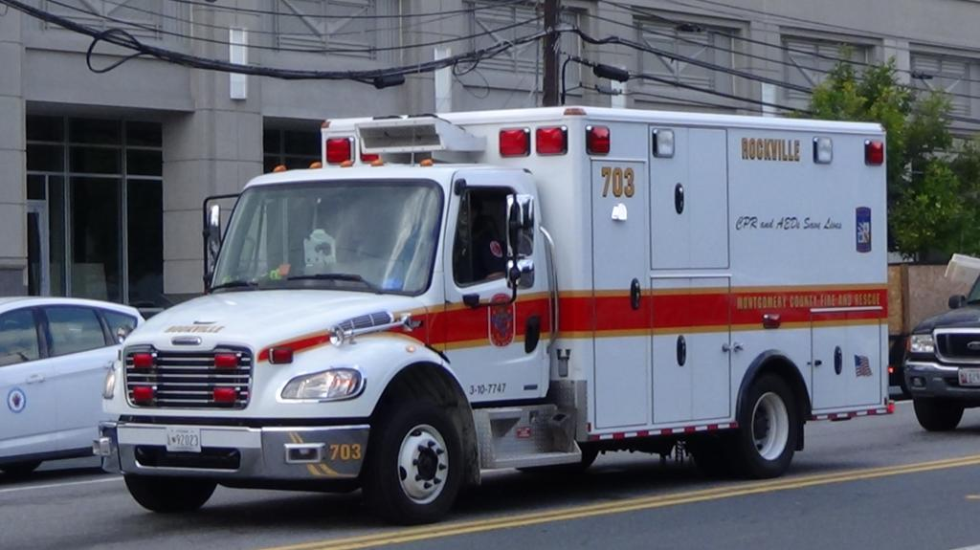

- Length 23’ 6”, Width 9’ 6”, Height: 10’ 6”, Gross Vehicle Weight 15,500 pounds
- Mobile Radio, Mobile Data Computer (MDC), 2- Motorola APX Series Portable Radios
- Germicidal Air Purification System
- 2- Traffic Safety Vests
- Navigational Aids (Maps, GPS, County Red Book)
- 1- Onboard “M” size Oxygen Cylinder with Zico electric oxygen tank lift
- 2- Portable “D” Size Oxygen Cylinder
- Onboard Suction and supplies
- 1- Reeves Stretcher
- 1- Child Car Seat
- Long Board Splints
- 1- Stair Chair
- 2- Survivor Lights, 1- Light Box
- 2- Scott Self Contained Breathing Apparatus
- Physio-Control AED LifePak 1000,
- 1- Portable Suction, Mass Casualty Incident Triage Bag
- 1- Fire Extinguisher and Road Flares
- 1- Tool Box/Bag
- 2-Long Spine Board and splinting equipment
- Short Spine Board, Kendrick Extrication Device
- 1- Ferno Scoop Stretcher
- 1- Ferno Patient Stretcher with 750 pound capacity
- Green Oxygen bag to include airway masks, BVM, BLS medications and Glucometer
- BLS Medications
- Onboard Suction and supplies
- BLS Airway Management Supplies
- 2-Obstetric Kits/Supplies
- BLS Trauma Supplies
- Immobilization Bag includes cervical collars and spinal precautions equipment
- Splinting Equipment
- Burn Management Supplies
- Infectious Control/Body Surface Isolation Supplies

Freightliner/International Advanced Life Support (Medic Unit):
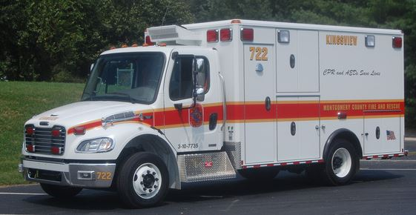
- Length 23’6”, Width 9’ 6”, Height: 10’6”, Gross Vehicle Weight 15,500 pounds
- Mobile Radio, Mobile Data Computer (MDC), 2- Motorola APX Series Portable Radios
- Germicidal Air Purification System
- 2- Traffic Safety Vests
- Navigational Aids including maps and Global Positioning System Device
- 1- Onboard “M” size Oxygen Cylinder with Zico electric oxygen tank lift
- 2- Portable “D” Size Oxygen Cylinder
- Onboard Suction and supplies
- 1- Reeves Stretcher
- 1- Child Car Seat
- Long Board Splints
- 1- Stair Chair
- 2- Survivor Lights, 1- Light Box
- 2- Scott Self Contained Breathing Apparatus
- 1 – Physio Control LifePak 15, portable monitor/defibrillator
- 1- Portable Suction, Mass Casualty Incident Triage Bag
- 1- Fire Extinguisher and Road Flares
- 1- Tool Box/Bag
- 2-Long Spine Board and splinting equipment
- Short Spine Board, Kendrick Extrication Device
- 1- Ferno Scoop Stretcher
- 1- Ferno Patient Stretcher with 750 pound capacity
- Green Oxygen bag to include airway masks, BVM, BLS medications and Glucometer
- Advance Life Support Bag- includes I.V. Kit’s, and over 30 Emergency Medications
- Advance Life Support Airway Bag- Airway kits, Emergency Intubations with Cameras, Emergency Cricothyrotomy Kits, Emergency Pneumothorax Kits
- Trauma Bag includes bandaging, cervical collars and spinal precautions equipment
- Onboard Suction and supplies
- BLS Airway Management Supplies
- 2-Obstetric Kits/Supplies
- BLS Trauma and Burn Management Supplies
Medical Ambulance Bus (MAB):
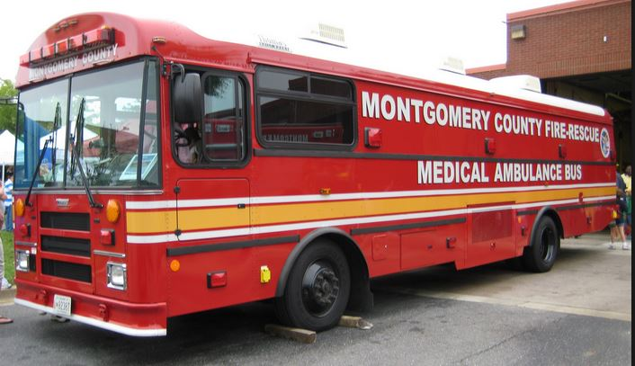

Montgomery County Fire/Rescue has 2 medical ambulance buses assigned to fire stations 22 and 26. The buses are a 2007 Thomas Bus with conversion by Spartan industries. These units enhance the Metropolitan Washington regional capability to deliver on-scene mass casualty care. These units are a set of 5 that were purchased with Urban Area Security Initiative (UASI) Federal grant funds. The other 4 units are located in Fairfax, Prince Georges, Arlington, and the District of Columbia.

- Length 37’, Width 9’ 6”, Height 12’ 4”, Gross Vehicle Weight 33,480 pounds
- Capability for twenty littered patients, with litters rated for 350 pounds.
- Removable articulating rear ramp.
- Eight “K” oxygen cylinders providing 15 liters per minute of oxygen for 16 patients, for up to a total of 3 hours.
- Liter flow controls for each patient.
- External inlet to feed oxygen from an external source to the medical ambulance bus.
- 12.5 Kilowatt generator.
- External inlet to provide shoreline electrical power to the medical ambulance bus.
- BLS patient treatment supplies.
- 2 bariatric cots with the capability to hold a patient 1100 pounds in the down position and 700 pounds in the raised position.

Mass Casualty Support Unit (MCSU):
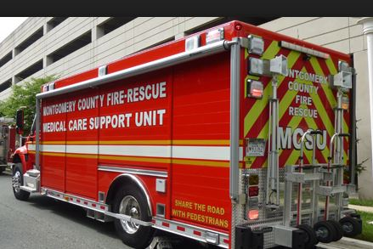

Montgomery County Fire/Rescue has 2 mass casualty support units assigned to fire stations 22 and 26. The support unit is a 2007 International chassis with a Hackney body. These units enhance the Metropolitan Washington regional capability to deliver on-scene mass casualty care. These units are a set of 5 that were purchased with Urban Area Security Initiative (UASI) Federal grant funds. The other 4 units are located in Fairfax, Prince Georges, Arlington, and the District of Columbia. The unit has the following equipment onboard:

- Length 30’, Width 9’ 6”, Height 10’ 2”, Gross Vehicle Weight 35,000 pounds
- Four body-mounted portable 750 watt flood lights.
- Two awnings that automatically retract when the wind exceeds 18 miles per hour.
- Automatic traction control and differential lock.
- Two hand carts mounted on the rear.
- One V-MUX Multiplex control module in cab for all operations.
- Mass casualty supplies adequate for 10 patients, including:
- 80 backboards with spinal immobolization straps.
- 40 field stretchers.
- Tarps, cones, and flags color-coded for triage areas.
- 4 “M cylinder oxygen tanks with distribution system.
- 4 2,000 watt portable generators with a light attached.

The cache has supplies apportioned for 50 patients on each side of the unit. The supplies are in containers that are color coded for triage. Additional supplies are provided in clear plastic containers.

Hazardous Materials Unit:
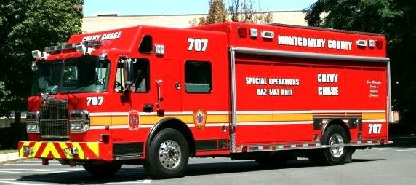
- Length 34' 6", Width 10' 1", Height 11' 6", Gross Vehicle Weight 44,000 pounds
- Mobile Radio, Mobile Data Computer (MDC), 4- Motorola APX Series Portable Radios
- 4 riding positions
- Designated Command Research Area
- Radio and Data signal Communications.
- Climate controlled storage in cab area
- 10 weather resistance roll up storage areas
- Interior adjustable shelving
- Exterior awning
- Built in absorbent storage
- Self contained stairway
- Top coffin weather resistance storage
- Power Take Off (PTO) driven Generator
- Light Tower
- Personnel Protective Assembles from Level A to Level D
- Self Contained Breathing Apparatus
- Communications for riding and entry position with in -suit capability
- Medical monitoring
- Air Monitoring sensors for single or multi gas
- Photoionization Detection
- Powdered classification
- WMD for Chemical and Biological
- Radiation detection for personnel or area
- Liquid transfer equipment
- Diking, damming ,plugging capabilities
- Over packing capabilities
- Decontamination equipment for simple to multi-stage arrangements

Mobile Air Unit:
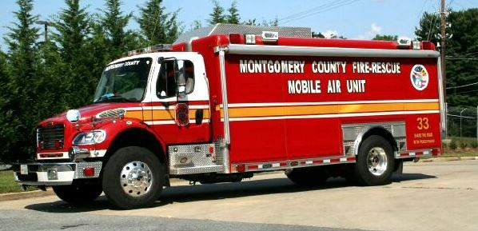
- Length: 31’6”, Width: 9’, Height: 10’, Gross Vehicle Weight 33,000 pounds
- Mobile Radio, Mobile Data Computer (MDC), 2- Motorola APX Series Portable Radios
- Driven by 3 cylinder diesel motor
- Fuel Capacity: 50 Gal.
- 6000 Pounds per Square Inch Breathing Air Compressor
- 4 Breathing air cylinder Cascade System
- 5 Breathing air cylinder cart
- Air Cylinder Filling Station
- 20- Spare Self Contained Breathing Apparatus Cylinders
- 200’ 6000 pounds per square inch (PSI). Air Line on Reel
- 250’ 6000 PSI. Portable Air Line
- 3- Self Contained Breathing Apparatus
- Generator: 50 Kilowatt Winco Model 50CDS 120/240
- Electrical Grounding Cable with stake
- 6000 Watt Light Tower (4 1500 Watt lights) with remote control
- Portable 500 Watt Quartz Light
- 2- 200’ 10/3 Electric Cord on Reels
- 1- 300’ 10/3 Electric Cord on Reel
- 1- 25’ 3 Prong Electric cord
- 4- 50’ 3 Prong Electric Cords
- 9- Electrical Pig Tale Adapters
- 1- 20 Electric Smoke Ejector
- 1- 24” Electric Smoke Ejector
- 1- 18” Gas Blower
- 1- 50’ Polypropylene Rope
- Cab: Maps, Hazmat Response Guide, Montgomery/PG Radio and Portables
- 1- Tool Box
- Traffic Triangles
- Wheel Chocks
- 1- 20 pound ABC Dry Chemical Extinguisher

Bomb Unit:
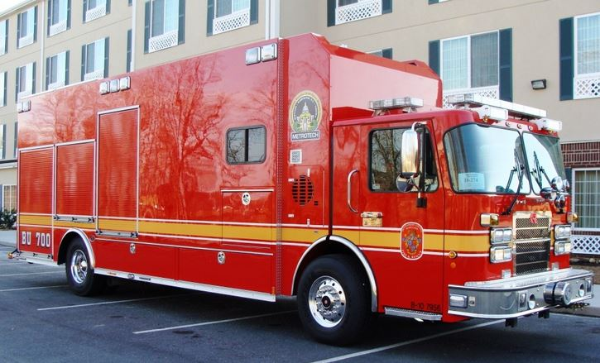
- Length: 37’, Height: 12’ 8”, Width: 9’ 5”, Gross Vehicle Weight 47,000 pounds
- Mobile Radio, Mobile Data Computer (MDC), 2- Motorola APX Series Portable Radios
- ONAN 20 Kilowatt on board generator
- Fully automatic awning on Drivers side
- 20’ Mast video camera
- 20’ Light tower
- Multiple platforms and kits for use in Fire and Explosion investigations
- Inventory list limited for security concerns

Chesapeake Model Rescue Boat:
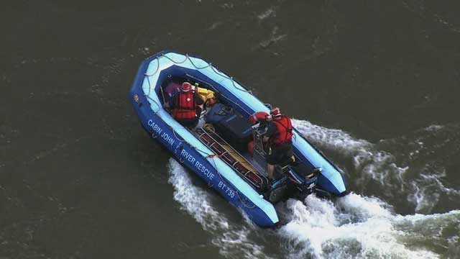

- Length: 17’2”, Width: 7’10”, Weight 625lbs (w/ Engine) 375lbs (w/o Engine), Power Rating 80 Horsepower
- Designed working load 3000 Pounds, Maximum buoyancy 7200 Pounds
- 65 Horsepower Mercury Jet Drive Outboard Engine (4 cycle)
- Mobile Radio capable of Multi-Jurisdictional Communication
- Rope Rescue Equipment- Rigging bag, 1-150’ lifeline, 1-150’ utility line
- Stokes Basket with accessories including rigid backboard and Helicopter Bridle
- EMS First Aid Bag including Oxygen Cylinder and Emergency Blankets
- 2 Life Rings, Cinch ring collar, 4 throw bags
- 4 Patient Personal Flotation Devices and Helmets
- 4 Paddles, 2 Walking Poles, Gaff Hook
- 45 min high pressure SCBA cylinder with Air Regulator and Fill hose
- Spot Light
- Air Horn, Flare Gun, Glow sticks, and Dye Markers
- Tool Box
- Manufactured by Demaree Inflatable Boats (DIB)

Rescue Sled Style Boat:
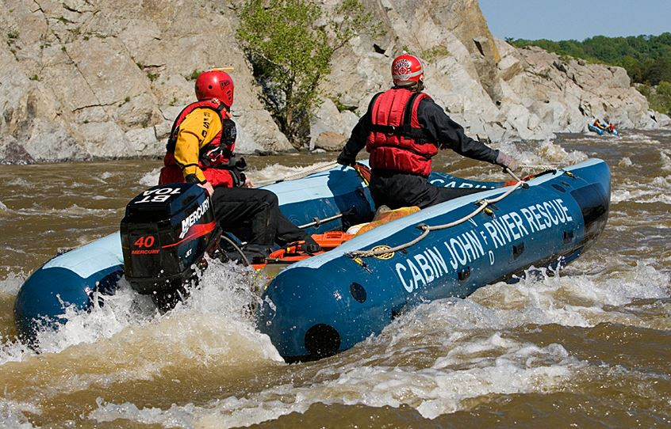

- Length: 14’ 6”, Width: 7’ , Weight: 475lbs (w/ engine) 225lbs (w/o engine)
- 40 Horsepower Mercury Jet Drive Outboard Engine (4 cycle)
- Rope Rescue Equipment- Rigging bag, 1-150’ lifeline, 1-150’ utility line
- EMS First Aid Bag including Oxygen Cylinder and Emergency Blankets
- 2 Life Rings, Cinch ring collar, 4 throw bags
- 4 Patient Personal Flotation Devices and Helmets
- 4 Paddles, 2 Walking Poles, Gaff Hook
- Spot Light
- Air Horn, Flare Gun, Glow sticks, and Dye Markers
- Tool Box
- Manufactured by Demaree Inflatable Boats (DIB)

Airboat:
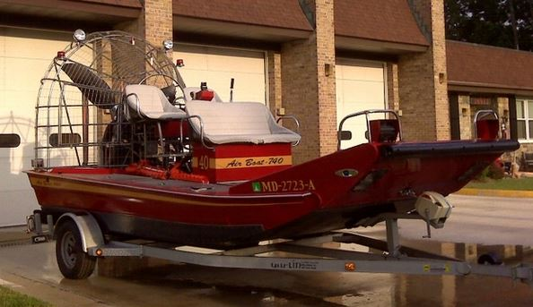

- Length 20’ 6", Width 8' 4", Transom 24” Height 9’ without trailer, 10’ 8” on trailer
- 8 persons or 1600 pounds rated capacity
- Hull Construction: Welded Marine grade aluminum alloy with bottom and side T-bar stiffeners.
- Engine: 350 CI V-8 Gasoline Engine, 300 Horse Power,
- Fuel Capacity: 40 Gallons, Oil Capacity: 5 Quarts
- Gauges: Tachometer, Temperature, Oil Pressure, Voltmeter
- Bilge Pumps: (2) automatic activated with manual override switch on dash.
- Lighting: Coast Guard approved running lights (fore & aft). Auxiliary halogen
- 1- Spare Tire, 2- Wheel Chocks
- Mobile Radio capable of Multi-Jurisdictional Communication
- Bow line with Bag
- Anchor with Rope
- Rescuer/Patient entry ladder
- Patient Rescue Body Ramp
- Life Ring with water rescue throw bag
- 1- Fire extinguisher
- 2- Rescue Hammers for rescue of patients from vehicles in the water
- 4- Sets of hearing protection
- 2- Water rescue rope throw bags
- 3- Sets of Patient water protective equipment including life vests and helmets.
- 3- Rescuer hand lights
- 1- Binoculars
- 2- Victim recovery bags
- 20- Color coded cyalume light sticks
- Patient/Victim marking spray paint can for search procedures
- 1- Tool Box with assorted small tools

Engine Tanker:
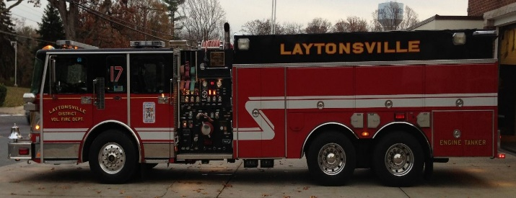
- Length: 35’ 6”, Width: 9’ 1”, Height: 10’-1”, Gross Vehicle Weight 64,000 pounds
- 1,750 Gallons per Minute Hale pump
- 2,000 Gallon Water Tank
- 50 Gallon Class “B” Foam Tank (Enough for approximately 16600 gallons of finished foam solution)
- 2,100 Gallon Portable Folding Water Tank
- 1,800’ of 4” Large Diameter Supply Hose
- 2- 200’ of 1 ¾” Attack Line (pre-connect)
- 1- 250’ of 1 ¾” Attack Line (pre-connect)
- 1- 250’ of 2” Attack Line (pre-connect)
- 1- 250’ of 3” Attack Line (with blitz fire nozzle) (pre-connect)
- 1- 300’ booster hose (pre-connect)
- 2- Side Water Dump Chutes
- 1- Rear Dump Water Dump Chute
- Mobile Radio, Mobile Data Computer (MDC), 4- Motorola APX Series Portable Radios
- 10 Kilowatt Power Take Off on board generator
- Fixed 1,000 watt flood lights
- 2- 150’ pre-connected electric cord reels
- 2,000 watt portable generator with 500 watt fixed light
- 50’ portable electric cord reel with 500 watt fixed light
- 24’ Extension Ladder, 14’ Ground Ladder, 10’ Attic Ladder
- Forcible Entry- 1 set of irons, 1 hydra-ram
- Metro bag

Brush Engine:
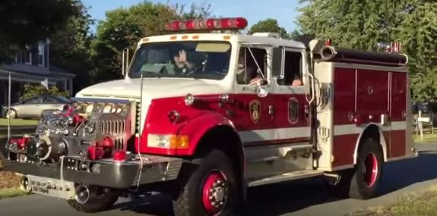
- Length: 27’ 6” , Width: 7’ 9”, Height: 9’ 5”, Gross Vehicle Weight 39,000 pounds
- Mobile Radio, Mobile Data Computer (MDC), 4- Motorola APX Series Portable Radios
- 750 Gallon per Minute Hale single-stage front mount pump
- 500 gallon water tank
- “Pump and Roll” capability
- Four Wheel Drive
- 4 person front facing seating
- 2- 200’ of 1 ¾” Attack Line (pre-connect)
- 1- 200’ of 2” Attack Line (pre-connect)
- 1- 150’ of 1” Booster Reel Line (pre-connect)
- 600’ – 3” Supply Line
- 1500’ – 4” Large Diameter Supply Line
- 3 – 10’ Hard Sleeve Drafting Line
- 48 feet of Ground Ladders:
- 14’ Roof Ladder
- 24’ Extension Ladder
- 10’ Folding Attic Ladder
- On board 110 volt inverter
- 5 Kilowatt portable generator
- 2- 500 Watt Portable Tripod lights
- Stihl MS260 Chainsaw
- Pro-Pak portable foam system
- Standard forcible entry equipment

Brush Truck:
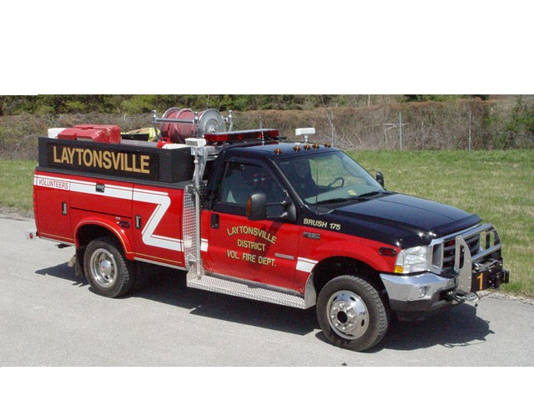
- Length: 21’ 8”, Width: 9’ 1”, Height: 7’ 10”, Gross Vehicle Weight 13, 880 pounds
- 400 Gallon per Minute pump
- 300 Gallon Tank
- Mobile Radio, 2- Motorola APX Series Portable Radios
- 200’ of 3” Supply Hose
- 400’ forestry hose
- 150’ of 1 ¾” hose
- 1- 300’ booster hose
- 3500 watt on board generator
- Fixed 500 watt flood lights
- Portable 500 watt light
- Sthil chain saw
- 12,000 pound capacity electric winch

Rescue Engine:
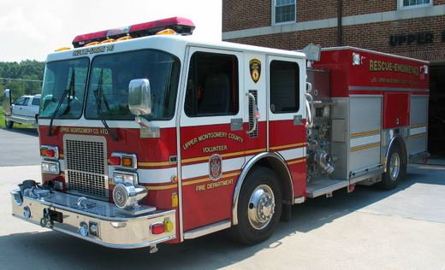
- Length 37’ 4”, Width 9’ 9”, Height 10’ 2”, Gross Vehicle Weight 63,,000 pounds
- Class A engine with Compressed Air Foam capacity
- 1500 Gallon Water Tank
- 2000 Gallon per Minute Hale Q-Max Pump
- Pre-piped mounted master stream device 500 - 1000 Gallons per Minute capacity
- Mobile Radio, Mobile Data Computer (MDC), 4- Motorola APX Series Portable Radios
- 20 Kilowatt Onboard Diesel Generator
- Will Burt 6,000 Watt Pole Light Tower with 4 – 1500 watt lights
- 1 – 250’ Electric Cord Reel
- 1 – 200’ Electric Cord Reel
- Portable lighting and power
- 2050 feet of 4” Large Diameter Supply Hose
- (3) Pre-connected Cross lays
- (2) Pre-connected lines off of the rear step
- (1) Standpipe racks consisting of 150 feet of 1 3/4” line
- 24’ Extension Ladder, 14’ Ground Ladder, 10’ Attic Ladder
- Standard forcible entry equipment including Halligan Bar, Axe, and Rabbit Tool
- A state of the art Hurst hydraulic rescue tool system (Jaws of Life), including pre-connected to reels so that each tool is "hot" and ready to use immediately on arrival.
- Paratech Rescue Strut package - use in vehicle, trench rescue, and building collapse
- 26 Ton Air Bags
- Cribbing and Shoring for vehicle stabilization
- Chains and Ratchet Straps for vehicle stabilization
- Ventilation Fans
- Lock out/Tag Out kit
- Rope Rescue Equipment including Rigging Bags and Lifeline
- Complete set of Dewalt battery operated hand tools
- Water Rescue equipment including Personal Flotation Device’s and Helmets
- Rescue Air tool compliment
All Terrain Vehicle:
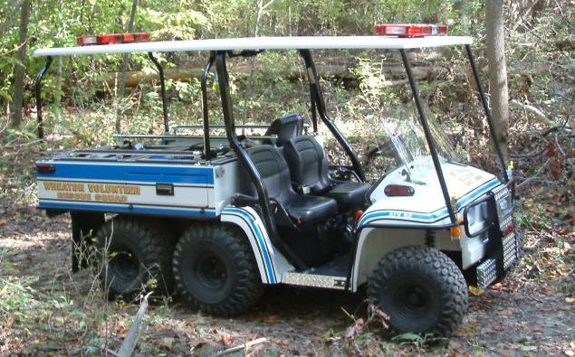
- Length: 10’ 2", Height: 70”, Width: 60” Gross Vehicle Weight 2487 pounds
- Capable of carrying a patient and 3 fire department personnel
- Also used to carry and deliver equipment and personnel off road
- Has a compliment of BLS equipment
- Can be outfitted with ALS equipment
- Towed to scene using an open trailer and pickup truck or SUV
- Deployed from trailer in under 2 minutes

Emergency Medical Services Supervisor:
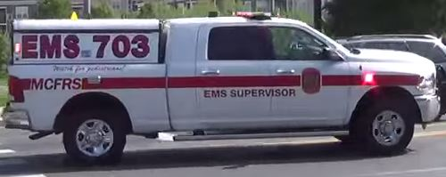
- Length: 21’, Width:8’ 3”, Height: 6 ’9”, Gross Vehicle Weight 9000 pounds
- Seating for 6 people with headsets for 2. Can be used as Command platform
- 2 Mobile Radios, Mobile Data Computer (MDC), 1- Motorola APX Series Portable Radio
- Maryland state Medical Radio
- Lucas CPR device
- Complete set of Advanced Life Support gear.
- Continuous Positive Airway Pressure (CPAP) Therapy Device.
- King Vision Video Laryngoscope
- Multi-Casualty Incident equipment with flags, vests, colored tarps, colored ribbons and triage tags, and Patient Tracking forms
- Spare complete LifePak 15 to be used as loaner unit
- Basic water rescue gear, Personal Flotation Device, Throw Bag
- Secured box with Morphine and Versed for field distribution as needed
- 2 DUO Dote Kits
- Cyano Kit – Cyanide Poising antidote kit
- Spare LifePak 15 accessories (12 lead cables, 3 lead cables, pulse ox and rainbow cables, BP cuffs, Spare Batteries)
- Self Contained Breathing Apparatus
- Halligan bar
- 2 Streamlight Flash lights
- Emergency Kit with pre-paid Gas cards, food cards, visa cards and cash
- RAD 57 meter, Carbon Monoxide Meter

