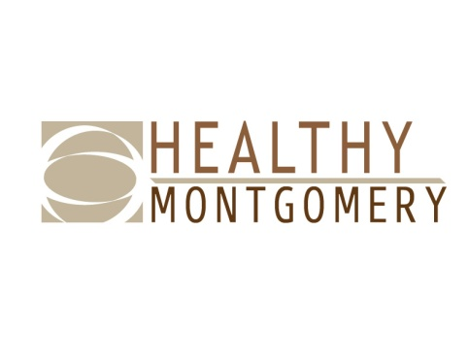
Healthy Montgomery Steering Committee Meeting
Ingleside at King Farm
701 King Farm Blvd, Rockville, MD 20850
Monday, April 9, 2018 ■ 6:00PM-8:00PM

Members and Alternates Present: Uma Ahluwalia, Raymond Crowel, Monika Driver, Travis Gayles, Leslie Graham, Michelle Hawkins, Denise James, Vicki Kane, George Leventhal, Kimberley McBride, Kathy McCallum, Kate McGrail, Nguyen K. Nguyen, Cesar Palacios, Diana Saladini, Monique Sanfuentes, Michael Stoto, Elijah Wheeler

Healthy Montgomery Staff: Rita Deng, Karen Thompkins

IPHI Staff: Michelle Caruso, Julia Groenfeldt, Evelyn Kelly, Michael Rhein

Guests: Vince Cobb, Ana Cortes (phone), Jessica Curtis, Jamie Dirksen, Brianna Downing, Beth Geno, Vincent Gibbs, Mouhanad Hammami, Emily Heberlein, Kate McGrail, Linda McMillan (phone), Sanjana Quasem, Sara Safi, Jenny Vidas

Meeting materials made available online or provided at the meeting:
- Agenda
- February 5 Draft Minutes for Approval
- Strategic Alignment Behavioral Health Report Overview
- Healthy Montgomery Strategic Alignment
- Transforming Communities Initiative Overview
- Trinity Community Health Institute Presentation
- Conceptual Geniuses Presentation

Topic/Presenter | Key Points | Action Item/  Responsible Person
Welcome and Opening Remarks, Co-Chair Leventhal | Co-Chair Leventhal welcomed the group and requested that all attendees introduce themselves. | N/A
Approval of February Minutes, Co-Chair Leventhal | The February meeting minutes were approved with no objection. | Upload February minutes to the HM website – HM Staff
HHS Director’s Report Uma Ahluwalia (DHHS) | The 2018 legislative session has ended and there were several health-related bills that may impact the work of HHS and its partners.  The County Executive recently released his FY19 proposed budget. Ms. Ahluwalia held a Community Budget Briefing of the proposed budget. | N/A
Health Officer’s Report  Dr. Travis Gayles, DHHS | The 2018 County Health Rankings Report was released last month. Even though Montgomery County persists as the healthiest county in the state, pockets of disparities remain.  At the recent metro area Public Health Officers meeting, there was discussion of a regional Health Impact Assessment.  Community Forums around the HM priority areas have begun. A cancer forum was held in Silver Spring and attended by 50 individuals. Dr. Gayles is approaching Maternal and Infant health disparities from a different perspective (morbidity vs mortality) by ethnic/racial groups. | N/A
Transforming Communities Initiative (TCI) Michael Rhein & Evelyn Kelly – IPHI  Jamie Dirksen, Trinity Health | IPHI provided an overview of TCI. The TCI Strategy Areas are school health, food access, nutrition standards in early childhood settings, safe routes to school, and tobacco-free living.  Ms. Dirksen provided an overview of Trinity Health system and TCI. Trinity is conducting its annual site visit of the TCI grant awardees. The status of the Montgomery County TCI was given. | N/A
Conceptual Geniuses, Brianna Downing | Conceptual Geniuses has been retained to create a new logo design for Healthy Montgomery. Ms. Downing used HiP Cuyahoga as a case study to demonstrate the potential uses of an enhanced communications profile. | Distribute a survey to the HMSC within the next two weeks. – HM Staff  Present new logo options to HMSC at June Meeting – Conceptual Geniuses.
Behavioral Health and Crisis Services (BHCS) Strategic Alignment Report – Rita Deng, HM and Dr. Crowel, BHCS | Ms. Deng highlighted HM’s current activities in working with the community to meet goals and objectives from the new report, Strategic Alignment: A Collective Vision for Behavioral Health in Montgomery County, Maryland.  Dr. Crowel provided an overview of the strategic alignment plan that resulted from a multi-stakeholder process in 2016 using the appreciative inquiry model. | N/A
Healthy Montgomery Workgroups – Updates  Hospital Workgroup, Monique Sanfuentes  Health in All Policies, Cesar Palacios  Measurement and Evaluation Sub-committee, Michael Stoto  Chronic Disease/TCI, Kimberly McBride | The Hospital Workgroup is reviewing mental health initiatives and existing data gaps. Documentaries such as the S Word can be very helpful in addressing mental health and suicide prevention.  The HiAP workgroup is conducting an environmental scan of departmental websites. HM staff met with Transportation and Housing to review the scan. The workgroup will present at Makeover Montgomery 4 on May 11th. The National Association of City and County Health Officials (NACCHO) will provide technical assistance to the workgroup.  The M&E Subcommittee does not have an update at this time.  Eat Well Be Active (EWBA) is planning implementation meetings to gather information on Chronic Disease CHIP progress. Four meetings will be held in different geographic locations with a goal to include smaller, community-based organizations. The meetings are currently planned for May/June. EWBA will develop an annual progress report for the Chronic Disease section of the CHIP. | N/A
Wrap-Up/Adjourn, Co-Chair Leventhal | The next Healthy Montgomery Steering Committee meeting will be held on June 4th at Ingleside at King Farm (along with all additional 2018 meetings) | N/A

