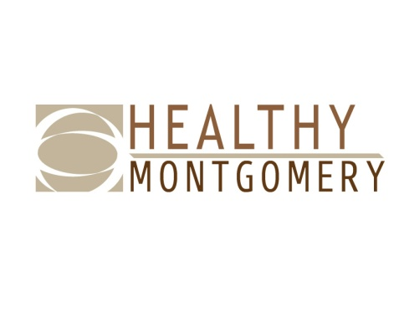
Healthy Montgomery Steering Committee Meeting
Ingleside at King Farm
701 King Farm Blvd, Rockville, MD 20850
Monday, February 5, 2018 ■ 6:00PM-8:00PM

Members and Alternates Present: Uma Ahluwalia, Raymond Crowel, Jackie DeCarlo, Marybeth Dugan, Travis Gayles, Jeff Goldman, Amy Gyau-Moyer, Vicki Kane, April Kaplan, George Leventhal, Amy Lindsey, Marilyn Lynk, Dairy Marroquin, Kimberley McBride, Kate McGrail, Nguyen K. Nguyen, Samuel Oji, Elizabeth Rathbone, Myriam Torrico

Healthy Montgomery Staff: Rita Deng, Dourakine Rosarion, Karen Thompkins

IPHI Staff: Michelle Caruso, Michael Rhein

Guests: Alan Kaplan, Mansfield Kaseman, Chunfu Liu, Sanjana Quasem, Alex Weston

Meeting materials made available online or provided at the meeting:
- Agenda
- Draft December 4th Meeting Minutes (for Approval)
- Final draft of BCC Legislation Document
- Nexus Montgomery Presentation
- Community Health Improvement Plan Interim Progress Report

Topic/Presenter | Key Points | Action Item(s) | Responsible  Person
Welcome and Opening Remarks, Co-Chairs G. Leventhal and J. DeCarlo | The Co-Chairs welcomed the group and requested that all attendees introduce themselves. | N/A
Approval of December 4th Minutes – Action Item, Co-Chairs G. Leventhal and J. DeCarlo | The December 4th meeting minutes were approved with no objection. | Upload December 4th minutes to the HM website. | HM Staff
HHS Director’s Comments, Uma Ahluwalia (DHHS) | The Maryland legislative session has begun. Legislation that may have local impact are HB0726 to establish a state-based health care program and HB0152 to coordinate databases across the state to update voter registration. A final report has been submitted to the State with recommendations to establish Health in All Policies.  To date, 41,983 enrollments were completed during Open Enrollment. There were 146 less clients in comparison to the previous year. The uninsured rate has decreased by 3% amongst ACA-eligible residents.  During a recent townhall meeting with the County Executive, there was a request for more public health efforts to address smoking. | N/A | N/A
Boards, Commission, Committee Designation - Final Review  Uma Ahluwalia (DHHS) | There was a minor edit to the BCC draft document. Members voted unanimously to approve the legislation that will be submitted to the County Executive’s Office. | Submit the proposed legislation to the County Executive’s Office. | HM Staff
Nexus Montgomery - Presentation  Jeff Goldman, Orlando Wright, Susan Donovan, The Primary Care Coalition of Montgomery County | The presentation included an overview of the Nexus Montgomery Regional Partnership and some of the Nexus programs. | N/A | N/A
HHS Health Officer’s Comments  Dr. Travis Gayles (DHHS) | A formal partnership is being developed with the University of Maryland to increase opportunities for student preceptorships, research, grants and partnership development.  A framework for the Departments approach to health prevention and promotion is in development beginning with cataloguing all prevention and promotion efforts taking place across DHHS.  Health forums will take place across the county with a focus on Healthy Montgomery priorities. The HMSC hospital members will host the forums.  The county’s first State of Health Report will be released soon which is a comprehensive report of the health of residents. | N/A | N/A
Montgomery County Community Health Needs Assessment Planning  Rita Deng, Uma Ahluwalia (DHHS) | A summary of the steps of the CHNA process were reviewed. The group discussed possible timeframes for the next CHNA, community outreach and data needs. | Provide a proposed schedule at April session. | HM Staff
Healthy Montgomery Workgroups – Updates  Health in All Policies, Amy Lindsey  Behavioral Health, Raymond Crowel  Chronic Disease/TCI, Kimberly McBride  Measurement & Evaluation Subcommittee, Rita Deng on behalf of Michael Stoto | Working with the Collaboration Council, the behavioral health service provider inventory has been validated and updated with 25 new providers and programs via infoMontgomery that will be integrated via dataMontgomery as a community asset map. Collaborating with EveryMind, overdose intervention training is offered to the public with 18 more trainings to come. ESSENCE and additional data sources from Fire and Rescue/ Police track spikes of overdoses in real time. The BTheOne public education campaign has been launched.  The HiAP workgroup is conducting an environmental scan (by reviewing departmental websites) to identify HiAP initiatives taking place in Montgomery County. The workgroup submitted a proposal to present at Makeover Montgomery 4 - Competitive, Healthy, Inclusive, and Smart Communities.  Eat Well Be Active (EWBA) held a joint meeting with all Transforming Communities Initiative partners and sub-awardees in December. The EWBA Coordinating Committee is engaging in coalition and recruitment planning with a focus on improving community engagement. The EWBA School Working Group is focused this school year on providing insight and guidance for MCPS implementation of Local School Wellness Councils per the new MCPS Wellness Policy. HM and IPHI staff are working together to utilize TCI communications funding to improve Healthy Montgomery branding.  Students from Georgetown University presented proposed hospital service regions at the December 2017 Measurement & Evaluation Subcommittee meeting. The Subcommittee also provided feedback on measures to the Food is Medicine Project and reviewed TCI/ Eat Well Be Active Partnership measures and evaluation tools and plans, and provided feedback to Community Science in January. | N/A | HM Staff
Open Discussion | (none) | N/A | N/A
Wrap-Up/Adjourn, Co-Chairs G. Leventhal and J. DeCarlo | The next Healthy Montgomery Steering Committee meeting will be held on April 9th at Ingleside at King Farm (along with all additional 2018 meetings) | N/A | N/A

