Translation Request Guidelines
When submitting a translation request to the Translations Unit please follow these guidelines.

What is the Translations Unit?
- The Translations Unit is part of the Office of Community Partnerships and provides timely, high-quality translation services and review of translated documents to various county departments. This helps in minimizing cultural and linguistic barriers, promoting community involvement and access to services. The Unit currently provides translations in six languages which are Spanish, Chinese (traditional), French, Amharic, Korean and Vietnamese.

- Before submitting a request, please ensure the content is proofread, in its final form and is written in plain language. A best practice for submitting documents is to ensure that they are complete with no ambiguous and unclear phrases.

- The Translations Unit only accepts the following file formats: MS Word, Excel, PowerPoint, TXT, and HTML. PDF files can be accepted if the document is text only. For PDFs with pictures and graphics, please only send us the text without the image. Consider providing text in a table for translation, as our translation system does not support pictures and graphics. See DocuReady Cover Sheet below for more instruction.

- Ensure that the document you are submitting is not more than 15 pages.

- The unit only provides translations in the six languages listed above, any translation outside of these languages should be sent to your Department’s Language Access Liaison.

- Please submit requests at least 14 business days prior to your expected return date. The return time can vary depending on the length and complexity of projects and current capacity of the Translations Unit.

- Submit your translation request by email to translations@montgomerycountymd.gov and deborah.daymude@montgomerycountymd.gov.

- These guidelines will help the Translations Unit return your translation request on time and ensure that we maintain a high level of quality.

If you have any questions about how to submit a translation request, contact translations@montgomerycountymd.gov or Mark Losha, 240-793-3897 mark.losha@montgomerycountymd.gov.
Thank you for your support and collaboration.

MCG Translations Unit
DocuReady Cover Sheet

To ensure we deliver the best possible translation, please review the following instructions, and complete the checklist on the next page. Once this cover sheet is submitted, we will process your translation request.

Document Formatting
- Text: The text for translation must be in editable, plain text, without formatting, graphics, or images. Consider putting your text into a table in a Word or Excel document.
- Images: If your document includes graphics or images with text, you must also provide that text in a table for translation. This often includes document headers, externally sourced charts and graphs, icons, etc. Please see the example below. Additionally, include the original document or graphic as a reference alongside your Microsoft Word table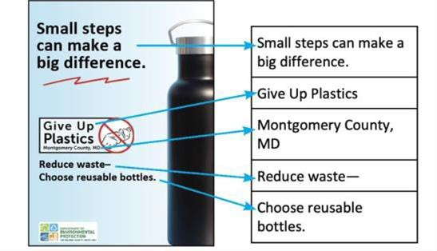

Target language: Which language or languages would you like your document translated into?
Document Purpose & Type: How do you plan to use the translated text? What kind of document or material are we translating? For example: Website content, legal document, brochure, flyer, etc.
Deadline Date: When do you need your translation ready? The Translation Unit requires a minimum of 14 business days to complete most requests, depending on length and complexity.
Terms Glossary: Provide a separate document containing definitions for ALL acronyms, abbreviations, and special nouns such as program names or creative terms. Even terms you think are well-known.
Reference Material: Provide links or attachments for reference material. The reference material should be enough that any person can understand the purpose of the document without any prior knowledge or context. Examples include:
- Links to websites where your department may post the completed translated material
- Source-language (English) materials that might help our team to better understand and process your request
- Topic-specific glossary
- Related content, research materials, and details about the target audience

Checklist for Submission
- The text is in an editable format.
- There are no images in the document containing text for translation.
- I have provided an accompanying document with a table for any text embedded in an image.
- I have provided a separate document explaining all special terms, acronyms, and abbreviations.
- I have included all reference material in my submission.

