Probationary Employee Instructions

Congratulations on completing recruit school and welcome to your probationary packet. Your probationary packet is designed to introduce you to station activities while continuing to develop your firefighting and Emergency Medical skills. This packet will guide you from basic information to complex skills.

Your assigned officer will be the primary contact and source of information while completing your probation. Your shift officer will provide direction and structure, and all questions concerning your probationary packet should be funneled through them. While your officer has the primary responsibility of ensuring that you have adequate time and resources to complete your probationary packet, he/she may not be your primary instructor or preceptor. Your shift officer will provide the most appropriate resources based upon the specific task that you have to complete. You should review your probationary packet with him/her so that you can agree on the best learning method for you.

You will be provided with a timeline to complete your assignments. While the deadlines are listed, keep in mind that the assignments will have to be reviewed by your shift officer prior to presenting the finished product to your Battalion Chief. It is to your benefit to complete your coursework in a timely manner. So that unforeseen complications will not hinder its completion and corrections can be made before forwarding your work to your Battalion Chief.

Your completed packet should have a cover sheet, counseling report, practical sign-off, and written component. (in that order) All forms must be filled out and signed by you and your station officer for each module then attached to your packet for review.

You are encouraged to make the most out of your probationary packet and the learning opportunity that it presents. You are also reminded that at the end of your probationary period you and your assigned station officer will return to the training academy for probationary testing. In order to successfully complete probation, you must pass all testing requirements (Written, Practical, and IPE) and shall obtain your EMS Driver Status. Directions for each module are provided below. You should keep copies of all your coursework and correspondences with your supervisors.

General Knowledge Module
The General Knowledge module is a three (3) week module that will consist of basic station activities designed to prepare the employee for station life as well as fire and EMS skills required for their probationary year. This module will consist of 4 non-staffing shifts. However, completion of skills and written assignments are expected to be completed as outlined on the timeline section by the probationary timeline. The station officer will be required to complete a counseling report at the end of the module. The probationary employee will be assigned to both the ambulance and engine during this module. This will help familiarize them with both units prior to being considered as minimum staffing.

Fire and EMS Modules
The Fire and EMS modules will consist of two three-week periods per each module. The Fire and EMS Modules will contain information, skills and written assignments specific to that particular module. The scheduling of the Probationary Employee’s modules are based upon the sole discretion of the supervisor, but should consider station and battalion resources. If the Fire and EMS Modules are split, please start with Period 1 for each, as they are progressive in nature. The timeline requirements are the same regardless of Fire or EMS modules being split or kept together. The station officer is reminded that a counseling report must be completed at the end of each period as directed on the timeline page. The EMS Period 2 Module has less written work than the other Modules to allow time for the probationary employee to concentrate on obtaining their EMS Unit Driver Certification.

Additional Knowledge and Review
The additional knowledge and review module is a three (3) week module completed just prior to probationary testing. This module is designed to allow the probationary employee, time to complete scenario-based skills as well as written assignments to prepare them for final testing. During this module the station officer is responsible for the completion and reporting of the IPPA which should include review and feedback portions as stated in Article 59 and FCGO 07-18.

Testing
The probationary employee will return to the training academy for probationary testing, which will consist of a two parts: Written/IPE testing and Fire/EMS practical testing. The probationary employee will report to the academy in class ‘C’ uniform. (The probationary employees assigned station officer will be required to accompany the probationary employee to the training academy to participate in the probationary testing process). It is expected that the employee’s assigned officer will participate in the employee’s testing process. The Recruit Training Office will attempt to change test dates to ensure that this can occur.

Journal Entries
The probationary employee will be required to complete a journal entry for each workday. This entry should include incidents that they responded on, observations, drills, Lessons Learned, and what they did for PT. The Journal shall be readily available upon the request at the station. Entries may not violate any law, including HIPPA or FERPA act.

Counseling Report Instructions
The purpose of the counseling reports is to track the progression of the probationary employee; therefore the counseling report should include as much detail as possible. The station officer is required to complete a counseling report at the end of each training module. The station officer should also complete a counseling report if the probationary employee exhibits any exceptional behavior or performance deficiencies, including undesired behaviors

If for any reason a probationary deadline may be missed, the supervisor is to immediately contact the battalion chief, and submit a counseling report documenting the reason(s). The probationary employee should receive copies of all signed and forwarded paperwork.

EMS Unit Driver Requirement
To successfully complete probation the probationary employee must complete all requirements to become a certified EMS Unit Driver. The probationary employee has completed the EVO Couse in Recruit School and will be required to fulfill remaining obligations set forth by policy and procedure 23-07AMII. All questions and test procedures will be directed and handled by the Driving Training Coordinator. (**It is recommended that the probationary employee start this process during the EMS Module - Period 2**)

Physical Fitness Requirements
One of the objectives of the probationary employee training program is to build a solid foundation of wellness. Once the probationary employee leaves the training academy, they are still required and expected to maintain a certain level of fitness. The probationary employee will be required to successfully completed the Incumbent Performance Evaluation within 11 minutes as part of their probationary testing.

MCFRS Incumbent Performance Evaluation Program
The Incumbent Performance Evaluation (IPE) is a self-evaluation of an individual’s ability to physically perform essential functions required in the occupation of firefighting. The Montgomery County Fire and Rescue Service has developed an individual performance evaluation that protects the safety of the fire fighter and provides for the appropriate delivery of fire suppression and rescue services.

This program has been developed in conjunction with IAFF Local 1664 and Montgomery County Fire and Rescue management. The IPE program has been developed to initially provide individuals an opportunity to participate in a self-evaluation of their abilities to physically perform essential functions in the occupation of fire-fighting and to gather data associated with these essential functions during the pilot period.

The IPE consists of 9 events designed to provide a self-evaluation of the incumbent’s physical ability as a fire fighter to operate effectively on an incident scene.

IPE EVENTS:

- personal protective equipment
- ladder carry, raise, extension event
- forcible entry event
- high rise pack event
- stair event
- hand line advancement event
- victim rescue event
- pike pole event
- equipment event

There is a recovery period after completion of each event.

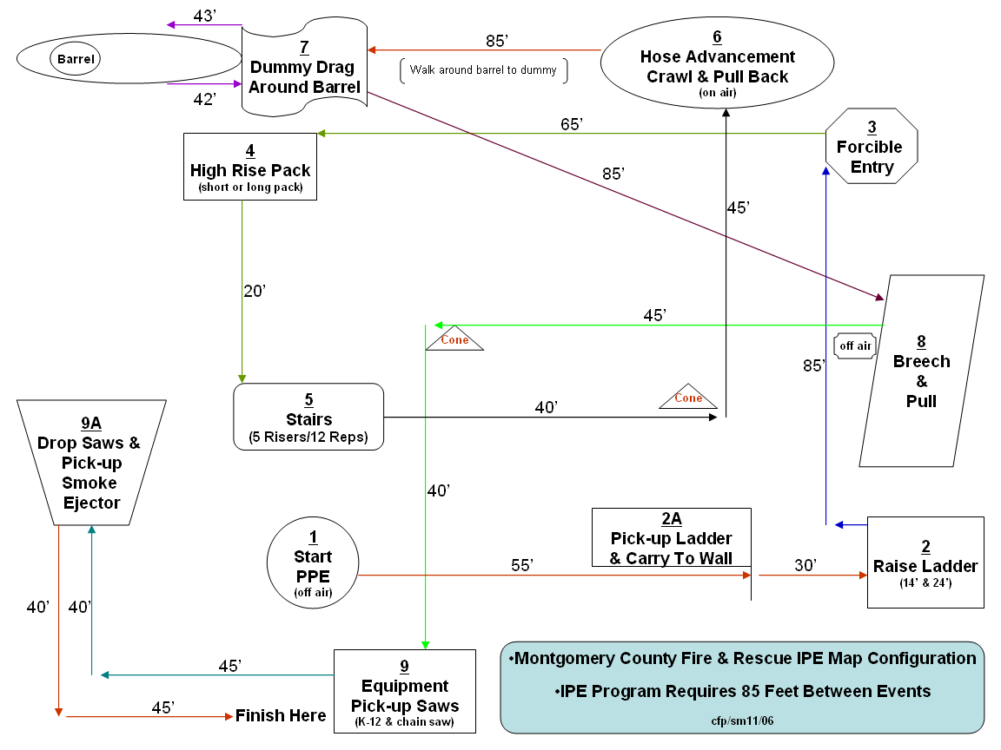

It is also in the best interest of the employee to continue to build upon the level of fitness that they have achieved up to this point. Listed below is a chart of acceptable standard that are given to recruits ending their probationary year. This can be used as a guide to maintaining a level of physical fitness needed for your career. At any point you need assistance you are encouraged to seek help from a peer fitness instructor within the department.

Fitness Component | 70% | 100%
Push ups | 30 | >60
Curl ups | 50 | 90
Pull ups | 3 | >12
Aerobic Capacity (1 ½ mile run) | 12 minutes | <10:00 minutes
Flexibility (sit & Reach) | 11 inches | >22 inches
Grip Strength > | 84 pounds | 124 pounds

