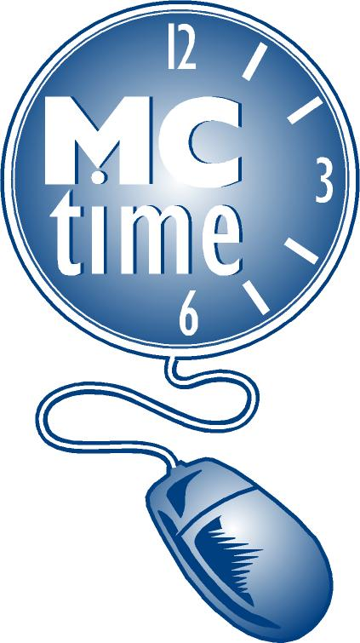 Timecard Correction Request
for Previous Pay Period
 |  | Date Requested
Employee Name (Last, First) |  | Employee #:
Department Name: |  | Department #:
Manager Name: |  | Phone #:
Manager’s Signature:
*Battalion Chief Name & Signature (FRS Only): |  | Phone #:
Pay Period Begins: |  | Pay Period End:
Describe Change Required:

 | Add or Delete Reported Hours for a Specific Date(s)
 |  |  |  | Transfer Codes to Be Charged***
Add/ Delete | Date | Pay Code | Hours | Cost Center | Project Task & Exp Org | Activity Code / Reason Code
EX: Add | 01/04/09 | Hours Worked (should be paid as Overtime) | 1.5 | CC 32590 | PT 2001927-Gen001 50660 | A20  or COR200
MCFRS Personnel Only: Do not send the form directly to Payroll. The Form must be sent to your Battalion Chief for review and approval prior to submitting to fire.mcfrs-mctime@montgomerycountymd.gov .

EMAIL to: Finance, Payroll (financepayroll@montgomerycountymd.gov ) Or FAX: 240-777-8843

*** Note: Timecard correction should not be submitted for accounting purposes. A journal entry should be submitted to General Accounting Section.
NOTE: The correction will appear on the Historical Edit tab (Manager View only) in the Pay Period that when processed and in the grid of the original pay period as a shaded transaction. Employees can view the information in Totals Summary.

FOR PAYROLL TEAM ONLY
- Date Processed Effective Date: ___________________________ By: ___________________
- Include in MCtime totals for:
__ Totals for effective date, current pay rate equals historical pay rate
__ Impact Accruals (use only when Leave codes are affected)
Leave boxes blank if the correction was made in HRMS, and just updating MCtime
__ Sent confirmation email: Correction Completed

