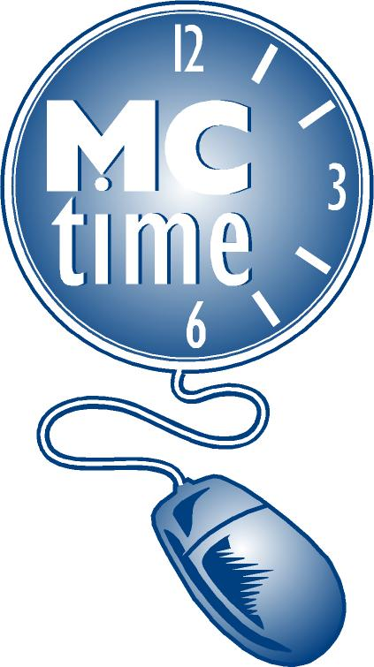MCtime
Department Director Delegation
FY____

Dept. Number |  | Dept. Name

I authorize the following employees to complete and approve all MCtime forms on my behalf for the department.

Name | Signature | Phone | Job Title

I do not authorize any employee to complete and approve any
MCtime forms for the department.

Director’s Signature | ______________________________________

Print Name
__________________________________________________
Date

FOR MCtime FUNCTIONAL TEAM ONLY
Received By: ________________
Date: _______________________

