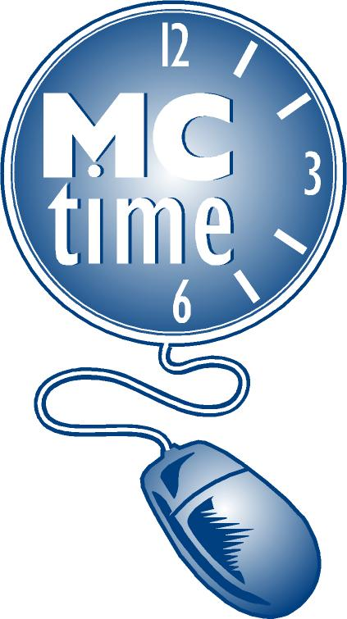Employee Name
Employee ID Number
Department # / Name  Number | Fire Rescue (FRS) #45
Date
Supervisor Signature
Schedule Start Date

Select a Pattern where week A corresponds to Schedule Start Date:

R10 FRS 5 WK, WK 1 –
 | Mo | Tu | We | Th | Fr
A | 10 | 10 | 10 | 10 | -
B | 10 | 10 | 10 | - | 10
C | 10 | 10 | - | 10 | 10
D | 10 | - | 10 | 10 | 10
E | - | 10 | 10 | 10 | 10

R10 FRS 5 WK, WK 2
 | Mo | Tu | We | Th | Fr
A | 10 | 10 | 10 | - | 10
B | 10 | 10 | - | 10 | 10
C | 10 | - | 10 | 10 | 10
D | - | 10 | 10 | 10 | 10
E | 10 | 10 | 10 | 10 | -

R10 FRS 5 WK, WK 3
 | Mo | Tu | We | Th | Fr
A | 10 | 10 | - | 10 | 10
B | 10 | - | 10 | 10 | 10
C | - | 10 | 10 | 10 | 10
D | 10 | 10 | 10 | 10 | -
E | 10 | 10 | 10 | - | 10

R10 FRS 5 WK, WK 4
 | Mo | Tu | We | Th | Fr
A | 10 | - | 10 | 10 | 10
B | - | 10 | 10 | 10 | 10
C | 10 | 10 | 10 | 10 | -
D | 10 | 10 | 10 | - | 10
E | 10 | 10 | - | 10 | 10

R10 FRS 5 WK, WK 5
 | Mo | Tu | We | Th | Fr
A | - | 10 | 10 | 10 | 10
B | 10 | 10 | 10 | 10 | -
C | 10 | 10 | 10 | - | 10
D | 10 | 10 | - | 10 | 10
E | 10 | - | 10 | 10 | 10

For MCtime Functional Team Only:

Processed By: ___________ Date: _____ Notified: ________ Reviewed By: _________ Date: _________
Form Created: 5/5/22

