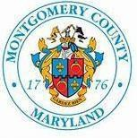
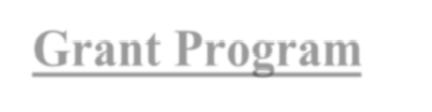
Community Engagement Clusters
Regional Service Office

Neighborhood Events Matching Fund Grant Program

Overview:
The Montgomery County Government established the Neighborhood Events Matching Funds Grant Program (NEMF) to promote community engagement, encourage capacity building, networking, and stimulate the local economy. This program is administered by the five Regional Service Offices. Neighborhood organizations, block groups, tenant associations, and civic clubs that are active and in good standing may apply for funds to hold events and activities by completing an application.
Eligible activities include those that are open to residents and create sustainable and lasting impacts for the neighborhood. Due to increased demand and the limited budget for this program, funding priority will be given to first-time applicants. The maximum fund amount is $1000 per applicant, per funding cycle (July 1, 2024 – June 30, 2025). Funds will be given on a first-come, first-served basis.

Instructions:
- Complete the application form and return it to the contact listed below.

- Provide proof of payment for the expenditures from the eligible activity.
- Grant funds will be matched dollar for dollar (1:1) with cash or in-kind donations.

- All events must comply with the Montgomery County Law.

Process:
- Upon review of the application by the County, the applicant will be notified as to whether the application is approved and the amount of funds that will be provided to support the activity.
- Approved applicants will be required to agree to the conditions of the grant program prior to payment by the County.

Contact
Talia Beaulieu-Hains
Community Projects Manager
Mid-County Regional Services Center
Talia.Beaulieuhains@montgomerycountymd.gov
(240) 927-3632

