Minutes of May 6, 2010 Meeting
Committee for Ethnic Affairs
Executive Office Building Auditorium

Members Attending: Enas Elhanafi, Harry Iceland, Rayness Mayne, Walton Dawson, Kennedy Odzafi and Joshua Hedaya

Absent: Tyson Bellamy, Arthur Bezwada, Charmaine Cruise, Lobna Ismail, Abdul Karzai, Jorge Restrepo, Chief Alexander Taku, Lesley Vossen, Mark Puryear and Johnny Yataco

Guest: Dr. Clarice A. Somersall, Montgomery College

OCP Staff: Lisa Austin

Meeting – Chair called the meeting to order at 7:05 p.m. and welcomed everyone.

Introductions by CEA members with brief history of their service on the CEA.
Chairwomen welcomed and introduced Dr. Somersall, read her bio to the members, and invited her to give the committee members an overview on her work projects and priorities and to give us her insight on joining the efforts, creating new opportunities of collaboration.

Dr. Somersall

She has been with Montgomery College for 21 years in a variety of positions and roles, including faculty. She started the Assessment Center. Dr. Somersall described that the college now serves students from 170 countries and she has found that everyone is “different but so much alike under the skin.” Some of the work she developed:
- Diversity training to the college from the Diversity Management Institute
- Proud of her involvement
- Hispanic Business Institute with the Department of Economic Development and the Hispanic Chamber
- Founding member of MCAEL where the Council commissioned her to do a study for MCAEL
- She’s had faculty go to teach in China
- Realized that the size of the college (60,000+), 3 campuses that there may be duplication of outreach efforts, needed to be brought together to collaborate
- Formed an outreach group to talk about students’ needs in their communities – “I love working with people.”

Josh: What would she recommend to a group such as the CEA?

Dr.S: Have Reed Dewey come and give a talk to the CEA about helping the homeless. Also speakers regarding second language issues.
Enas: Thanked Dr. Somersall for enlightening the committee with her presentation. Also, thanked for taking the time to be with the committee. The CEA committee appreciates your efforts and welcomes the opportunity of collaboration.

Lecture Series –
Harry and Leslie briefed the committee on the upcoming lecture with Steve Roberts on immigration. Enas mentioned that there should be someone who introduces him and facilitates a Q & A. It was suggested Bruce Adams, Leslie, and Harry as possible facilitators. It was agreed that someone from the committee should do it. Leslie and Harry were reluctant to do it, Josh volunteered to do it as well as Enas. It was agreed that Enas should do it as she was the original founder of the lecture series and chairwomen of the CEA.

CEA Brochure –
Enas proposed to finalize the brochure from by Thursday the 13th. Walton and Kennedy had issues with the photography, and did not think it was diverse enough for CEA’s standards.

After some discussion the committee agreed that Walton would have one week to submit any changes he wished to Enas for the brochure; however, after that date, the CEA would move forward with the brochure and publish it.

CEA Website –
Enas indicated that the CEA website was updated with up to date documents and a photo. Walton and Chief have suggested in a previous meeting to work on redesign the website. There was no update.

World of Montgomery Festival –

Josh updated the committee on his meeting at the Latino Economic Development Council in April regarding the WMF. As cash is tight this year, the fair itself may very well not be going on. He said he is waiting on more information from Bruce Adams and will update the committee as he knows more.

Community Events Calendar–
There was a follow up on April events. Chairwoman argued the members to attend and participate in the community events. In addition to posting these events on the CEA Facebook page.

CEA Retreat –
Enas explained that with the CEA retreat approaching in October it was important to start planning it now, especially since the committee will be off in July and August.

CEA-County Cable Program –
Enas indicated that she has sent to Karen Falcon at the county Public Information office, an overview about a proposed program based on Mr. Leggett interest in creating a monthly “World of Montgomery” cable show to reach out to all community. Mr. Leggett has communicated this interest with the CEA Committee members during Feb meeting. The purpose that Enas communicated with the Public Information Office is [ to inform the community about events, activities and success stories at the county; to educate about how diversity of our county brings great achievements by its residents contributions; to inform about the county’s efforts in working towards a better diverse community and to share with the community , their issues, concerns and interests]. There was no feedback. Will follow-up on this issue.
CEA Membership –
It was announced that the CEA will begin to accept new applicants for the coming year. It was suggested that each member reach out to their respective communities to drum up more applicants.

Enas asked if current members whose terms were expiring would be renewing their membership. Kennedy mentioned that he already had.

Adjournment
The meeting was adjourned at 8:30pm

Handouts (attached):
- The meeting agenda
- Dr. Clarice A. Somersall Bio
- Chairwoman Activities update- May 6th Meeting
- 2009-2010 Committee For Ethnic Affairs Attendance
- Author Steven V. Roberts Invitation

Montgomery County, Maryland
Committee for Ethnic Affairs
EXECUTIVE OFFICE BUILDING AUDITORIUM
101 Monroe Street
Rockville, MD 20850
Agenda
May 6st, 2010

7:00 PM | Call to Order & Welcome | Chair, Enas Elhanafi
7:05 PM | Guest Speaker | Dr. Clarice Somersall, Interim Vice President for Academic Initiatives and Partnerships, Montgomery College
7:35 PM | Approve minutes of:  - March 7, 2010 meeting  - April 1, 2010 meeting | The Full Committee
7:45 PM | CEA Brochure | The Full Committee
7:50 PM | CEA Website | Walton Dawson & Chief Alexander Taku
7:55 PM | CEA 1st Conversation Series: Steve Roberts (May 27 ) | Harry Iceland &, Lesley Moore Vossen
8:00PM | World of Montgomery Festival | Josh Hedaya &  Mark Puryear
8:05PM | Community Events Calendar  Follow-up and Update  - Heritage Months (April, May & June)  - Other Community Events | The Full Committee
8:15 PM | CEA-County Cable Program | Enas Elhanafi
8:20 PM | Membership Update | Lisa Austin (OCP) & Enas Elhanafi
8:25PM | New Business | The Full Committee
8:30 PM | Adjourn | Chair, Enas Elhanafi

Dr. Clarice Somersall Bio:
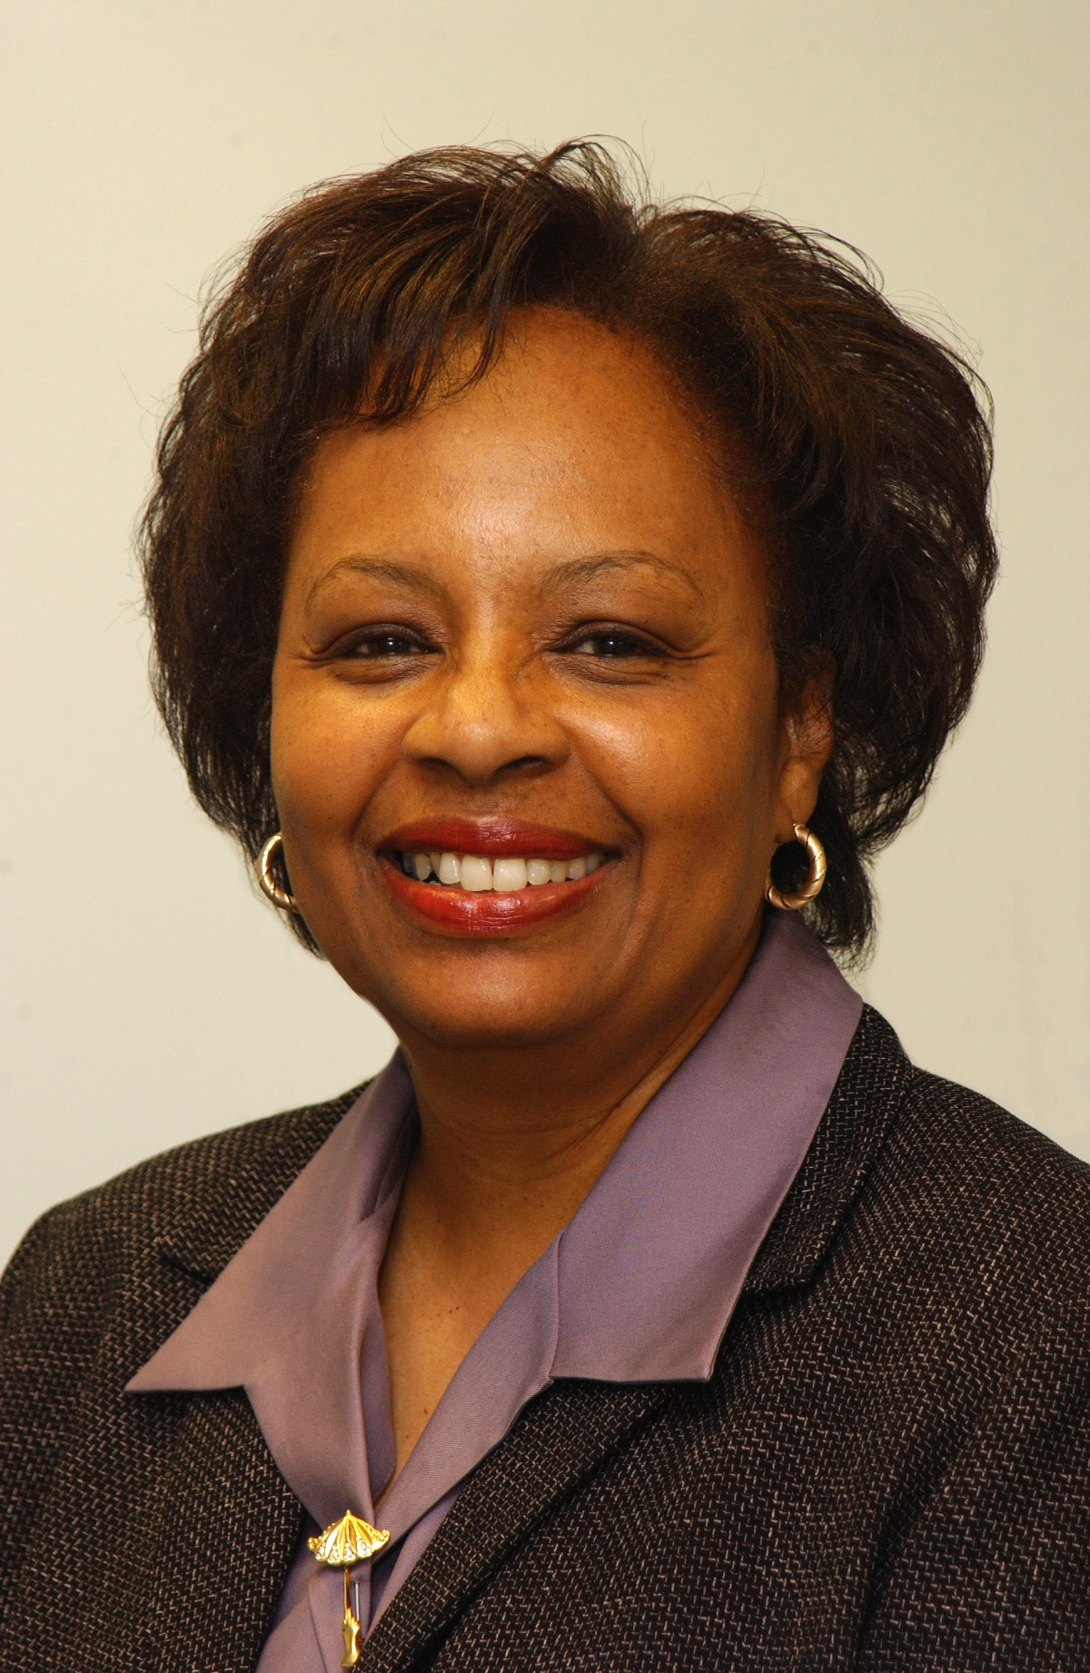
Dr. Clarice Somersall
Interim Vice President for Academic Initiatives & Partnerships
Montgomery College
In the role of Vice President for Academic Initiatives & Partnerships, Dr. Somersall leads a series of teams that have been formed at the college to shape the College's vision for adopting a "learning-centered college" approach. Somersall has been with Montgomery College for close to 20 years, having served as a faculty member, dean, and academic administrator, prior to her current interim post at the Takoma Park Campus. During her tenure at the college, Somersall has played an instrumental role in the creation and implementation of programs such as Pathways to Success, the Hispanic Business Institute, and the Diversity Management Institute. Somersall began her professional career in Bermuda, having served as a reading specialist at both the primary and postsecondary levels of education. She holds an Ed. D. in Community College Leadership form Morgan State University, master's degree in developmental education and a certificate in supervisory management from the Institute for Supervisory Management, London, England.

TO : The Committee of Ethnic Affairs Members
FROM: Enas Elhanafi, Chair
COPY TO: Office of Community Partnerships
Bruce Adams
Lisa Austin
RE: Chairwoman Activities update- May 6th Meeting

Chairwoman Activities Update:
- Event: Following the Presidential Summit on Entrepreneurship, The Aspen Institute & Arab Empowerment Initiative event on: THE FACES OF MUSLIM & ARAB AMERICANS ANSWERING OBAMA’S CALL Public and Cultural Diplomacy Luncheon & Networking Reception. Highlighting creative minds, entrepreneurs, civil society leaders & international business opportunities
Thursday, April 29, 2010- Willard Intercontinental Hotel
- Event: Muslim Women in the Arts
April 22, 2010 - County Executive building , Rockville
- Event: The Continental African Community: Leadership and Opportunity in the Obama Era
Friday April 16, 2010- Executive Office Building
- Meeting with Ms. Vivian Lawyer, Chief Human Resources Officer, Montgomery College, to discuss Collaboration and partnership opportunity with the CEA. April 2, 2010 -Montgomery College, Rockville Campus
- Updating the CEA Facebook page with county and community events , resources and news
- Working on updating the documents materials on the CEA website
- Follow-up with on CEA redesign with CEA Committee Members( Walton and Chief)
- Preparing thank you letters to all members leaving or were serving on the Executive committee
- Communications and follow-up with committee members by emails and phone related with the following topics: CEA brochure, CEA website, conversation series, community events and membership renewal
- Communications with the office of Dr. Somersall regarding May 6 meeting
- Event: Arab American Heritage County Executive Proclamation
March 31, 2010 County Executive building , Rockville

2009-2010COMMITTEE FOR ETHNIC AFFAIRS ATTENDANCE
P=Present; A=Absent; R=Resigned
Last Name | First Name | 2009 | Sept. | Oct. | Nov. | Dec. | Jan. | 1-30Retreat | Feb. | Mar. | April
Bellamy | Tyson |  | A | A | P | P | A | A | A/P | P | A
Bezwada | Arthur |  | P | P | A | P | A | A | P | P | A
Chen | Yen-Ju |  | P | P | P | P | P | A | A | P | A
Cruise | Charmaine |  | P | P | P | P | P | P | P | A | P
Dawson | Walton |  | P | P | A | P | P | A | P | P | P
Edokobi | Emmanuel |  | A | A | A | P | A | P | A | A | A
Elhanafi | Enas |  | P | P | P | P | A | P | P | P | P
Hedaya | Joshua |  | A | A | P | P | P | P | P | P | A
Iceland | Harry |  | A | P | A | A | P | P | P | P | P
Ismail | Lobna (Luby) |  | P | P | A | P | P | P | P | P | A
Karzai | Abdul |  | A | A | A | P | A | A | A | A | A
Mayne | Rayness |  | A | P | P | P | P | P | P | P | A
Moore | Hans |  | P | P | A | P | A | A | A | A | A
Odzafi | Kennedy |  | P | P | P | P | P | P | P | P | P
Puryear | Mark |  | A | P | P | A | P | P | A | A | A
Restrepo | Jorge |  | A | A | A | P | P | P | A | A | A
Spence | Grace |  | A | P | A | A | A | A | A | P | A
Taku | Chief Alexander |  | P | A | A | A | P | P | A | A | P
Vossen | Lesley Moore |  | P | P | P | P | A | A | P | P | P
Yataco | Johnny |  | P | P | A | A | P | P | A | A | A
Nadine Benton | Resigned
Jenny Freeman | Resigned
Michael Friedman | Resigned
Tiffany Heath | Resigned
Christy Hoang | Resigned
Kimberley Powell | Resigned
Anna Towns | Resigned

Author Steven V. Roberts Invitation

The Montgomery County Committee for Ethnic Affairs invites you to join author Steven V. Roberts for a Community Conversation. Information about the program is included in the attached flyer.
Roberts recently published book, From Every End of This Earth: 13 Families and the New Lives They Made in America, profiles 13 families who immigrated to America. While the immigration experience is different for each family, one common thread is what Roberts describes as the sacrifice generation, the ones that face “the pain of dislocation, of missing home, of living in two worlds and never feeling completely comfortable in either one.” For many immigrants, this sacrifice is made for the sake of their children.
Following Roberts’ discussion of immigrant experiences, audience members may share their own stories of their immigration experiences.
This program is the first in a pilot program developed by the Committee on Ethnic Affairs (CEA) to encourage communication amongst the diverse communities of Montgomery County. The CEA is under the umbrella of the Office of the County Executive, Office of Community Partnerships. Its purpose is to bridge the cultural diversity of all ethnic groups in Montgomery County and its mission is to advise the County Executive and the County Council on public policy that relates to ethnic affairs and to promote maximum involvement of all ethnic groups in the County government and other County services and programs.
Please join County Executive Ike Leggett, Professor Roberts, other community leaders, and the Committee for Ethnic Affairs for this Community Conversation on Monday, May 24, 2010 from 7 to 9 pm at the First floor meeting room of the Rockville Library (21 Maryland Avenue.)

